MINISTRY OF EDUCATION AND TRAINING

**FPT UNIVERSITY**

Capstone Project Document

**Keeping Track of Child System**

|  |  |
| --- | --- |
| **Group 13** | |
| **Group member** | Nguyễn Thanh Nghĩa – Team Leader – SE61642  Cao Huy Bảo – Team Member – SE61802  Đoàn Duy Anh – Team Member – SE62023  Nguyễn Anh Duy – Team Member – SE61611 |
| **Supervisor** | Mrs. Nguyễn Thị Cẩm Hương |
| **Ext. Supervisor** | N/A |
| **Capstone Project**  **code** | KTOCS |

**-Ho Chi Minh, 04/2018-**

*This page is intentionally left blank*

Table of Contents

Table of Contents 1

List of Tables 3

List of Figure 5

Definitions, Acronyms, and Abbreviations 9

A. Introduction 9

1. Project Information 9

2. Introduction. 9

3. Current Situation 9

4. Problem Definition 10

5. Proposed Solution. 10

5.1 Feature functions 10

5.2 Advantage and disadvantages 10

6. Functional Requirements 11

7. Role and Responsibility 12

B. Software Project Management Plan 12

1. Problem Definition 12

1.1 Name of this Capstone Project 12

1.2 Problem Abstract 12

1.3 Project Overview 12

2. Project Organization 15

2.1 Software Process Model 15

2.2. Roles and Responsibilities 16

2.3 Tools and Techniques 18

3. Project Management Plan 18

3.1. Software development life cycle 18

3.2.Phase Detail 20

4. Coding Convention: 23

C. Software Requirement Specification 23

1. User Requirement Specification: 23

1.1 Guest Requirement 23

1.2 Children Requirement 24

1.3 Parent Requirement 24

2. System Requirement Specification: 24

2.1 External Interface Requirement 24

2.2 System Overview Use Case 26

D. Software Design Description 95

1. Design Overview 95

2. System Architectural Design 96

2.1 Web service Application Architecture Description 96

2.2 Android application architecture description 96

3. Component Diagram 97

4. Detailed Description 98

4.1 Class Diagram 98

4.2 Class Diagram Explanation 99

4.3 Interaction Diagram 113

5. Interface 166

5.1 Android Interface Design 166

6. Database Design 200

6.1 Web Service Logical Diagram 200

6.2. Web Service Data Dictionary 201

7.Algorithms 206

7.1 Notify parent if children move out or move in of trusted location 206

E. System Implementation & Test 211

1. Introduction 211

1.1 Overview 211

1.2 Test Approach 211

2. Database Relationship Diagram 212

2.1 Physical Diagram 212

2.2 Data Dictionary 213

3. Performance Measures 218

4. Test Plan 219

5. System Testing Test Case 219

5.1 Android Application Test case: 222

F. Sotfware User’s Manual 246

1. Installation Guide 246

1.1 Setting up environment at server side 246

1.2 Deployment at server side 246

1.3 Setting up the environment at client side 252

2. User Guide 255

List of Tables

Table 1: Definitions 9

Table 2: Roles and Responsibility 12

Table 3 Hardware Requirement for Server 14

Table 4 Hardware Requirement for Mobile 15

Table 5 Software Requirement 15

Table 6: Roles and Responsibilities 18

Table 7: Tools and Techniques 18

Table 8: Software development life cycle 20

Table 9: Requirement Analysis 21

Table 10: System Design 21

Table 11: Implementation 22

Table 12: Testing 22

Table 13: Development 22

Table 14: Maintenance 22

Table 15: USE CASE – UC_P.01 - Login 28

Table 16: USE CASE – UC_G.01 - Register 31

Table 17: USE CASE – UC_P.02 - Add new children‘s device 34

Table 18: USE CASE – UC_P.03 - Remove children’s device 36

Table 19: USE CASE – UC_P.04 - View List Children 37

Table 20: USE CASE – UC_P.05 - View Children’s Information 39

Table 21: USE CASE – UC_P.06 - Edit Children’s Information 41

Table 22: USE CASE – UC_P.07 - Edit parent information 44

Table 23: USE CASE – UC_C.01 - Show QR code 46

Table 24: USE CASE – UC_C.02 - Approve or Rejected manage from parent 48

Table 25: USE CASE – UC_C.03 - View Children’s parents 50

Table 26: USE CASE – UC_C.04 - Logout 52

Table 27: USE CASE – UC_P.08 - View children’s location 53

Table 28: USE CASE – UC_P.09 - Setting Notification 55

Table 29: USE CASE – UC_P.10 - View Notifiction 57

Table 30: USE CASE – UC_P.11 - View Children Location 60

Table 31: USE CASE – UC_P.12 - View list trusted location 62

Table 32: USE CASE – UC_P.13 - Remove trusted location 64

Table 33: USE CASE – UC_P.14- Add trusted location 68

Table 34: USE CASE – UC_P.15 - View trusted location detail and list schedule of trusted location 70

Table 35: USE CASE – UC_P.16 - Add schedule for children trusted location 73

Table 36: USE CASE – UC_P.17 - Update schedule for children trusted location 75

Table 37: USE CASE – UC_P.18 - Remove Schedule 77

Table 38: USE CASE – UC_P19 - View list all Schedule 79

Table 39: USE CASE – UC_P.20 - View call logs 81

Table 40: USE CASE – UC_P.21 - View Message list 84

Table 41: USE CASE – UC_P22 - View Message detail 85

Table 42: USE CASE – UC_P.23 - View Contact 87

Table 43: USE CASE – UC_P.24 - View Contact’s Message 90

Table 44: USE CASE – UC_P.25 - View Contact’s Call log 92

Table 45: USE CASE – UC_P.26 - View Contacts Detail 95

Table 46: <Attribute> Parent 99

Table 47: <Method> Parent 103

Table 48: <Attribute> Children 104

Table 49: <Method> Children 105

Table 50: <Attribute> Parent manage Children 105

Table 51: <Method> Parent manage Children 105

Table 52: <Attribute> Notification Center 106

Table 53: <Method> Notification Center 106

Table 54:<Atribute> Contact 107

Table 55:<Method> Contact 107

Table 56:<Attribute>CallLog 108

Table 57:<Method>CallLog 108

Table 58:<Attribute>LocationLog 109

Table 59:<Method>LocationLog 109

Table 60:<Attribute>Message Log 109

Table 61:<Method>Message Log 110

Table 62:<Attribute>Trusted location 110

Table 63:<Method>Trusted Location 111

Table 64:<Attribute>Children’s Trusted Location 111

Table 65:<method>Children’s Trusted Location 112

Table 66:<Attribute>TimeTable 112

Table 67:<Method>TimeTable 112

Table 68:<Attribute>TimeSlot 113

Table 69:<Method>TimeSlot 113

Table 70: Table Web Entity Data Dictionary 201

Table 71: Table Detail Web Entity Data Dictionary 206

Table 72: Data Dictionary 213

Table 73: Attribute data dictionary 218

List of Figure

Figure 1: Chart Plan 16

Figure 2: System Overview Usecase 26

Figure 3: <Parent> Login 27

Figure 4: <Parent> Register 29

Figure 5: <Parent>Add new children‘s device 32

Figure 6: <Parent> Remove children’s device 34

Figure 7: <Parent> View List Children 36

Figure 8: <Parent> View Children’s Information 38

Figure 9: <Parent> Edit Children’s Information 39

Figure 10: <Parent> Edit parent information 42

Figure 11: <Children> Show QR code 45

Figure 12: <Children> Approve or Rejected manage from parent 47

Figure 13: <Children> View Children’s parents 48

Figure 14: <Childrent> Logout 50

Figure 15: <Parent> View children’s location 52

Figure 16: <Parent> Setting Notification 54

Figure 17: <Parent> View Notifiction 56

Figure 18: <Parent> View Children Location 58

Figure 19: <Parent> View list trusted location 60

Figure 20: <Parent> Remove trusted location 62

Figure 21: <Parent> Add trusted location 64

Figure 22: <Parent> View trusted location detail and list schedule of trusted location 68

Figure 23: <Parent> Add schedule for children trusted location 70

Figure 24: <Parent> Update schedule for children trusted location 73

Figure 25: <Parent> Remove Schedule 76

Figure 26: <Parent> View list all Schedule 78

Figure 27: <Parent> View call logs 80

Figure 28: <Parent> View Message list 82

Figure 29: <Parent> View Message detail 84

Figure 30: <Parent> View Contact 86

Figure 31: <Parent> View Contact’s Message 88

Figure 32: <Parent> View Contact’s Call log 90

Figure 33: <Parent> View Contacts Detail 92

Figure 34: System architectural 96

Figure 35: Component Diagram 97

Figure 36: Class Diagram 98

Figure 37: Activity Diagram - <Guest> Register 114

Figure 38: Activity Diagram - <Parent> Login 116

Figure 39: Activity Diagram - <Parent > Scan QR code to add children 118

Figure 40: Activity Diagram - <Parent> Input QR code to add children 120

Figure 41: Activity Diagram - <Parent> Update Children 122

Figure 42: Activity Diagram - <Parent> Update parent 123

Figure 43: Activity Diagram - <Parent> Delete children 125

Figure 44: Activity Diagram - <Children> Show QR code 126

Figure 45: Activity Diagram - <Children> Confirm parent manage 127

Figure 46: Activity Diagram - <Children> View list parent 128

Figure 47: Activity Diagram - <Parent> View Current children’s location 130

Figure 48: Activity Diagram - <Parent> Directions to current children's location 131

Figure 49: Activity Diagram - <Parent> View list trusted location 132

Figure 50: Activity Diagram - <Parent> Search place to add 134

Figure 51: Activity Diagram <Parent> Add trusted location by current place 137

Figure 52: Activity Diagram - <Parent> Get all Contact 138

Figure 53: Activity Diagram - <Parent> Get all call logs 139

Figure 54: Activity Diagram - <Parent> Get all Message 140

Figure 55: Activity Diagram - <Parent> View Contacts 142

Figure 56: Activity Diagram - <Parent> View List Message 143

Figure 57: Activity Diagram - <Parent> View Call Logs 144

Figure 58: Activity Diagram - <Parent> View message Detail 146

Figure 59: Activity Diagram - <Parent> View contact’s detail 147

Figure 60: Activity Diagram - <Parent> View contact’s message 148

Figure 61: Activity Diagram - <Parent> View contact’s Call Log 149

Figure 62: Activity Diagram - <Parent> View Trusted Location 150

Figure 63: Activity Diagram - <Parent> Add a new trusted location 151

Figure 64: Activity Diagram - <Parent> Delete a Trusted Location 153

Figure 65: Activity Diagram - <Parent> View All Schedule 154

Figure 66: Activity Diagram - <Parent> Add new Schedule 155

Figure 67: Activity Diagram - <Parent> Update a schedule 156

Figure 68: Activity Diagram - <Parent> Delete a schedule 157

Figure 69: Activity Diagram - <Parent> View Schedule of Trusted Location 158

Figure 70: Activity Diagram - <Parent> Setting Notifcation 160

Figure 71: Activity Diagram - <Parent> View Notification 160

Figure 72: Activity Diagram - <Parent> View Notification Detail 161

Figure 73: Activity Diagram - <Parent> View Children Location 162

Figure 74: Acitvity Diagram - <Parent> Direction Route 163

Figure 75: Activity Diagram - <Children> Log Out 164

Figure 76: Main page 166

Figure 77 Login page 167

Figure 78 Register page 168

Figure 79 Parent page 169

Figure 80 Setting page 170

Figure 81 Notification setting page 171

Figure 82 Edit information of parent page 172

Figure 83 Add new children page 174

Figure 84 View list children page 175

Figure 85 Edit children page 176

Figure 86 Children page 177

Figure 87 Option page 179

Figure 88 View Conacts page 181

Figure 89 View detail phone number in contacts 182

Figure 90 View call logs page 183

Figure 91 View message logs page 184

Figure 92 View detail message page 186

Figure 93 Search contacts 186

Figure 94 Search call logs 187

Figure 95 Search call logs by calendar 188

Figure 96 Notification center page 189

Figure 97 View detail no internet notification page 190

Figure 98 View detail out of trusted location notification page 191

Figure 99 View trusted location page 192

Figure 100 : Pop up to add a place 193

Figure 101 : Map page to choose a place set trusted location 194

Figure 102: Pop up place chosen 195

Figure 103: Schedule for trusted location page 196

Figure 104: Pop up delete a schedule 197

Figure 105: View Children location 198

Figure 106: Logical Diagram 200

Figure 107: Flow chart 208

Figure 108: Web Service Physical Diagram 212

Figure 109: Guest Activity Flow 219

Figure 110: Parent activity flow 220

Figure 111: Children activity flow 221

Figure 112: Prepare deployment package 247

Figure 113: Setup port for MySQL 248

Figure 114: Setup username/password for MySQL 249

Figure 115: Connect database with other username and password 250

Figure 116: After unzip apache-tomcat-8.5.10.zip 250

Figure 117: startup.bat to start and shutdown.bat to stop 251

Figure 118: Run Apache Tomcat 251

Figure 119: Deploy web service 252

Figure 120: Test Web Service for computer 253

Figure 121: Change setting to install unknown source apk 253

Figure 122: Test Web Service for phone 254

Definitions, Acronyms, and Abbreviations

|  |  |
| --- | --- |
| **Name** | **Definition** |
| KTOCS | Keeping Track of Child System |

Table 1: Definitions

1. **Introduction**
   1. **Project Information**

- Project name: Keeping Track of Child System- Project Code: KTOCS- Product Type: Android Application- Start Date: Jan 8th, 2018- End Date: May 1st, 2018

* 1. **Introduction**We present you a solution to support parents to protect their children better. Currently, there are many risks that children have to go through while they go to school, going out like kidnaper, enticements and child sexual abuse. Therefore, we offer a solution to parents who could prevent and protect their children in modern life.

In our project, we build an Android application that allow parents know where their children are, when and where the children go to a strange location, keep track of their children message to prevent bad and cyber enticements.

* 1. **Current Situation**

- The parents usually work for long hours – got little time to care for their child.

- The children:

+ Mostly have to go to school alone on foot or by bicycle, by bike.

+ Have easy access to websites without grown-ups supervise.

- The society:

+ Increasing on report of child sexual abuse, child abuse on social media, papers.

+ Child kidnapping, enticements on messaging for ransom and organs theft are being reported.

+ Many unhealthy websites are freely established.

* 1. **Problem Definition**  
     There is a wide range of disadvantages of the current situation:
* Cannot set up locations where children regularly visit.
* There is no notice when the child leaves the established area.
* Cannot retrieve children's details messages, calls, contacts.
* Losing privacy when keeping tracked on apps.
  1. **Proposed Solution**

The software allows parents to track their children. Parents could add information about their children and establish locations where children are frequently visited. By taking advantage of the GPS on the phone, parents can control their child's safety by checking whether their child is still in the installed location.

**5.1 Feature functions**

**-** The parent could add a new children’s information.

- The parent could establish locations where children are frequently visited.

- The parent could view all call logs from child’s smartphone.

- The parent could view all messages from child’s smartphone.

- The parent could view all location on child’s smartphone.

- The parent could view all contact from child’s smartphone

- The parent could receive the alert when child not infrequently location.

### 5.2 Advantage and disadvantages

* Advantages: Application allows parents to take advantage of their child's smartphone to check if the children are safe or unsafe.
* Disadvantages: children needs a smartphone that is always have internet connection and GPS mode. In addition, the battery power must also be large to keep tracking without interruption.
  1. **Functional Requirements**

Parent component:

* Register new account
* Login the application
* Add new children’s device
* Manage list of children
* Get call logs and all information about each call
* Access children’s conversations and message content
* Access children’s contact number
* Set list of trusted location for each child
* Get alert when children not in trusted location after (time)
* Schedule location day by day for each child

Children’s component:

* View the usernames are controlling their phone.
* Show QR code to parent scan when add new children.
* Require code to exit from parent when log out the application.
* Approve or Rejected when parent or other people want to control.
  1. **Role and Responsibility**

|  |  |  |  |  |
| --- | --- | --- | --- | --- |
| No | Full name | Role | Position | Contact |
| 1 | Nguyễn Thị Cẩm Hương | Project Manager | Instructor | [Huongntc2@fe.edu.vn](mailto:Huongntc2@fe.edu.vn) |
| 2 | Nguyễn Thanh Nghĩa | Developer | Leader | [Nghiantse61642@fpt.edu.vn](mailto:Nghiantse61642@fpt.edu.vn) |
| 3 | Cao Huy Bảo | Developer | Member | [Baochse61802@fpt.edu.vn](mailto:Baochse61802@fpt.edu.vn) |
| 4 | Đoàn Duy Anh | Developer | Member | [Anhddse62023@fpt.edu.vn](mailto:Anhddse62023@fpt.edu.vn) |
| 5 | Nguyễn Anh Duy | Developer | Member | [Duynase61611@fpt.edu.vn](mailto:Duynase61611@fpt.edu.vn) |

Table 2: Roles and Responsibility

# B. Software Project Management Plan

# 1. Problem Definition

* 1. **Name of this Capstone Project**

Keep Track of children system

* 1. **Problem Abstract**

Currently, in Viet Nam there are many reports on media and papers about children being kidnapping, entice and children abuse. Therefore, parents these days not only want to protect but also want to prevent, keep track of their children before the crime have a chance to occur.

Keep Track of children system is an application which helps users to create a set of safe list locations where children usually go, provide the ability to use GPS technology to base on the safe list locations, will notify to parents when there is suspicious action occurs. Our system also helps parents to monitor children's suspicious phone calls and harmful message.

* 1. **Project Overview**
     1. **Current Situation**

- **Android Phone applications**: There are several applications which Provide tracking SMS tracker and call blocker, some application can also Block in-app purchases, app installs, ad clicks and block certain webpage.

- **Advantages**: Keep track of children if they are safe. Access to call logs, message.

- **Disadvantages**:

+ Smartphone needs to be always in internet mode and GPS mode so the phone's battery run out fast.

+ Risk of privacy violation.

* + 1. **The Proposed System**

- The system is designed for the parent to be able to create their children's profile and generate code to register the children's phone.

- We use GPS to track the children's phone, and android permission to get call logs, message.

* + - 1. **Mobile Application**

-To parent:

+ Create children’s profile

+ Create list of safe locations accounting for the children

+ Get notification when children’s phone was gone to an untrusted location

+ Periodically get announcement the new call logs, message, current location of the children

-To children:

+ Application will hide in the background and start with android startup in case of phone reboot

+ In case of disconnecting with network, data will still be stored in local memory to report

* + 1. **Boundaries of the System**

- The system can be used by every person have Android Phone 4.0 devices or later with internet connection.

- The language of the application is Vietnamese.

- The complete product includes:

* The mobile Android application.
* All the process document involved.
  + 1. **Future Plans**

-The current application is not focused on browsing behavior, we plan in the future will be able to provide blocking pornography web access on children’s phone, pono ads, SMS filter to prevent sexting.

* + 1. **Development Environment**

1.3.5.1 Hardware requirements  
**For Server**

|  |  |  |
| --- | --- | --- |
| Windows | Minimum Requirements | Recommended |
| Internet Connection | Cable, Wi-Fi ( 8 Mbps) | Cable, Wi-Fi (16 Mbps) |
| Operating System | Window Server 2008 | Window Server 2012 |
| Computer Processor | Intel® Xeon ® 1.4GHz | Intel® Xeon ® Quad-Core (12M Cache, 2.50 GHz) |
| RAM | 1GB RAM | 2GB |
| I/O Speed | 120MB/s | 350MB/s |

**Table 3 Hardware Requirement for Server**

**For Mobile**

|  |  |  |
| --- | --- | --- |
| Mobile | Minimum Requirements | Recommended |
| Internet Connection | 2 Mbps | 4 Mbps |
| Operating System | Android 5.0 | Android 6.0 |
| Hardware | GPS supported | GPS supported |
| Memory | 150MB | 150MB more |

**Table 4 Hardware Requirement for Mobile**

**1.3.5.2 Software requirements**

|  |  |  |
| --- | --- | --- |
| Software | Name / Version | Description |
| Operating system | Window Server 2012 | Operating system and platform for development |
| Environment | Java EE 6 | Specification for developing web application |
| IDE | Android Studio 3.0, IntelliJ IDEA 2017.3.1 | Programming tools |
| DBMS | MySQL 5.6 | Used to create & manage the database for system |
| Source control | SourceTree 2.4.7.0 | Used for source control |
| Web browser | Chrome 42 or above | Testing browser |

**Table 5 Software Requirement**

# 2. Project Organization

2.1 **Software Process Model**

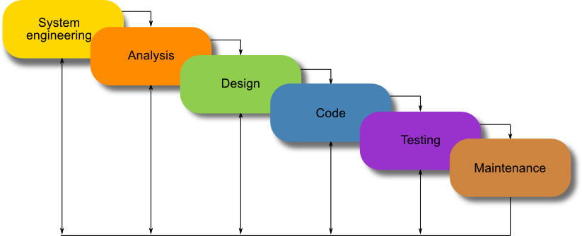

Figure 1: Waterfall Model

For more information: <https://airbrake.io/blog/sdlc/waterfall-model>

This project is developed under waterfall model. We customized the model to capable of our current situation. We choose this model because of the following reasons:

* This project is 4 months long, which can be considered a short project.
* Based on the researchers and clarify about Vietnam today’s society, children being kidnapping, children abuse. Fears of any parents, who are busy with their work, …They need to be alert any time when their children get risk or the sooner they realize the risk to their child. The requirement of the project is to know the features needed to assist in monitoring their children.
* This project needs deep understanding about the android system, which we need strong background knowledge.

2.2. Roles and Responsibilities

|  |  |  |  |
| --- | --- | --- | --- |
| No | Full name | Role in Group | Responsibilities |
| 1 | Nguyễn Thị Cẩm Hương | Supervisor / Project Manager | * Clarify user requirement. * Technical support and business analysis. * Tracking development process. * Review document and product. |
| 2 | Nguyễn Thanh Nghĩa | Team Leader, BA, Developer, Tester | - Tracking process.  - Planning project, distribute tasks.  - Requirement analysis.  - Database design.  - Documentation.  - GUI Design.  - Coding.  - Testing.  - Deploy product. |
| 3 | Cao Huy Bảo | BA, Developer, Tester | - Requirement analysis.  - Database design.  - Documentation.  - GUI Design.  - Coding.  - Testing. |
| 4 | Đoàn Duy Anh | BA, Developer, Tester | - Requirement analysis.  - Database design.  - Documentation.  - GUI Design.  - Coding.  - Testing. |
| 5 | Nguyễn Anh Duy | BA, Developer, Tester | - Requirement analysis.  - Database design.  - Documentation.  - GUI Design.  - Coding.  - Testing. |

Table 6: Roles and Responsibilities

## 2.3 Tools and Techniques

|  |  |
| --- | --- |
| Tool / Technique | Name / version |
| Frontend | HTML, CSS, JavaScript, JQuery, Bootstrap |
| Backend | Spring, Hibernate, Android |
| Web server | Apache Tomcat 8 |
| Development tool | Intellij IDEA, Android Studio |
| DBMS | MySQL 5.6, Local Android DB |
| Source control | Bitbucket |
| Modeling tool | StarUML 5.0 |
| Document tool | Microsoft Word 2016 |

Table 7: Tools and Techniques

1. **Project Management Plan**
   1. **Software development life cycle**

|  |  |  |  |  |  |
| --- | --- | --- | --- | --- | --- |
| Phase | Description | Deliverable | Resource needed | Dependencies and Constrains | Risk |
| Requirement analysis | -Collect requirement from customer.  -Identify and clarity requriments | -Introduction of proposed system.  -Software requirement  specification.  -Project Task Plan.  - Prototypes | 20 workdays | N/A | -Missing requirement  -Misunderstand requirement  -Unclear scope  -Lack of understanding of team members |
| System Design | -Architecture design for the system  - Detail design using top-down break down  - Choose Architecture style | - Software Design Document  - Base code structure  - Technology notes | 20 workdays | Depend on “Requirement Analysis” | - Lack of experience.  - Not fulfil requirement. |
| Implementation | -Coding system core  functions and other feature with GUI  - Unit test | - Main user’s  functions on  mobile. | 60 workdays | Depend on “Design”. | - Lack of experience and  knowledge.  - Human mistake. |
| Testing | - Integration test the system  - Alpha test  - Correct bugs  - Beta test  - Acceptane test | - Test document | 20 workdays | Depend on “Implementation” | - Lack of experience.  -Missing test case |
| Development | - deployed in customer environment | -Installation guide.  - User  Manual | 10 workdays | Depend on “Testing” | - Human mistake. |
| Maintenance | fix issues come up in client environment  - released patches, versions | -Customer’s feedback | 10 workdays | Depend on “Maintenace” | - Lack of experience |

Table 8: Software development life cycle

* 1. **Phase Detail**
     1. **Phase 1: Requirement Analysis**

|  |  |  |
| --- | --- | --- |
| Task | Description | Author |
| 1. Collect requirements . | Find which systems currently provide similar service, their strengths and weakness. | Nguyễn Anh Duy |
| 2. Identify and clarify main functions. | Define which main functions system should provide. | Nguyễn Thanh Nghĩa |
| 3. Create System  Introduction. | Complete Introduction Report. | Nguyễn Thanh Nghĩa |
| 4. Software Project  Management Plan. | Prepare Project Management Plan. | Nguyễn Thanh Nghĩa |
| 5. Prototype. | Build a prototype of proposed system (Mobile). | Nguyễn Thanh Nghĩa |
| 6. SRS. | Create SRS document. | Nguyễn Thanh Nghĩa |

Table 9: Requirement Analysis

* + 1. **Phase 2: System Design**

|  |  |  |
| --- | --- | --- |
| Task | Description | Author |
| 1. Detailed Design | Compare new document with existed documents of the system. | Đoàn Duy Anh |
| 2. Database Design | Based on parsed data to the recommendation.  Based on other needs to the recommendation. | Nguyễn Thanh Nghĩa  Cao Huy Bảo |
| 3. Technology research | Study Android Phone Application Development.  Study how to use Google API.  Study GPS location management.  Study Spring Boot | Nguyễn Thanh Nghĩa  Cao Huy Bảo |
| 4. Design Document | Prepare Project Management Plan. | Nguyễn Thanh Nghĩa |

Table 10: System Design

* + 1. **Phase 3: Implementation**

|  |  |  |
| --- | --- | --- |
| Task | Description | Author |
| 1. Mobile functions | Implement mobile application | Nguyễn Thanh Nghĩa  Cao Huy Bảo  Đoàn Duy Anh  Nguyễn Anh Duy |
| 2. Unit testing | Write test case and testing for mobile functions | Nguyễn Anh Duy |

Table 11: Implementation

* + 1. **Phase 4: Testing**

|  |  |  |
| --- | --- | --- |
| Task | Description | Author |
| 1. Integration testing | Write test case and testing systems. | Nguyễn Anh Duy |
| 2. Alpha testing | Do the alpha test with the customer. | Nguyễn Thanh Nghĩa  Cao Huy Bảo  Đoàn Duy Anh  Nguyễn Anh Duy |

Table 12: Testing

* + 1. **Phase 5: Development**

|  |  |  |
| --- | --- | --- |
| Task | Description | Author |
| 1. Deployed in the customer environment | Support customer on deploying application | Nguyễn Thanh Nghĩa |
| 2. Installation guide | Write installation guide | Nguyễn Thanh Nghĩa |
| 2. User Manual | Write user manual | Đoàn Duy Anh |

Table 13: Development

* + 1. **Phase 6: Maintenance**

|  |  |  |
| --- | --- | --- |
| Task | Description | Author |
| 1. Support and getting feedback | Support and get feedback from customer for further patches and version | Nguyễn Thanh Nghĩa  Cao Huy Bảo  Đoàn Duy Anh  Nguyễn Anh Duy |

Table 14: Maintenance

1. **Coding Convention:**

We use followings naming convention from the reference to capable with the current situation in our team:

* Naming Convention:
* Use camelCase for the Variable name. Example: txtUsername, btnLogin, …
* Use PascalCase for Function name. Example: ControllButton, MyClass, …
* Indentation:
* Four spaces should be used as the unit of indentation. The exact construction of the indentation (spaces vs. tabs) is unspecified. Tabs must be set exactly every 8 spaces (not 4).
* Declarations:
  + Do not put different types on the same line.
  + Do not declare variable name, function names on the same line.
  + No space between a method name and the parenthesis.
  + Open brace “{” appears at the end of the same line as the declaration statement.

This project follows “Code Conventions for the Java TM Programming Language, by Sun Microsystems, rev April 20, 1999”.

<http://www.oracle.com/technetwork/java/codeconventions-150003.pdf>

# C. Software Requirement Specification

## 1. User Requirement Specification:

### 1.1 Guest Requirement

Guest can use some functions in the system. To use all functions, guest must log in. These are some functions guest can use:

* Register
* Login

### 1.2 Children Requirement

* Show QR code
* Share QR code
* View Parent information
* Require logout code

### 1.3 Parent Requirement

Parent is guest who uses his/her account to log in to the system. The parent can use additional functions, such as:

* Scan QR code to Add Child
* Input QR code to Add Child
* Manage Children
* View list Children
* View Children information
* Edit children’s information
* View Call logs
* View Conversations
* Remove children’s information
* Manage trusted locations
* Add trusted location
* View present location
* View list trusted location
* Remove trusted location

## 2. System Requirement Specification:

### 2.1 External Interface Requirement

#### 2.1.1 User Interface

- The Parent can choose the application language between English and Vietnamese

- Use the consistent palette of colors between the text and the background.

- General requirement for graphical user interface of application on the mobile device is the GUI should be simple, reminiscent.

#### 2.1.2 Hardware Interface

- Smartphone

- Since neither the mobile application nor the web portal have any designated hardware, it does not have any direct hardware interfaces. The physical GPS is managed by the GPS application in the mobile phone and the hardware connection to the database server is managed by the underlying operating system on the mobile phone and the web server.

#### 2.1.3 Software Interface

- Mobile application: Android operating system (v5.0 or above).

#### 2.1.4 Communication Protocol

- Using Http protocol.

## 2.2 System Overview Use Case

Figure 2: System Overview Usecase

## 2.3 List of Use Case

### 2.3.1. <Parent> Login

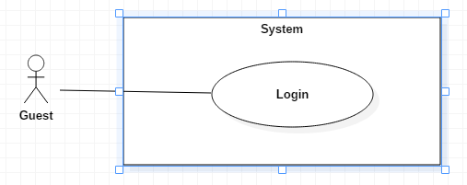

Figure 3: <Parent> Login

|  |  |  |  |  |  |
| --- | --- | --- | --- | --- | --- |
| USE CASE – UC_P.01 | | | | | |
| Use Case No. | | UC_P.01 | **Use Case Version** | | 2.0 |
| Use Case Name | | Login | | | |
| Author | | Nguyen Anh Duy | | | |
| Date | | 20/01/2018 | **Priority** | | Normal |
| Actor:   * Guest   Summary:   * This use case allows guest to log into the system.   Goal:   * Guest can log into the system.   Triggers:   * Guest sends login command.   Preconditions:   * Guest have to Register an account successful or have an account in the system.   Post Conditions:   * Success: Guest login the system. * Fail: Show error message.   Main Success Scenario: | | | | | |
| Step | Actor Action | | | System Response | |
| 1 | Guest goes to login view. | | | The System requires identity information from Guest:   * Username: free text input, required, length 6 – 20 * Password: free text input, required, length 6 – 20 | |
| 2 | Guest inputs information. | | |  | |
| 3 | Guest sends command login to system | | | Guest will login system with their specific role | |
| Alternative Scenario: | | | | | |
| Step | Actor Action | | | System Response | |
| 1 | Guest input wrong identity information. | | | Wrong identity information, System shows error message. | |
| Exceptions: | | | | | |
| Step | Actor Action | | | System Response | |
| 1 | Missing of required fields | | | System notify guest to enter their identity information | |
| Relationships: N/A  Business Rules:   * After login to the system, guest will be redirected to screen add children. | | | | | |

Table 15: USE CASE – UC_P.01 - Login

### 2.3.2. <Guest> Register

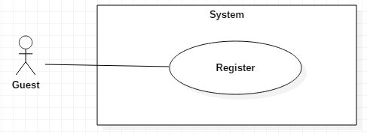

Figure 4: <Parent> Register

|  |  |  |  |  |  |  |
| --- | --- | --- | --- | --- | --- | --- |
| USE CASE – UC_G.01 | | | | | | |
| Use Case No. | | UC_G.01 | | **Use Case Version** | | 2.0 |
| Use Case Name | | Register | | | | |
| Author | | Nguyen Anh Duy | | | | |
| Date | | 20/01/2018 | | **Priority** | | Normal |
| Actor:   * Guest   Summary:   * This use case allows guest to register an account into the system.   Goal:   * Create new account into the database   Triggers:   * Guest click button “Parent”, then click link “Sign up”   Preconditions:   * N/A   Post Conditions:   * Success: Insert new account in the database * Fail: Show error message.   Main Success Scenario: | | | | | | |
| Step | Actor Action | | System Response | | | |
| 1 | Guest click “Parent” button | | Navigate to screen Log in | | | |
| 2 | Guest click link “Sign up” | | Navigate to register page which contains:   * “Username”: textbox, required, min length: 6, max length: 20. * “Fullname”: textbox, required, min length: 6, max length: 20. * “Password”: password, required, min length: 6, max length: 20. * “RePassword”: password, required, min length: 6, max length: 20. * “Email”:textbox, required, email,  max length: 50. | | | |
| 3 | Guest inputs information and click “Sign up” button. | | * Insert new member account into the database. * Redirect user to login page. | | | |
| Alternative Scenario: | | | | | | |
| Step | Actor Action | | | | System Response | |
| 1 | Guest the enter wrong information. | | | | Wrong information, System shows error message. | |
| Exceptions: | | | | | | |
| Step | Actor Action | | | | System Response | |
| 1 | “Username” is exited | | | | Show error message: “Username is exited”. | |
| 2 | “Username” is empty. | | | | Show error message: “Enter Username”. | |
| 3 | Length of “Username” is under 6 characters. | | | | Show error message: “MInimum 6 Characters” | |
| 4 | Length of “Username” is over 20 characters. | | | | Show error message: “Maximum 20 Characters” | |
| 5 | “Fullname” is empty. | | | | Show error message: “Enter Fullname”. | |
| 6 | Length of “Fullname” is under 6 characters. | | | | Show error message: “MInimum 6 Characters” | |
| 7 | Length of “Fullname” is over 20 characters. | | | | Show error message: “Maximum 20 Characters” | |
| 8 | “Password” is empty. | | | | Show error message: “Enter Password”. | |
| 9 | Length of “Password” is under 6 characters. | | | | Show error message: “Minimum 6 Character” | |
| 10 | Length of “Password ” is over 20 characters. | | | | Show error message: “Maximum 20 Characters” | |
| 11 | “RePassword” is empty. | | | | Show error message: “Enter RePassword”. | |
| 12 | Value of “RePassword” is different to “Password”. | | | | Show error message: “RePassword is not match”. | |
| 13 | “Email” is empty | | | | Show error message: “Enter Email”. | |
| 14 | “Email” is not valid format | | | | Show error message: “Email is not valid”. | |
| 15 | Length of “Email” is over 50 characters. | | | | Show error message: “Maximum 50 character”. | |
| Relationships: N/A  Business Rules:  After Register account successful to the system, guest will be redirected to login page to confirm the account. | | | | | | |

Table 16: USE CASE – UC_G.01 - Register

### 2.3.3. <Parent>Add new children‘s device

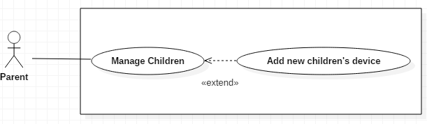

Figure 5: <Parent>Add new children‘s device

|  |  |  |  |  |  |  |
| --- | --- | --- | --- | --- | --- | --- |
| USE CASE – UC_P.02 | | | | | | |
| Use Case No. | | UC_P.02 | **Use Case Version** | | | 2.0 |
| Use Case Name | | Add new children’s device | | | | |
| Author | | Nguyen Anh Duy | | | | |
| Date | | 20/01/2018 | **Priority** | | | Normal |
| Actor:   * Parent   Summary:   * This use case allows parent add new children’s device   Goal:   * Parent can manage many children   Triggers:  Parent click “Scan QR to Add Children” button  Preconditions:   * Guest have to be Parent   Post Conditions:   * Success: Parent add successful new children ‘s device * Fail: Show error message   Main Success Scenario: | | | | | | |
| Step | Actor Action | | | System Response | | |
| 1 | Parent click “Scan QR to Add Children” button | | | * Appears on the camera screen to scan the QR code | | |
| 2 | Parent scan QR code on children ‘s device | | | * Confirm QR code and navigate add child screen. | | |
| 3 | Parent input children’s information. | | | * “Child’s name:” textbox, required, min length: 6, max length: 20. * “Code to Child exit:” textbox, required, min length: 6, max length: 20. | | |
| 4 | Parent click “Add Child” button | | | * Show message:”Waiting Approve from Children” | | |
| Alternative Scenario: | | | | | | |
| Step | Actor Action | | | System Response | | |
| 1 | Parent click “Input Child ’s code device” button | | | * Navigate to add child screen | | |
| 2 | Parent input children’s information. | | | * “Child’s code device” show on children’s device * “Child’s name:” textbox, required, min length: 6, max length: 20. * “Code to Child exit:” textbox, required, min length: 6, max length: 20. | | |
| 3 | Parent click “Add Child” button | | | * Show message:” Waiting Approve from Children” | | |
| Exceptions: | | | | | | |
| Step | Actor Action | | | | System Response | |
| 1 | Cannot scan QR code | | | | Show error message: “Cannot scan QR code” | |
| 2 | Input wrong code in children’s device | | | | Show error message:”Enter wrong code” | |
| 3 | “Child’s name” is empty. | | | | Show error message: “Enter Child’s name”. | |
| 4 | Length of “Child’s name” is under 6 characters. | | | | Show error message: “Minimum 6 characters” | |
| 5 | Length of “Child’s name” is over 20 characters. | | | | Show error message: “Maximum 20 characters” | |
| 6 | Exit Code to Exit for Children” is empty. | | | | Show error message: “Enter Exit Code” | |
| 7 | Exit Code to Exit for Children” is under 6 characters. | | | | Show error message: “Minimum 6 characters” | |
| 8 | Exit Code to Exit for Children” is over 20characters. | | | | Show error message: “Maximum 20 characters” | |
| Relationships: Children.  Business Rules:   * After add successful new children into parent’s account, the parent can manage children from their account. | | | | | | |

Table 17: USE CASE – UC_P.02 - Add new children‘s device

### 2.3.4. <Parent> Remove children’s device

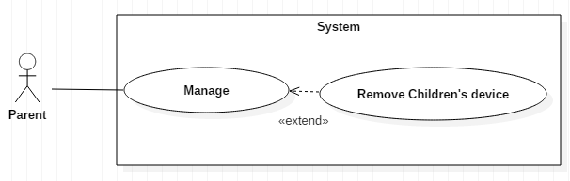

Figure 6: <Parent> Remove children’s device

|  |  |  |  |  |  |
| --- | --- | --- | --- | --- | --- |
| USE CASE – UC_P.03 | | | | | |
| Use Case No. | | UC_P.03 | **Use Case Version** | | 2.0 |
| Use Case Name | | Remove children’s device | | | |
| Author | | Nguyen Anh Duy | | | |
| Date | | 20/01/2018 | **Priority** | | Normal |
| Actor:   * Parent   Summary:   * This use case allow parent remove the children’s device.   Goal:   * The parent does not want to keep track children’s device.   Triggers:   * The parent clicks “Delete Child” on managing children screen.   Preconditions:   * Guest has to be Parent.   Post Conditions:   * Success: Children’s device will be deleted from the screen. * Fail: Show error message.   Main Success Scenario: | | | | | |
| Step | Actor Action | | | System Response | |
| 1 | Parent clicks “Delete Child” on managing children screen | | | Show pop-up confirm parent want “Delete” or “Cancel” | |
| 2 | Parent choose “Delete” | | | Show message: “Remove Child Successful” | |
| Alternative Scenario: | | | | | |
| Step | Actor Action | | | System Response | |
| 1 | Parent choose “Cancel” | | | Pop-up will turn off. | |
| Exceptions: | | | | | |
| Step | Actor Action | | | System Response | |
| 1 | Network is not available | | | Show popup message ‘Please check your network connection’ | |
| Relationships: Children  Business Rules:   * Children’s status change to Deactivate | | | | | |

Table 18: USE CASE – UC_P.03 - Remove children’s device

### 2.3.5. <Parent> View List Children

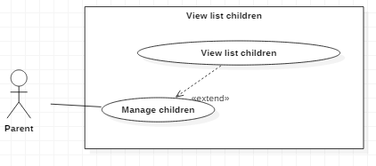

Figure 7: <Parent> View List Children

|  |  |  |  |  |  |
| --- | --- | --- | --- | --- | --- |
| USE CASE – UC_P.04 | | | | | |
| Use Case No. | | UC_P.04 | **Use Case Version** | | 2.0 |
| Use Case Name | | View list children | | | |
| Author | | Nguyễn Anh Duy | | | |
| Date | | 21/01/2018 | **Priority** | | Normal |
| **Actor:**   * Parent   **Summary:**   * This use case allows parent view all children whom parent manage   **Goal:**   * List children’s device of parent   **Triggers:**   * Parent press “List children”   **Preconditions:**   * User must be a parent   **Post Conditions:**   * Success: Show list children * Fail: Show error message   **Main Success Scenario:** | | | | | |
| Step | Actor Action | | | System Response | |
| 1 | Parent press “List Children” button | | | Navigate to List Children page and show list children | |
| Alternative Scenario: | | | | | |
| Step | Actor Action | | | System Response | |
| 1 | Parent press “List Children” button | | | Navigate to List Children page and show “List is empty” | |
| Exceptions: | | | | | |
| Step | Actor Action | | | System Response | |
| 1 | Network is not available | | | Show message ‘Please check your network connection’ | |
| **Relationships:**   * Children   **Business Rules:**  - List is loaded from system | | | | | |

Table 19: USE CASE – UC_P.04 - View List Children

### 2.3.6. <Parent> View Children’s Information

Figure 8: <Parent> View Children’s Information

|  |  |  |  |  |  |
| --- | --- | --- | --- | --- | --- |
| USE CASE – UC_P.05 | | | | | |
| Use Case No. | | UC_P.05 | **Use Case Version** | | 2.0 |
| Use Case Name | | View children information | | | |
| Author | | Nguyen Anh Duy | | | |
| Date | | 21/01/2018 | **Priority** | | Normal |
| **Actor:**   * Parent   **Summary:**   * This use case allows parent view children information detail   **Goal:**   * All information of children is shown   **Triggers:**   * Parent selected children and click   **Preconditions:**   * User must be a parent   **Post Conditions:**   * Success: Show page children’s information * Fail: Show error message   **Main Success Scenario:** | | | | | |
| Step | Actor Action | | | System Response | |
| 1 | Parent select children on “Children’s list” page | | | System go to “Children’s information” page and:  + Show all information of selected children | |
| Alternative Scenario: | | | | | |
| Step | Actor Action | | | System Response | |
| 1 | If user taps “←” | | | System navigates back to “Children’s list” page successfully. | |
| Exceptions: | | | | | |
| Step | Actor Action | | | System Response | |
| 1 | Network is not available | | | Show popup message ‘Please check your network connection’ | |
| **Relationships:**   * Children   **Business Rules:**  - Children information is loaded from system | | | | | |

Table 20: USE CASE – UC_P.05 - View Children’s Information

### 2.3.7. <Parent> Edit Children’s Information

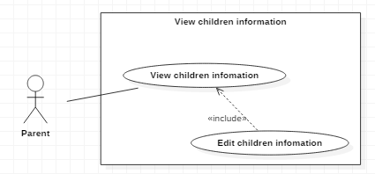

Figure 9: <Parent> Edit Children’s Information

|  |  |  |  |  |  |
| --- | --- | --- | --- | --- | --- |
| USE CASE – UC_P.06 | | | | | |
| Use Case No. | | UC_P.06 | **Use Case Version** | | 2.0 |
| Use Case Name | | Edit children information | | | |
| Author | | Nguyen Anh Duy | | | |
| Date | | 21/01/2018 | **Priority** | | Normal |
| **Actor:**   * Parent   **Summary:**   * This use case allows parent edit children information   **Goal:**   * Edit children information successful   **Triggers:**   * Parent press “Edit Children” button on “Children’s Option” page   **Preconditions:**   * User must be a parent   **Post Conditions:**   * Success: Children information edited successfully * Fail: Show error message   **Main Success Scenario:** | | | | | |
| Step | Actor Action | | | System Response | |
| 1 | Parent press “Edit Children” button | | | System go to “Edit children’s information” page with contains:   * “Child’s name:” textbox, required, min length: 6, max length: 20. * “Exit Code for Child:” textbox, required, min length: 6, max length: 20. | |
| 2 | Parent input valid information | | |  | |
| 3 | Parent press “Update” button | | | System saved new information of children and navigate to “Children’s Option” page | |
| Alternative Scenario: | | | | | |
| Step | Actor Action | | | System Response | |
| 1 | If user taps “←” | | | _system navigates back to “Children’s Option page” page successfully. | |
| 2 | Parent enter invalid information | | | System show error message. | |
| Exceptions: | | | | | |
| Step | Actor Action | | | System Response | |
| 1 | Network is not available | | | Show message ‘Please check your network connection’ | |
| 2 | Missing of required fields | | | System notify guest to enter their identity information | |
| 3 | Length of “Fullname” is under 6 characters. | | | Show error message: “Minimum 6 characters”” | |
| 4 | Length of “Fullname” is over 20 characters. | | | Show error message: “Maximum 20 characters” | |
| 5 | Length “Exit Code for Child” is under 6 charcters | | | Show error message: “Minimum 6 characters”” | |
| 6 | Length “Exit Code for Child” is over 20 characters | | | Show error message: “Maximum 20 characters” | |
| **Relationships:**   * Children   **Business Rules:**  - Children information is loaded from system | | | | | |

Table 21: USE CASE – UC_P.06 - Edit Children’s Information

### 2.3.8 <Parent> Edit parent information

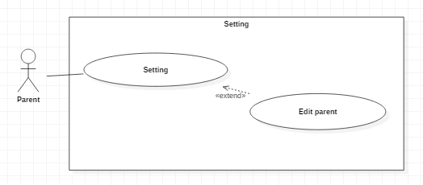

Figure 10: <Parent> Edit parent information

|  |  |  |  |  |  |  |
| --- | --- | --- | --- | --- | --- | --- |
| USE CASE – UC_P.07 | | | | | | |
| Use Case No. | | UC_P.07 | | **Use Case Version** | | 2.0 |
| Use Case Name | | Edit parent infomation | | | | |
| Author | | Nguyen Anh Duy | | | | |
| Date | | 20/01/2018 | | **Priority** | | Normal |
| Actor:   * Parent   Summary:   * This use case allows parent to update an account into the system.   Goal:   * Edit an account into the database   Triggers:   * Guest click button “Setting”, then click “Edit parent” button   Preconditions:   * Must be the parent   Post Conditions:   * Success: Update the account in the database * Fail: Show error message.   Main Success Scenario: | | | | | | |
| Step | Actor Action | | System Response | | | |
| 1 | Parent click “Setting” button | | Navigate to screen setting page | | | |
| 2 | Parent click “Setting” button | | Navigate to screen edit page | | | |
| 3 | Guest inputs information | | Navigate to edit page which contains:   * “Fullname”: textbox, required, min length: 6, max length: 20. * “Password”: password, required, min length: 6, max length: 20. * “RePassword”: password, required, min length: 6, max length: 20. * “Email”:textbox, required, email,  max length: 50. | | | |
| 4 | Guest inputs information and click “Update” button. | | * Update the account into the database. * Redirect user to parent page. | | | |
| Alternative Scenario: | | | | | | |
| Step | Actor Action | | | | System Response | |
| 1 | Parent the enter wrong information. | | | | Wrong information, System shows error message. | |
| Exceptions: | | | | | | |
| Step | Actor Action | | | | System Response | |
| 1 | “Fullname” is empty. | | | | Show error message: “Enter Fullname”. | |
| 2 | Length of “Fullname” is under 6 characters. | | | | Show error message: “MInimum 6 Characters” | |
| 3 | Length of “Fullname” is over 20 characters. | | | | Show error message: “Maximum 20 Characters” | |
| 4 | Value of “Username” has already existed. | | | | Show error message: “Username is Exists”. | |
| 5 | “Password” is empty. | | | | Show error message: “Enter Password”. | |
| 6 | Length of “Password” is under 6 characters. | | | | Show error message: “Minimum 6 Character” | |
| 7 | Length of “Password ” is over 20 characters. | | | | Show error message: “Maximum 20 Characters” | |
| 8 | “RePassword” is empty. | | | | Show error message: “Enter RePassword”. | |
| 9 | Value of “RePassword” is different to “Password”. | | | | Show error message: “RePassword is not match”. | |
| 10 | “Email” is empty | | | | Show error message: “Enter Email”. | |
| 11 | “Email” is not valid format | | | | Show error message: “Email is not valid”. | |
| 12 | Length of “Email” is over 50 characters. | | | | Show error message: “Maximum 50 character”. | |
| Relationships: N/A  Business Rules:  After update account successful to the system, parent will be redirected to parent page . | | | | | | |

Table 22: USE CASE – UC_P.07 - Edit parent information

### 2.3.9 <Children> Show QR code

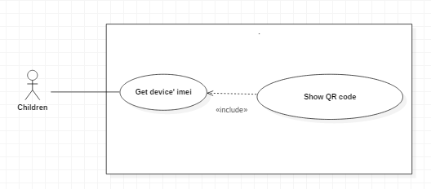

Figure 11: <Children> Show QR code

|  |  |  |  |  |  |
| --- | --- | --- | --- | --- | --- |
| USE CASE – UC_C.01 | | | | | |
| Use Case No. | | UC_C.01 | **Use Case Version** | | 2.0 |
| Use Case Name | | Show QR code | | | |
| Author | | Nguyen Anh Duy | | | |
| Date | | 21/01/2018 | **Priority** | | Normal |
| **Actor:**   * User   **Summary:**   * This use case allows children show QR code.   **Goal:**   * Show QR code to Parent Scan to add children   **Triggers:**   * Children press “Show QR code” on selected children page   **Preconditions:**   * N/A   **Post Conditions:**   * Success: Show QR code in children page * Fail: Show error message   **Main Success Scenario:** | | | | | |
| Step | Actor Action | | | System Response | |
| 1 | User choose role is children press “Children” button | | | - System go to children page | |
| 2 | Press “Show QR code” button | | | -Show image QR code on children page. | |
| Alternative Scenario: | | | | | |
| Step | Actor Action | | | System Response | |
| 1 | If user taps “←” | | | -System go back main page | |
| Exceptions: | | | | | |
| Step | Actor Action | | | System Response | |
| 1 | Don’t show image QR code | | | * Show message “Can’t show QR code” | |
| **Relationships:**   * Children   **Business Rules:**   * Show QR code to parent scan and add children to manage | | | | | |

Table 23: USE CASE – UC_C.01 - Show QR code

### 2.3.10. <Children> Approve or Rejected manage from parent

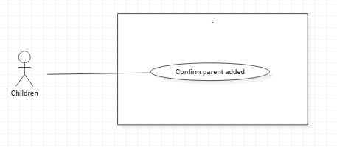

Figure 12: <Children> Approve or Rejected manage from parent

|  |  |  |  |  |  |
| --- | --- | --- | --- | --- | --- |
| USE CASE – UC_C.02 | | | | | |
| Use Case No. | | UC_C.02 | **Use Case Version** | | 2.0 |
| Use Case Name | | Approve or Rejected manage from parent | | | |
| Author | | Nguyen Anh Duy | | | |
| Date | | 21/01/2018 | **Priority** | | Normal |
| **Actor:**   * Children   **Summary:**   * This use case allows children Approve or Rejected manage from parent.   **Goal:**   * Confirm right parent of children, avoid strangers managing children   **Triggers:**   * Children press “Approve or Rejected” on popup selected in children page   **Preconditions:**   * Children   **Post Conditions:**   * Success: show message successful * Fail: show error message   **Main Success Scenario:** | | | | | |
| Step | Actor Action | | | System Response | |
| 1 | Children press “Approve” on popup | | | - System show message “Approve is succesful” and turn off popup. | |
| Alternative Scenario: | | | | | |
| Step | Actor Action | | | System Response | |
| 1 | Children press “Rejected” on popup | | | - System show message “Rejected is succesful” and turn off popup. | |
| Exceptions: | | | | | |
| Step | Actor Action | | | System Response | |
| 1 | Network is not available | | | * Show message ‘Network is not available. Please enable it.’ | |
| **Relationships:**   * Children   **Business Rules:**   * Confirm right parent to manage children. | | | | | |

Table 24: USE CASE – UC_C.02 - Approve or Rejected manage from parent

### 2.3.11 <Children> View Children’s parents

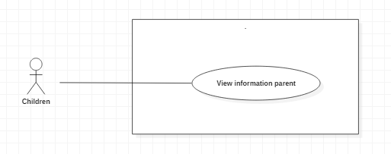

Figure 13: <Children> View Children’s parents

|  |  |  |  |  |  |
| --- | --- | --- | --- | --- | --- |
| USE CASE – UC_C.03 | | | | | |
| Use Case No. | | UC_C.03 | **Use Case Version** | | 2.0 |
| Use Case Name | | View Children’s parents | | | |
| Author | | Nguyen Anh Duy | | | |
| Date | | 21/01/2018 | **Priority** | | Normal |
| **Actor:**   * Children   **Summary:**   * This use case allows children View Children’s parents.   **Goal:**   * View parents managing children   **Triggers:**   * Children press “List parent” button on selected children page   **Preconditions:**   * Children   **Post Conditions:**   * Success: Show list parent * Fail: Show error message   **Main Success Scenario:** | | | | | |
| Step | Actor Action | | | System Response | |
| 1 | Children press “List parent” button | | | - Show list parent in children page. | |
| Alternative Scenario: | | | | | |
| Step | Actor Action | | | System Response | |
| 1 | Children press “List parent” button | | | - System show text“List parent is empty” | |
| Exceptions: | | | | | |
| Step | Actor Action | | | System Response | |
| 1 | Network is not available | | | * Show message ‘Network is not available. Please enable it.’ | |
| **Relationships:**   * Children   **Business Rules:**   * Know who is managing you | | | | | |

Table 25: USE CASE – UC_C.03 - View Children’s parents

### 2.3.12 <Childrent> Logout

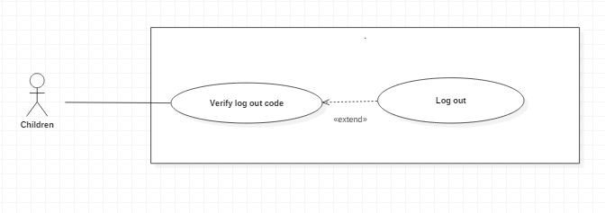

Figure 14: <Childrent> Logout

|  |  |  |  |  |  |
| --- | --- | --- | --- | --- | --- |
| USE CASE – UC_C.04 | | | | | |
| Use Case No. | | UC_C.04 | **Use Case Version** | | 2.0 |
| Use Case Name | | Log out | | | |
| Author | | Nguyen Anh Duy | | | |
| Date | | 21/01/2018 | **Priority** | | Normal |
| **Actor:**   * Children   **Summary:**   * This use case allows children logout children page.   **Goal:**   * Keep the child's role as the child   **Triggers:**   * Children press “←” or “Log out” buton on selected children page   **Preconditions:**   * Children   **Post Conditions:**   * Success: Com back main page * Fail: Show error message   **Main Success Scenario:** | | | | | |
| Step | Actor Action | | | System Response | |
| 1 | Children press “←” or “Log out” buton | | | - Show popup “You need code to exit from parent” | |
| 2 | Press “Ok” | | | -Navigate logout page | |
| 3 | Input code to exit | | |  | |
| 4 | Press “Logout” button | | | Navigate to main page | |
| Alternative Scenario: | | | | | |
| Step | Actor Action | | | System Response | |
| 1 | Children press “Cancel” button | | | - System turn off popup | |
| Exceptions: | | | | | |
| Step | Actor Action | | | System Response | |
| 1 | Network is not available | | | * Show message ‘Network is not available. Please enable it.’ | |
| 2 | Input wrong code to exit | | | * Show messge “Code to exit is wrong” | |
| **Relationships:**   * Children   **Business Rules:**   * Children get rid of the children page and can start off as a parent | | | | | |

Table 26: USE CASE – UC_C.04 - Logout

### 2.3.13. <Parent> View children’s location

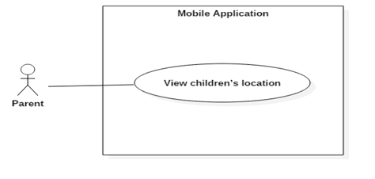

Figure 15: <Parent> View children’s location

|  |  |  |  |  |  |
| --- | --- | --- | --- | --- | --- |
| USE CASE – UC_P.08 | | | | | |
| Use Case No. | | UC_P.08 | **Use Case Version** | | 2.0 |
| Use Case Name | | View children’s location | | | |
| Author | | Nguyen Thanh Nghia | | | |
| Date | | 21/01/2018 | **Priority** | | High |
| **Actor:**   * Parent   **Summary:**   * This use case allows parent view children’s location.   **Goal:**   * Latest children’s location and the trusted location is displayed by a point on the map.   **Triggers:**   * Parent press “Child’s current location” on selected children’s management screen   **Preconditions:**   * User must be a parent   **Post Conditions:**   * Success: Latest children’s location and trusted location is displayed by point on map. * Fail: Show error message   **Main Success Scenario:** | | | | | |
| Step | Actor Action | | | System Response | |
| 1 | Parent chooses ‘Child’s current location’ in the child’s detail page | | | - System go to “Child’s current location” page and:  + Show list of trusted locations that parent set on the selected child. | |
| Alternative Scenario: | | | | | |
| Step | Actor Action | | | System Response | |
| 1 | If latest children’s location is empty | | | * Show message “The current location of the child is unknown” replace map | |
| 2 | If list trusted location is empty | | | * Show message “This child doesn't have trusted location” below map | |
| Exceptions: | | | | | |
| Step | Actor Action | | | System Response | |
| 1 | Network is not available | | | * Show popup message ‘Network is not available. Please enable it.’ | |
| **Relationships:**   * Children   **Business Rules:**  - Synchronize latest children’s location and trusted location to the local database.  - Load latest children’s location and trusted location to the local database.  - Displayed latest children’s location and trusted location by the point on the map. | | | | | |

Table 27: USE CASE – UC_P.08 - View children’s location

### 2.3.14 <Parent> Setting Notification

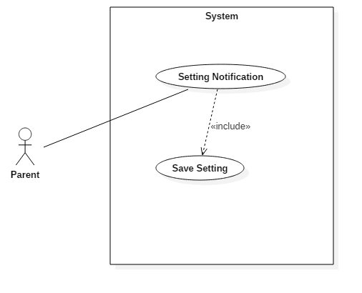

Figure 16: <Parent> Setting Notification

|  |  |  |  |  |  |  |
| --- | --- | --- | --- | --- | --- | --- |
| **USE CASE** – UC_P.09 | | | | | | |
| **Use Case No.** | | UC_P.09 | **Use Case Version** | | | 3.0 |
| **Use Case Name** | | Setting notification | | | | |
| **Author** | | Nguyen Thanh Nghia | | | | |
| **Date** | | 11/04/2018 | **Priority** | | | Normal |
| Actor:   * Parent   **Summary:**   * This use case allows parent setting own notification.   **Goal:**   * Own notification will notify extract.   **Triggers:**   * Parent press “Setting Notification” on setting screen   **Preconditions:**   * User must be a parent   **Post Conditions:**   * Success: Display setting notification page * Fail: Show message   **Main Success Scenario:** | | | | | | |
| Step | Actor Action | | | System Response | | |
| 1 | Parent chooses “Setting Notification” on Setting page | | | System goes to “Setting notification” page and:   * Display list checkbox for setting time show notification | | |
| 2 | Parent chooses notification setting checkbox. | | | Checkbox show effect checked or unchecked | | |
| 3 | Parent chooses “Save” | | | System shows message: ”Save successful.”  [Exception 1] | | |
| **Alternative Scenario: N/A** | | | | | | |
| **Exceptions:** | | | | | | |
| Step | Actor Action | | | | System Response | |
| 1 | Save setting is error | | | | System shows: “Save not successful.” | |
| **Relationships:** **N/A**  **Business Rules:**   * Load saved setting from database local. * Save new setting to database local. | | | | | | |

Table 28: USE CASE – UC_P.09 - Setting Notification

### 2.3.15 <Parent> View Notifiction

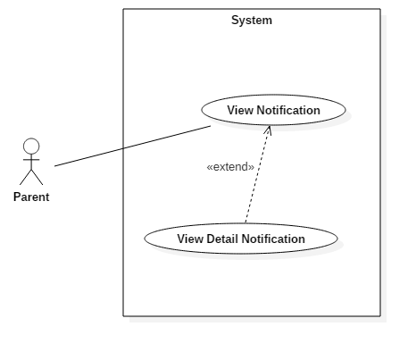

Figure 17: <Parent> View Notifiction

|  |  |  |  |  |  |  |  |  |
| --- | --- | --- | --- | --- | --- | --- | --- | --- |
| **USE CASE** – UC_P.10 | | | | | | | | |
| **Use Case No.** | | | UC_P.10 | **Use Case Version** | | | | 3.0 |
| **Use Case Name** | | | View notification | | | | | |
| **Author** | | | Nguyen Thanh Nghia | | | | | |
| **Date** | | | 11/04/2018 | **Priority** | | | | Normal |
| Actor:   * Parent   **Summary:**   * This use case allows parent view notification and view detail notification.   **Goal:**   * Parent can view preview notification and view internet notification or location notification.   **Triggers:**   * Parent press “Notification Center” on children page.   **Preconditions:**   * User must be a parent   **Post Conditions:**  **-** Success: Display setting notification center page  - Fail: Show message  **Main Success Scenario:** | | | | | | | | |
| Step | | Actor Action | | | System Response | | | |
| 1 | | Parent chooses “Notification Center” in the children’s detail page. | | | System goes to “Notification Center” page and:  - Display list notification.  [Exceptions 1] | | | |
| 2 | | Parent chooses notification item.  [Alternative 1,2] | | | Display notification detail. | | | |
| **Alternative Scenario: N/A** | | | | | | | | |
| Step | Actor Action | | | | | | System Response | |
| 1 | Parent chooses internet notification item. | | | | | | System goes to “Internet Notification ” page:  - Display internet notification details. | |
| 2 | Parent chooses location notification item. | | | | | | System goes to “Location Notification ” page:  - Display location notification details.  -Display history children location on map.  [Exceptions 2] | |
| **Exceptions:** | | | | | | | | |
| Step | | Actor Action | | | | System Response | | |
| 1 | | Cannot connect to server | | | | System shows: “Network is not available” | | |
| 2 | | Location children is not valid | | | | System display location notification details without map. | | |
| **Relationships:** **N/A**  **Business Rules:**   * Load notification from server. | | | | | | | | |

Table 29: USE CASE – UC_P.10 - View Notifiction

### 2.3.16 <Parent> View Children Location

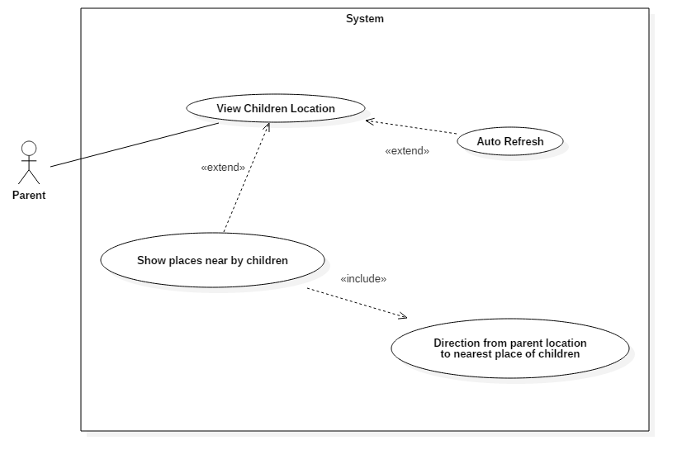

Figure 18: <Parent> View Children Location

|  |  |  |  |  |  |  |  |  |
| --- | --- | --- | --- | --- | --- | --- | --- | --- |
| **USE CASE** – UC_P.11 | | | | | | | | |
| **Use Case No.** | | | UC_P.11 | **Use Case Version** | | | | 4.0 |
| **Use Case Name** | | | View children location | | | | | |
| **Author** | | | Nguyen Thanh Nghia | | | | | |
| **Date** | | | 11/04/2018 | **Priority** | | | | High |
| Actor:   * Parent   **Summary:**   * This use case allows parent view current children location.   **Goal:**   * Parent can view current children location, show places near by children and direction from parent location to children location.   **Triggers:**   * Parent press “Children location” on children page.   **Preconditions:**   * User must be a parent   **Post Conditions:**  **-** Success: Display children location on map.  - Fail: Show message  **Main Success Scenario:** | | | | | | | | |
| Step | | Actor Action | | | System Response | | | |
| 1 | | Parent chooses “Children locaion” in the children’s detail page.  [Alternative 1,2] | | | System goes to “Children location” page and:  - Display children location on map.  [Exceptions 1, 2] | | | |
| 2 | |  | | |  | | | |
| **Alternative Scenario: N/A** | | | | | | | | |
| Step | Actor Action | | | | | | System Response | |
| 1 | Parent taps “Auto refresh” button. | | | | | | System refreshes current children location and draws it on map. | |
| 2 | Parent taps:”Show near place” button | | | | | | System draws list places nearby children location.  [Exceptions 3] | |
| 3 | Parent taps: ”Direction” button | | | | | | System draw a a route from parent location to nearest places by children location on map. | |
| **Exceptions:** | | | | | | | | |
| Step | | Actor Action | | | | System Response | | |
| 1 | | Cannot connect to server | | | | System shows message: “Network is not available” | | |
| 2 | | No internet access | | | | System shows message: “Network is not available” | | |
| 3 | | No place near by children location | | | | System shows message: “No large place near by children location” | | |
| **Relationships:** **N/A**  **Business Rules:**   * Get lasted children location from web server. * Get current parent location via GPS. * Get list places near by current children location via Google API. * Found nearest place from the list places near by children location. * Direction route from current children location to nearest place. | | | | | | | | |

Table 30: USE CASE – UC_P.11 - View Children Location

### 2.3.17. <Parent> View list trusted location

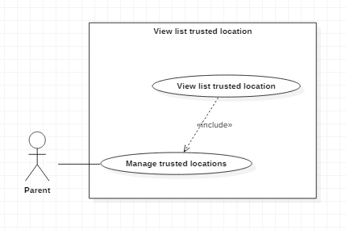

Figure 19: <Parent> View list trusted location

|  |  |  |  |  |  |
| --- | --- | --- | --- | --- | --- |
| USE CASE – UC_P.12 | | | | | |
| Use Case No. | | UC_P.12 | **Use Case Version** | | 2.0 |
| Use Case Name | | View children’s list trusted location | | | |
| Author | | Cao Huy Bao | | | |
| Date | | 20/01/2018 | **Priority** | | Normal |
| **Actor:**  Parent  **Summary:**  View children’s contact  **Goal:**  Contact of children is shows on the list  **Triggers:**  User press “Contacts”  **Preconditions:**  User must be a parent  **Post Conditions:**  Success: Contact is shown on list  Fail: Show error message  **Main Success Scenario:** | | | | | |
| Step | Actor Action | | | System Response | |
| 1 | Parent chooses ‘Trusted locations in the child’s detail page | | | System go to “Trusted locations” page and:  + Show list of trusted locations that parent set on the selected children. | |
| Alternative Scenario: | | | | | |
| Step | Actor Action | | | System Response | |
| 1 | If list trusted location is empty | | | _ Show message “There is no data” on screen if list is empty | |
| 2 | If user taps “🡨” | | | _System navigates back to children detail successfully. | |
| Exceptions: | | | | | |
| Step | Actor Action | | | System Response | |
| 1 | Network is not available | | | _Show popup message “Error Network, try again later” | |
| **Relationships:**   * Children   **Business Rules:**  - List is loaded from system  - Parent will receive the alert when the selected children are getting out of these locations. | | | | | |

Table 31: USE CASE – UC_P.12 - View list trusted location

### 2.3.18. <Parent> Remove trusted location

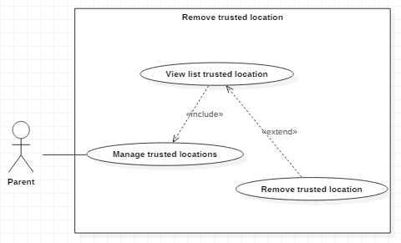

Figure 20: <Parent> Remove trusted location

|  |  |  |  |  |  |
| --- | --- | --- | --- | --- | --- |
| USE CASE – UC_P.13 | | | | | |
| Use Case No. | | UC_P.13 | **Use Case Version** | | 2.0 |
| Use Case Name | | Remove trusted location | | | |
| Author | | Cao Huy Bao | | | |
| Date | | 20/01/2018 | **Priority** | | Normal |
| **Actor:**   * Parent   **Summary:**   * Remove trusted location of selected children   **Goal:**   * The selected location is removed from children’s list trusted locations   **Triggers:**   * User hold on selected location   **Preconditions:**   * User must be a parent * User is on page “Trusted location”   **Post Conditions:** | | | | | |
| Step | Actor Action | | | System Response | |
| 1 | Parent chooses “Trusted locations” in the child’s detail page | | | _System go to “Trusted locations” page and show list of trusted locations that parent set on the selected children. | |
| 2 | Parent hold the selected location on screen | | | _ Display a pop up with the message “You are removing the “location name” out of list?” and 2 options “Delete” and “Cancel” | |
| 3 | Parent click ‘Delete’ button | | | _ System remove location from children’s trusted location list and reload list | |
| Alternative Scenario: | | | | | |
| Step | Actor Action | | | System Response | |
| 1 | If list trusted location is empty | | | _ Show message “There is no data” on screen if list is empty | |
| 2 | Parent click “Cancel” | | | _ The pop-up message is disappeared and reloads list. | |
| 3 | If user taps “🡨” | | | _ The pop-up message is disappeared and reloads list. | |
| Exceptions: | | | | | |
| Step | Actor Action | | | System Response | |
| 1 | Network is not available | | | _Show error message “Network error” | |
| 2 | Parent click “Delete” | | | _ System didn’t remove location and show error message “Something went wrong, please try again later.” and close the pop up after 3 seconds | |
| **Relationships:**   * Children   **Business Rules:**  - Delete location of selected children’s trusted location list on “ChildrenTrustedLocationEntity” data but won’t delete the “TrustedLocationEntity”  - Synchronize new trusted location list to children’s device-local database | | | | | |

Table 32: USE CASE – UC_P.13 - Remove trusted location

### 2.3.19. <Parent> Add trusted location

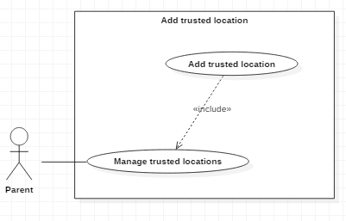

Figure 21: <Parent> Add trusted location

|  |  |  |  |  |  |
| --- | --- | --- | --- | --- | --- |
| USE CASE – UC_P.14 | | | | | |
| Use Case No. | | UC_P.14 | **Use Case Version** | | 2.0 |
| Use Case Name | | Add trusted location | | | |
| Author | | Cao Huy Bao | | | |
| Date | | 20/01/2018 | **Priority** | | Normal |
| **Actor:**   * **Parent**   **Summary:**   * Add trusted location of selected children   **Goal:**   * Trusted location added to children’s trusted location list   **Triggers:**   * User click button “Add a place” on the bottom of screen   **Preconditions:**   * User must be a parent * User is on page “Trusted location”   **Post Conditions:**   * Success: Location is added to children’s trusted location list * Fail: Show error message   **Main Success Scenario:** | | | | | |
| Step | Actor Action | | | System Response | |
| 1 | Parent click “Add a Place” on the bottom of screen | | | _ Show a dialog with 2 text-box: “Name” and “Floor”, a “choose a place” button, confirm button and cancel button. | |
| 2 | Parent input valid value for 2 text-box and click the “choose a place” button | | | _ System go to map screen | |
| 3 | Parent click on the search bar  Alternative (5, 7) | | | _ Show the keyboard on bottom the screen | |
| 4 | Parent input “Location name” and click “enter” or “search-icon” | | | _ System show suggest list of involve “location name” | |
| 5 | Parent chooses the location | | | _ System show a pop up with title “Use this place?” with the name of location behind title, and after that is the address of the location.  _Show a map with this location is picked.  _2 option button, the first one is “Change location” and the second is “Select” | |
| 6 | Parent click “Select” button | | | _System go back to the dialog in step 1 response. | |
| 7 | Parent click confirm button | | | _System add trusted location for children successful | |
| Alternative Scenario: | | | | | |
| Step | Actor Action | | | System Response | |
| 1 | Network is not available | | | _Show error message “Network error” | |
| 2 | If “Location Name” is not valid or can’t find | | | _System show pop up message “No result for “Location Name” | |
| 3 | If user tap “🡨” | | | _ System go back to map screen | |
| 4 | If user tap “🡨” | | | _System go back to a dialog without any location were chosen | |
| 4 | If user tap “Cancel” button | | | _System go back to Children’s Trusted Location Page | |
| 5 | Parent move the map to wanted location  Move to step 6 | | | _ Map move and pick location on map | |
| 6 | Parent click “Select this location” on middle screen | | | _ System show a pop up with title “Use this place?” with the name of location behind title, and after that is the address of the location.  _Show a map with this location is picked.  _2 option button, the first one is “Change location” and the second is “Select” | |
| 7 | Parent swipe on the bottom of screen  Move to step 8 | | | _ Show the list of nearly place of parent’s current location | |
| 8 | Parent chooses the location | | | _ System show a pop up with title “Use this place?” with the name of location behind title, and after that is the address of the location.  _Show a map with this location is picked.  _2 option button, the first one is “Change location” and the second is “Select” | |
| Exceptions: | | | | | |
| Step | Actor Action | | | System Response | |
| 1 | Network is not available | | | Show error message ”Please check your network connection” | |
| 2 | GPS is not available | | | _ System require user turn on GPS of device | |
| 3 | No place is chosen | | | _System didn’t add location to server and show a message “Create fail” | |
| **Relationships:**   * Children   **Business Rules:**  - When adding trusted location of children success, the trusted location will add to “Trusted location List” on system server, and create a children trusted location on server with all of valid input value  - Synchronize new trusted location list to server. | | | | | |

Table 33: USE CASE – UC_P.14- Add trusted location

### 2.3.20 <Parent> View trusted location detail and list schedule of trusted location

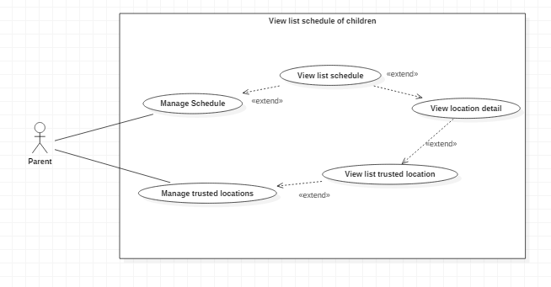

Figure 22: <Parent> View trusted location detail and list schedule of trusted location

|  |  |  |  |  |  |
| --- | --- | --- | --- | --- | --- |
| USE CASE – UC_P.15 | | | | | |
| Use Case No. | | UC_P.15 | **Use Case Version** | | 2.0 |
| Use Case Name | | View trusted location detail and list schedule of trusted location | | | |
| Author | | Cao Huy Bao | | | |
| Date | | 20/01/2018 | **Priority** | | Normal |
| **Actor:**   * Parent   **Summary:**   * This use case allows parent view trusted location detail, list schedule of location   **Goal:**   * Trusted location of children is shown, schedule is shown on list   **Triggers:**   * Parent select a location from list   **Preconditions:**   * User must be a parent * Parent must be on “Trusted locations” page   **Post Conditions:**   * Success: Trusted location detail is shown on screen * Fail: Show error message   **Main Success Scenario:** | | | | | |
| Step | Actor Action | | | System Response | |
| 1 | Parent select a location on “Trusted Locations” page | | | _System go to “Trusted locations detail” page  _Show a page with detail of children trusted location on top  -Show a list of children location schedule on middle  - Show a button “Add new schedule” on bottom | |
| Alternative Scenario: | | | | | |
| Step | Actor Action | | | System Response | |
| 1 | User taps “Back” | | | System navigates back to trusted location list successfully. | |
| Exceptions: | | | | | |
| Step | Actor Action | | | System Response | |
| 1 | Network is not available | | | _Show popup message “Error Network, try again later” | |
| **Relationships:**   * Children, Trusted Location   **Business Rules:**  - Location is loaded from system | | | | | |

Table 34: USE CASE – UC_P.15 - View trusted location detail and list schedule of trusted location

### 2.3.21 <Parent> Add schedule for children trusted location

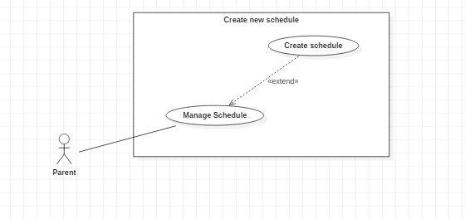

Figure 23: <Parent> Add schedule for children trusted location

|  |  |  |  |  |  |
| --- | --- | --- | --- | --- | --- |
| USE CASE – UC_P.16 | | | | | |
| Use Case No. | | UC_P.16 | **Use Case Version** | | 2.0 |
| Use Case Name | | Add schedule for children trusted location | | | |
| Author | | Cao Huy Bao | | | |
| Date | | 20/01/2018 | **Priority** | | Normal |
| **Actor:**   * **Parent**   **Summary:**   * Add schedule for trusted location of selected children   **Goal:**   * Schedule will add to children trusted location’s schedule list   **Triggers:**   * User click button “Add new schedule” on the bottom of screen   **Preconditions:**   * User must be a parent * User is on page “Trusted location detail”   **Post Conditions:**   * Success: Schedule is added successful into children’s trusted location **schedule list** * Fail: Show error message   **Main Success Scenario:** | | | | | |
| Step | Actor Action | | | System Response | |
| 1 | Parent click “Add new schedule” on the bottom of screen | | | _ System go to the create schedule page with 6 Number Picker:  + Children’s trusted location  + Days of week  + From time hour  + From time minute  + To time hour  + To time minute  _ The button “Create Schedule” | |
| 2 | Parent choose valid value from the pickers:  + Choose location from picker  + Choose (from time hour + from time minute) must be smaller than (to time hour + to time minute)  + Choose (to time hour + to time minute) – (from time hour + from time minute) must be larger than 15 minutes | | | _ System check valid value and add to server if value is valid and time range is available | |
| Alternative Scenario: | | | | | |
| Step | Actor Action | | | System Response | |
| 1 | Network is not available | | | _Show error message “Network error” | |
| 2 | If the day and time range have in children’s trusted location schedule | | | _System show a notification dialog “Your time you choose is invalid, view all schedule to check” | |
| 3 | If from time larger or equal to time | | | System show a notification dialog “To time must be larger than from time. Please try again” | |
| 4 | If user tap “🡨” | | | _System go back trusted location detail page | |
| Exceptions: | | | | | |
| Step | Actor Action | | | System Response | |
| 1 | Network is not available | | | _Show error message “Network error” | |
| **Relationships:**   * Children, Trusted Location   **Business Rules:**  - When adding schedule to server. Server will check the valid time slot for location and save if available  - Synchronize new schedule for trusted location for children list | | | | | |

Table 35: USE CASE – UC_P.16 - Add schedule for children trusted location

### 2.3.22 <Parent> Update schedule for children trusted location

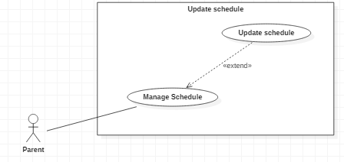

Figure 24: <Parent> Update schedule for children trusted location

|  |  |  |  |  |  |
| --- | --- | --- | --- | --- | --- |
| USE CASE – UC_P.17 | | | | | |
| Use Case No. | | UC_P.17 | **Use Case Version** | | 2.0 |
| Use Case Name | | Update schedule for children trusted location | | | |
| Author | | Cao Huy Bao | | | |
| Date | | 20/01/2018 | **Priority** | | Normal |
| **Actor:**   * **Parent**   **Summary:**   * Update schedule for trusted location of selected children   **Goal:**   * Schedule will update to children trusted location’s schedule list   **Triggers:**   * User tap row of selected schedule on all schedule table   **Preconditions:**   * User must be a parent * User is on page “All Schedule”   **Post Conditions:**   * Success: Schedule is updated successful into children’s trusted locationschedule list * Fail: Show error message   **Main Success Scenario:** | | | | | |
| Step | Actor Action | | | System Response | |
| 1 | Parent click on selected row of all schedule | | | _ System go to the create schedule page with 6 Number Picker:  + Children’s trusted location of that schedule (Can’t edit)  + Days of week  + From time hour  + From time minute  + To time hour  + To time minute  _ The button “Update Schedule” | |
| 2 | Parent choose valid value from the pickers:  + Choose (from time hour + from time minute) must be smaller than (to time hour + to time minute)  + Choose (to time hour + to time minute) – (from time hour + from time minute) must be larger than 15 minutes | | | _ System check valid value and add to server if value is valid and time range is available | |
| Alternative Scenario: | | | | | |
| Step | Actor Action | | | System Response | |
| 1 | Network is not available | | | _Show error message “Network error” | |
| 2 | If the day and time range have in children’s trusted location schedule | | | _System show a notification dialog “Your time you choose is invalid, view all schedule to check” | |
| 3 | If from time larger or equal to time | | | System show a notification dialog “To time must be larger than from time. Please try again” | |
| 4 | If user tap “🡨” | | | _System go back trusted location detail page | |
| Exceptions: | | | | | |
| Step | Actor Action | | | System Response | |
| 1 | Network is not available | | | _Show error message “Network error” | |
| **Relationships:**   * Children, Trusted Location   **Business Rules:**  - When parent is updating schedule to server. Server will check the valid time slot for location and save if available  - Synchronize update schedule for trusted location for children list | | | | | |

Table 36: USE CASE – UC_P.17 - Update schedule for children trusted location

2.3.23 <Parent> Remove Schedule

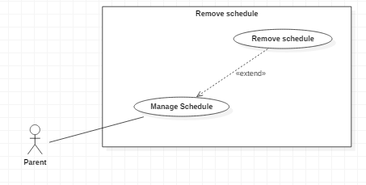

Figure 25: <Parent> Remove Schedule

|  |  |  |  |  |  |
| --- | --- | --- | --- | --- | --- |
| USE CASE – UC_P.18 | | | | | |
| Use Case No. | | UC_P.18 | **Use Case Version** | | 2.0 |
| Use Case Name | | Remove Schedule | | | |
| Author | | Cao Huy Bao | | | |
| Date | | 20/01/2018 | **Priority** | | Normal |
| **Actor:**   * Parent   **Summary:**   * Remove schedule of children and trusted location   **Goal:**   * The selected schedule is removed from children’s trusted location schedule   **Triggers:**   * User hold on selected schedule   **Preconditions:**   * User must be a parent * User is on page “Trusted location detail”   **Post Conditions:** | | | | | |
| Step | Actor Action | | | System Response | |
| 1 | Parent hold the selected schedule on screen | | | _ Display a pop up with the message “You are removing the schedule out of list?” and 2 options “Delete” and “Cancel” | |
| 2 | Parent click ‘Delete’ button | | | _ System remove location from children’s trusted location schedule list and reload list | |
| Alternative Scenario: | | | | | |
| Step | Actor Action | | | System Response | |
| 1 | If list schedule is empty | | | _ Show message “There is no data” on screen if list is empty | |
| 2 | Parent click “Cancel” | | | _ The pop-up message is disappeared and reloads list. | |
| 3 | If user taps “🡨” | | | _ The pop-up message is disappeared and reloads list. | |
| Exceptions: | | | | | |
| Step | Actor Action | | | System Response | |
| 1 | Network is not available | | | _Show error message “Network error” | |
| 2 | Parent click “Delete” | | | _ System didn’t remove location and show error message “Something went wrong, please try again later.” and close the pop up after 3 seconds | |
| **Relationships:**   * Children   **Business Rules:**  - Disable time table for children and location.  - Synchronize new schedule list to server | | | | | |

Table 37: USE CASE – UC_P.18 - Remove Schedule

### 2.3.24 <Parent> View list all Schedule

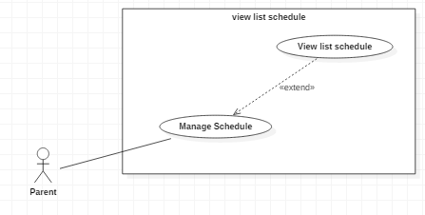

Figure 26: <Parent> View list all Schedule

|  |  |  |  |  |  |
| --- | --- | --- | --- | --- | --- |
| USE CASE – UC_P19 | | | | | |
| Use Case No. | | UC_P19 | **Use Case Version** | | 2.0 |
| Use Case Name | | View children’s all schedule available | | | |
| Author | | Cao Huy Bao | | | |
| Date | | 20/01/2018 | **Priority** | | Normal |
| **Actor:**  Parent  **Summary:**  View all schedule of the selected children  **Goal:**  Table of all schedule is shown  **Triggers:**  User press “View schedule”  **Preconditions:**  User must be a parent  User must be on page Trusted Location or page Trusted Location Detail  **Post Conditions:**  Success: Schedule is shown on table  Fail: Show error message  **Main Success Scenario:** | | | | | |
| Step | Actor Action | | | System Response | |
| 1 | Parent chooses “View schedule” on title bar | | | System go to “All schedule” page and:  + Show table all schedule of children. | |
| Alternative Scenario: | | | | | |
| Step | Actor Action | | | System Response | |
| 1 | If list schedule is empty | | | _ Show message a table with header but nothing in body | |
| 2 | If user taps “🡨” | | | _System navigates back to previous page successfully. | |
| Exceptions: | | | | | |
| Step | Actor Action | | | System Response | |
| 1 | Network is not available | | | _Show popup message “Error Network, try again later” | |
| **Relationships:**   * Children   **Business Rules:**  - List is loaded from system | | | | | |

Table 38: USE CASE – UC_P19 - View list all Schedule

### 2.3.25. <Parent> View call logs:

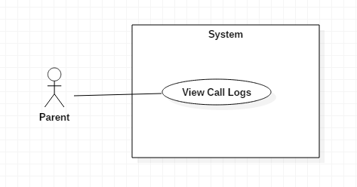

Figure 27: <Parent> View call logs

|  |  |  |  |  |  |
| --- | --- | --- | --- | --- | --- |
| USE CASE – UC_P.20 | | | | | |
| Use Case No. | | UC_P.20 | **Use Case Version** | | 2.0 |
| Use Case Name | | View Call Logs | | | |
| Author | | Doan Duy Anh | | | |
| Date | | 20/01/2018 | **Priority** | | Normal |
| **Actor:**  Parent  **Summary:**  View Call Logs of the children  **Goal:**  Call Log of children is show on list  **Triggers:**  User press “Call log”  **Preconditions:**  User must be a parent  **Post Conditions:**  Success: Call log is show on list  Fail: Show error message  **Main Success Scenario:** | | | | | |
| Step | Actor Action | | | System Response | |
| 1 | The user chooses ”Call Log” in the child’s detail page | | | The system goes to call log page and show list of calls that the selected children receive or call. | |
| Alternative Scenario: | | | | | |
| Step | Actor Action | | | System Response | |
| 1 | User taps “Back” | | | System navigates back to children detail successfully. | |
| 2 | The user chooses ”Call Log” when call log is empty. | | | Show “Empty”. | |
| Exceptions: | | | | | |
| Step | Actor Action | | | System Response | |
| 1 | Network is not available | | | Show error message ”Please check your network connection” | |
| **Relationships:**  N/a  **Business Rules:**  - Call log of children will be updated to the database when the children’s device has network connection.  - Call log is sort by date  - If children receive or call from a number that does not have name in the children’s device, the number’s name will be shown as “Unsaved number” | | | | | |

Table 39: USE CASE – UC_P.20 - View call logs

### 2.3.26. <Parent> View Message list

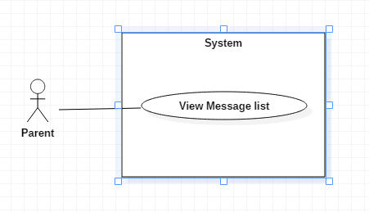

Figure 28: <Parent> View Message list

|  |  |  |  |  |  |
| --- | --- | --- | --- | --- | --- |
| USE CASE – UC_P.21 | | | | | |
| Use Case No. | | UC_P.21 | **Use Case Version** | | 2.0 |
| Use Case Name | | View Message list | | | |
| Author | | Doan Duy Anh | | | |
| Date | | 20/01/2018 | **Priority** | | Normal |
| **Actor:**  Parent  **Summary:**  View Message list of the children  **Goal:**  The message of children shows on the list  **Triggers:**  User press “Message”  **Preconditions:**  User must be a parent  **Post Conditions:**  Success: message is shown on list  Fail: Show error message  **Main Success Scenario:** | | | | | |
| Step | Actor Action | | | System Response | |
| 1 | The user chooses ”Message” in the child’s detail page | | | -The system goes to call log page and show list of message that the selected children receive or send. | |
| Alternative Scenario: | | | | | |
| Step | Actor Action | | | System Response | |
| 1 | User taps “Back” | | | System navigates back to children detail successfully. | |
| 2 | The user chooses ”Message” when message is empty | | | Show “Empty” | |
| Exceptions: | | | | | |
| Step | Actor Action | | | System Response | |
| 1 | Network is not available | | | Show error message ”Please check your network connection” | |
| **Relationships:**  N/a  **Business Rules:**  - Message list of children will be updated to the database when the children’s device has network connection.  - Message list is sort by date  - If children receive or message from a number that does not have a name in the children’s device, the number’s name will be shown as “Unsaved number”. | | | | | |

Table 40: USE CASE – UC_P.21 - View Message list

### 2.3.27. <Parent> View Message detail

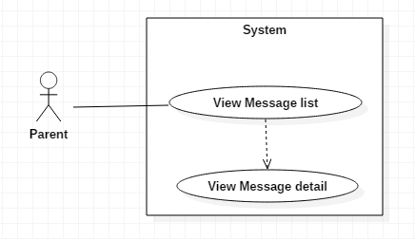

Figure 29: <Parent> View Message detail

|  |  |  |  |  |  |
| --- | --- | --- | --- | --- | --- |
| USE CASE – UC_P22 | | | | | |
| Use Case No. | | UC_P22 | **Use Case Version** | | 2.0 |
| Use Case Name | | View Message detail | | | |
| Author | | Doan Duy Anh | | | |
| Date | | 20/01/2018 | **Priority** | | Normal |
| **Actor:**  Parent  **Summary:**  View Message detail  **Goal:**  Detail of the selected message is show  **Triggers:**  User press on the message info on message list  **Preconditions:**  User must be a parent  **Post Conditions:**  Success: message content is show  Fail: Show error message  **Main Success Scenario:** | | | | | |
| Step | Actor Action | | | System Response | |
| 1 | User tap on an item on message list | | | System go to message detail page and  Show detail of the selected message. | |
| Alternative Scenario: | | | | | |
| Step | Actor Action | | | System Response | |
| 1 | User taps “Back” | | | System navigates back to message list successfully. | |
| Exceptions: | | | | | |
| Step | Actor Action | | | System Response | |
| 1 | Network is not available | | | Show error message ”Please check your network connection” | |
| **Relationships:**  N/a  **Business Rules:**  - Message detail includes:  +If the message was sent by the children: receiver, time, content  +If the message was sent to the children: sender, time, content | | | | | |

Table 41: USE CASE – UC_P22 - View Message detail

### 2.3.28. <Parent> View Contact

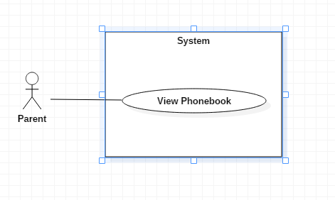

Figure 30: <Parent> View Contact

|  |  |  |  |  |  |
| --- | --- | --- | --- | --- | --- |
| USE CASE – UC_P.23 | | | | | |
| Use Case No. | | UC_P.23 | **Use Case Version** | | 2.0 |
| Use Case Name | | View contact | | | |
| Author | | Doan Duy Anh | | | |
| Date | | 20/01/2018 | **Priority** | | Normal |
| **Actor:**  Parent  **Summary:**  View children’s contact  **Goal:**  Contact of children is shows on the list  **Triggers:**  User press “Contacts”  **Preconditions:**  User must be a parent  **Post Conditions:**  Success: Contact is shown on list  Fail: Show error message  **Main Success Scenario:** | | | | | |
| Step | Actor Action | | | System Response | |
| 1 | The user chooses ”Contacts” in the child’s detail page | | | -The system goes to call log page and show contact that the selected children save on his/her phone. | |
| Alternative Scenario: | | | | | |
| Step | Actor Action | | | System Response | |
| 1 | User taps “Back” | | | System navigates back to children detail successfully. | |
| 2 | The user chooses ”Contacts” when phonebook is empty | | | Show “Empty”. | |
| Exceptions: | | | | | |
| Step | Actor Action | | | System Response | |
| 1 | Network is not available | | | Show error message ”Please check your network connection” | |
| **Relationships:**  N/a  **Business Rules:**  - Call log of children will be updated to the database when the children’s device has network connection. | | | | | |

Table 42: USE CASE – UC_P.23 - View Contact

### 2.3.29 <Parent> View Contact’s Message

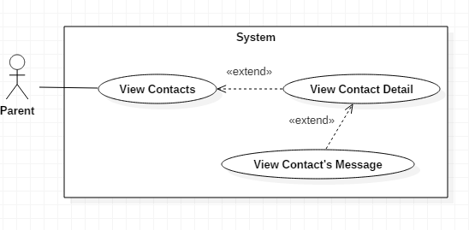

Figure 31: <Parent> View Contact’s Message

|  |  |  |  |  |  |
| --- | --- | --- | --- | --- | --- |
| USE CASE – UC_P.24 | | | | | |
| Use Case No. | | UC_P.24 | **Use Case Version** | | 2.0 |
| Use Case Name | | View Contact’s Message | | | |
| Author | | Doan Duy Anh | | | |
| Date | | 20/01/2018 | **Priority** | | Normal |
| Actor:   * Parent   Summary:   * This use case allows Parent to see the Message list of the selected contact on children’s device.   Goal:   * All of the selected contact’s message are showed.   Triggers:   * Parent press on :   + Contact info in message content page   + Button Message in Contact Detail page   Preconditions:   * User must be a parent   Post Conditions:   * Success: selected contact’s message list are showed. * Fail: Show error message.   Main Success Scenario: | | | | | |
| Step | Actor Action | | | System Response | |
| 1a | User press on the contact info in message content page | | | The System show List of Message that the children’s device receive or send with this contact’s phone number include:   * + Contact name   + Summary of message content   + Date and time of the message | |
| 1b | Guest sends command login to system | | | The System show List of Message that the children’s device receive or send with this contact’s phone number include:   * + Contact name   + Summary of message content   + Date and time of the message | |
| Alternative Scenario: | | | | | |
| Step | Actor Action | | | System Response | |
| 1 | User taps “Back” | | | System navigates back to previous page successfully. | |
| 2 | User chooses ”Message” when call log is empty. | | | Show “No Result found”. | |
| Exceptions: | | | | | |
| Step | Actor Action | | | System Response | |
| 1 | Network is not available | | | Show error message ”Please check your network connection” | |
| Relationships: N/A  Business Rules:  - Message are sort by date  - If the message does not have a contact name in the children’s device, the number’s name will be replace with phone number | | | | | |

Table 43: USE CASE – UC_P.24 - View Contact’s Message

### 2.3.30 <Parent> View Contact’s Call log

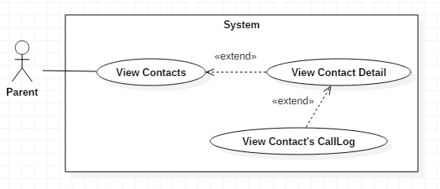

Figure 32: <Parent> View Contact’s Call log

|  |  |  |  |  |  |
| --- | --- | --- | --- | --- | --- |
| USE CASE – UC_P.25 | | | | | |
| Use Case No. | | UC_P.25 | **Use Case Version** | | 2.0 |
| Use Case Name | | View Contact’s CallLog | | | |
| Author | | Doan Duy Anh | | | |
| Date | | 20/01/2018 | **Priority** | | Normal |
| Actor:   * Parent   Summary:   * This use case allows Parent to see the Call Logs list of the selected contact on children’s device.   Goal:   * All of the selected contact’s Call Log are showed.   Triggers:   * Parent press on :   + A call log in callLogs list   + Button Call Log in Contact Detail page   Preconditions:   * User must be a parent   Post Conditions:   * Success: selected contact’s call logs list are showed. * Fail: Show error message.   Main Success Scenario: | | | | | |
| Step | Actor Action | | | System Response | |
| 1a | User press on the contact info in message content page | | | The System show List of Call log that the children’s device receive or call with this contact’s phone number include:   * + Contact name   + Phone Number   + Status   + Date and time and duration | |
| 1b | Guest sends command login to system | | | The System show List of Call Log that the children’s device receive or call with this contact’s phone number include:   * + Contact name   + Phone Number   + Status   + Date and time and duration | |
| Alternative Scenario: | | | | | |
| Step | Actor Action | | | System Response | |
| 1 | User taps “Back” | | | System navigates back to previous page successfully. | |
| 2 | User chooses ”Call Log” when call log is empty. | | | Show “No Result found”. | |
| Exceptions: | | | | | |
| Step | Actor Action | | | System Response | |
| 1 | Network is not available | | | Show error message ”Please check your network connection” | |
| Relationships: N/A  Business Rules:  - Call Logs are sort by date  - If the call log does not have a contact name in the children’s device, the number’s name will be replace with phone number | | | | | |

Table 44: USE CASE – UC_P.25 - View Contact’s Call log

### 2.3.31 <Parent> View Contacts Detail

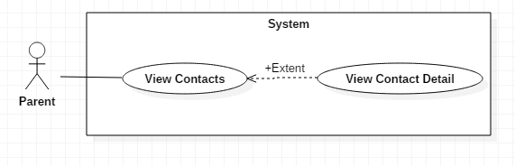

Figure 33: <Parent> View Contacts Detail

|  |  |  |  |  |  |
| --- | --- | --- | --- | --- | --- |
| USE CASE – UC_P.26 | | | | | |
| Use Case No. | | UC_P.26 | **Use Case Version** | | 2.0 |
| Use Case Name | | View Contact Detail | | | |
| Author | | Doan Duy Anh | | | |
| Date | | 20/01/2018 | **Priority** | | Normal |
| Actor:   * Parent   Summary:   * This use case allows Parent to see the contact on children’s device’s detail.   Goal:   * The selected contact’s detail and two option of view this contact’s call logs or message are showed.   Triggers:   * Parent press on :   + A contact in contacts list   + A call log in callLogs list   + Contact info in message content page   Preconditions:   * User must be a parent   Post Conditions:   * Success: selected contact’s detail and two option of view this contact’s call logs or message are showed. * Fail: Show error message.   Main Success Scenario: | | | | | |
| Step | Actor Action | | | System Response | |
| 1a | User press on an contact in the child’s contacts page. | | | The System show :   * The contact’s name * The contact’s number * Button Call Log * Button Message * List of Calls that the children’s device receive or call with this contact’s phone number include:   + Phone number   + Contact name   + Date and time of the call | |
| 1b | User press on an call log in the child’s Call logs page. | | | The System show :   * The contact’s name * The contact’s number * Button Call Log * Button Message * List of Calls that the children’s device receive or call with this contact’s phonenumber include:   + Phone number   + Contact name   + Date and time of the call | |
| 1c | Guest press on Contact info in message content page | | | The System show :   * The contact’s name * The contact’s number * Button Call Log * Button Message * List of Message that the children’s device receive or send with this contact’s phone number include:   + Contact name   + Summary of message content   + Date and time of the message | |
| Alternative Scenario: | | | | | |
| Step | Actor Action | | | System Response | |
| 1 | User taps “Back” | | | System navigates back to previous page successfully. | |
| 2 | User chooses ”Call Log” when call log is empty. | | | Show “No Result found”. | |
| 3 | User chooses ”Call Log” when call log is empty. | | | Show “No Result found”. | |
| 4 | User press Message button | | | See <parent>View Contact’s Message usecase | |
| 5 | User press Call Log button | | | See <parent>View Contact’s CallLog usecase | |
| Exceptions: | | | | | |
| Step | Actor Action | | | System Response | |
| 1 | Network is not available | | | Show error message ”Please check your network connection” | |
| Relationships: N/A  Business Rules:  - Call logs are sort by date  - Messages are sort by date  - If the call log, message and contact does not have a contact name in the children’s device, the number’s name will be replace with phone number | | | | | |

Table 45: USE CASE – UC_P.26 - View Contacts Detail

# D. Software Design Description

## 1. Design Overview

* This document describes the technical and user interface design of MIC system. It includes the architectural design, the detailed design of common functions and business functions and the design of database model.
* The architectural design describes the overall architecture of the system and the architecture of each main component and subsystem.
* The detailed design describes the static and dynamic structure for each component and functions. It includes class diagrams, class explanations and sequence diagrams for each use cases.
* The database design describes the relationships between entities and details of each entity.
* Document overview:
  + Section 2: gives an overall description of the system architecture design.
  + Section 3: gives component diagrams that describe the connection and integration of the system.
  + Section 4: gives the detail design description, which includes the class diagram, class explanation, and activity diagram to details the application functions.
  + Section 5: describe screens design.
  + Section 6: describes a fully attributed Entity Relationship Diagram.

## 2. System Architectural Design

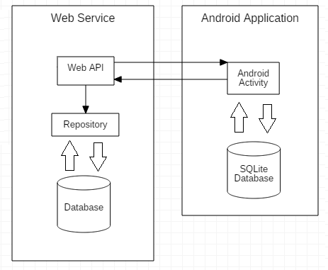

Figure 34: System architectural

### 2.1 Web service Application Architecture Description

- Web API: acts like event handler between Web application, Android application, and Repository to get, update data in the database.

- Repository: the marker for automatic exception translation in the persistence layer.

### 2.2 Android application architecture description

- The application is developed as an Android application because it’s a mobile operating system that is well known, widely used and has many features that support developing.

-Activity: the basic core of an android application that handles user input, calls Web API…

## 3. Component Diagram

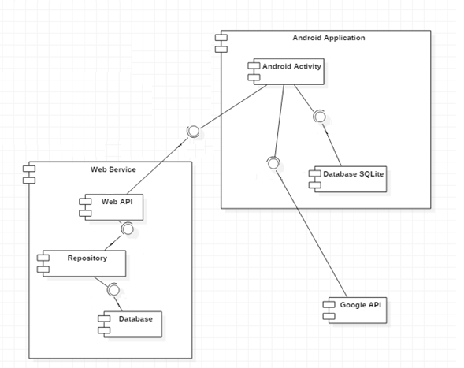

Figure 35: Component Diagram

|  |  |
| --- | --- |
| **Component dictionary: describe component** | |
| **Component Name** | **Description** |
| Web API | Handle event and processing for android application |
| Repository | Handle persistence layer. |
| Database | Store System data |
| Android Activity | All activity of the application |
| Database SQLite | Store local data before process |
| Google API | REST service |

## 4. Detailed Description

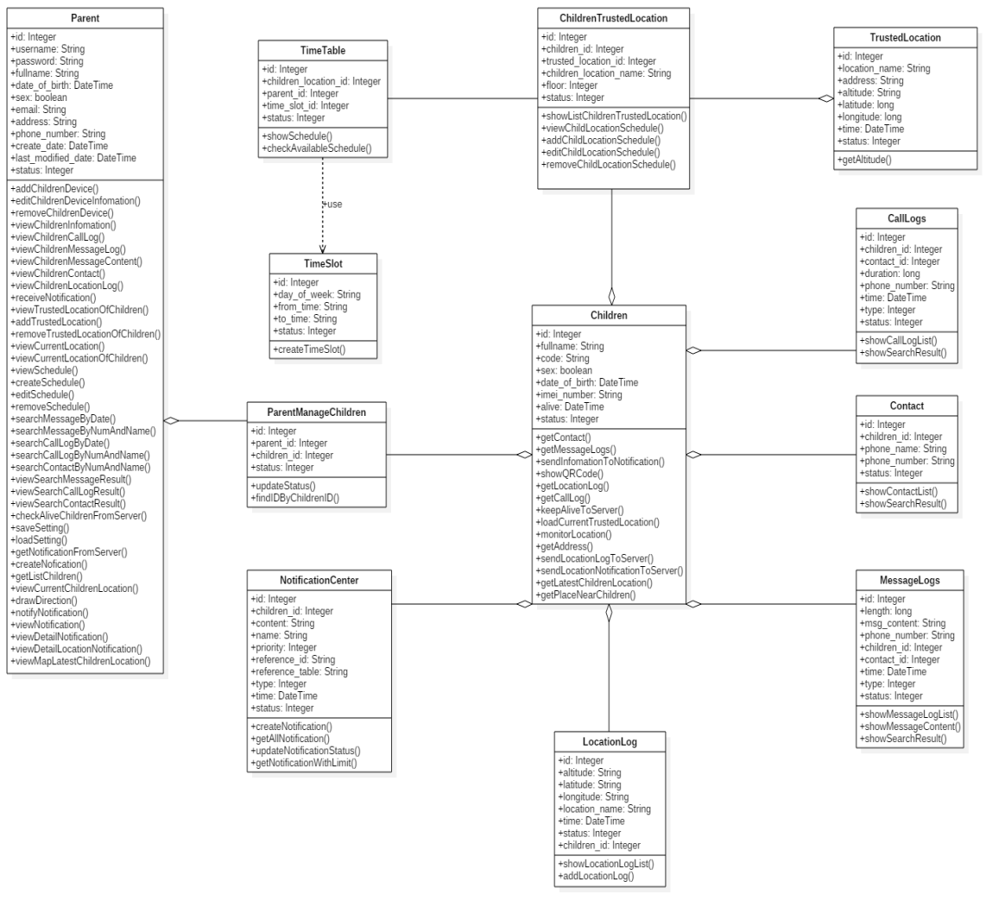 4.1 Class Diagram

Figure 36: Class Diagram

### 4.2 Class Diagram Explanation

#### 4.2.1 Parent

**Attribute**

|  |  |  |  |
| --- | --- | --- | --- |
| Attribute | Type | Visibility | Description |
| id | Integer | private | Unique identifier of parent |
| username | String | private | Unique identifier of an account |
| password | String | private | Password of an account |
| fullname | String | private | Parent's full name |
| sex | boolean | private | Parent's gender |
| email | String | private | Parent's email |
| address | String | private | Parent's address |
| phone_number | String | private | Parent's phone number |
| create_date | DateTime | private | Account's create date |
| last_modified | DateTime | private | Account's modified date |
| status | Integer | private | Status of parent's account |

Table 46: <Attribute> Parent

**Method**

|  |  |  |  |
| --- | --- | --- | --- |
| Method | Return type | Visibility | Description |
| addChildrenDevice() | String | Public | Add new children to manage |
| editChildrenDeviceInfomation() | String | Public | Edit children information |
| removeChildrenDevice() | String | Public | Remove children out of parent control |
| viewChildrenInfomation() | String | Public | View children information |
| viewChildrenCallLog() | List<CallLog> | Public | View children call log |
| viewChildrenMessageLog() | List<Message> | Public | View children message log |
| viewChildrenMessageContent() | Message | Public | View children message content |
| viewChildrenContact() | List<Contact> | Public | View children contact list |
| View ChildrenLocationLog() | Void | Public | View children Location log |
| receiveNotification() | Void | Public | Receive notification when children device has something new like: move out of trusted location, get new message, get new call, missed call |
| viewTrustedLocationOfChildren() | Void | Public | View list trusted location of each children |
| addTrustedLocation() | Void | Public | Add trusted location for each child |
| viewCurrentLocation() |  | Public | View your current location |
| viewCurrentLocationOfChildren() | Void | Public | View children’s current location |
| addTrustedLocation() | Void | Public | Add trusted location for children |
| removeTrustedLocationOfChildren() | Boolean | Public | Remove trusted location out of children’s trusted location list |
| viewCurrentLocation() | TrustedLocation | Public | View device current location |
| viewCurrentLocationOfChildren() | Void | Public | View current location of children |
| viewSchedule() | Void | Public | View schedule for each trusted location of each children |
| createSchedule() | Void | Public | Create new schedule for children |
| editSchedule() | Void | Public | Edit schedule information |
| removeSchedule() | Boolean | Public | Remove schedule of children |
| searchMessageByDate() | Void | Public | Search for message by date |
| searchMessageByNumAndName() | Void | Public | Search for message by name and nummber |
| searchCallLogByDate() | Void | Public | Search for call log by date |
| searchCallLogByNumAndName() | Void | Public | Search for call log by number and name |
| searchContactByNumAndName() | Void | Public | Search for contact by number and name |
| viewSearchMessageResult() | List<Message> | Public | View search message result |
| viewSearchCallLogResult() | List<CallLog> | Public | View search call log result |
| viewSearchContactResult() | List<Contact> | Public | View search contact result |
| checkAliveChildrenFromServer() | Boolean | Public | Check if children have app on |
| saveSetting() | Boolean | Public | Save parent’s setting |
| loadSetting() | Void | Public | Load parent’s setting |
| getNotificationFromServer() | List<Notification> | Public | Get notification from server |
| createNofication() | Void | Public | Create notification |
| getListChildren() |  | Public | Get list all children that parent managing |
| viewCurrentChildrenLocation() | Void | Public | View the current children’s location |
| drawDirection() | Void | Public | Draw Direction to children’s location |
| notifyNotification() | Void | Public | Notify to show the notifiction record |
| viewNotification() | Void | Public | View the notification |
| viewDetailNotification() | Void | Public | View the notification detail |
| viewDetailLocationNotification() | Void | Public | View the notification detail about location |
| viewMapLatestChildrenLocation() | Void | Public | View the latest children location in |

Table 47: <Method> Parent

#### 4.2.2 Children

**Attribute**

|  |  |  |  |
| --- | --- | --- | --- |
| Attribute | Type | Visibility | Description |
| id | Integer | private | Unique identifier of a children |
| code | String | private | Secret code |
| fullname | String | private | Children's full name |
| sex | boolean | private | Children's gender |
| date_of_birth | DateTime | private | Children's date of birth |
| imei_number | String | private | Unique identifier of children's device |
| alive | DateTime | private | Children’s register time |
| status | Integer | private | Status of children's device |

Table 48: <Attribute> Children

**Method**

|  |  |  |  |
| --- | --- | --- | --- |
| Method | Return type | Visibility | Description |
| getContact() | String | Public | Get contact list from device |
| getMessageLogs() | String | Public | Get message log from device |
| showQRCode() | Duy | Public | Get imei device to generate QRCode |
| getLocationLog() | LatLng | public | Get location log og children |
| getCallLog() | String | public | Get call log of children |
| keepAliveToServer() | Boolean | public | Send notice to server to determine if children device still connect |
| loadCurrentTrustedLocation() | ScheduleWithTrustedLocationModel | public | Load current trusted location |
| monitorLocation() | Void | public | Monitor if the location have been change |
| getAddress() | String | public | Get current address |
| sendLocationLogToServer() | Boolean | public | Send location log to server |
| sendLocationNotificationToServer() | Boolean | public | Send notification of location to server |
| getLatestChildrenLocation() | LatLng | public | Get the latest location of children |
| getPlaceNearChildren() | Void | public | Get place near children for direction |

Table 49: <Method> Children

#### 4.2.3 Parent manage Children

**Attribute**

|  |  |  |  |
| --- | --- | --- | --- |
| Attribute | Type | Visibility | Description |
| id | Integer | Private | Unique identifier of a Parent – Children management |
| Parent_id | Integer | private | Unique identifier of parent |
| Children_id | Integer | private | Unique identifier of a children |
| status | Integer | private | Parent manageChildren status |

Table 50: <Attribute> Parent manage Children

**Method**

|  |  |  |  |
| --- | --- | --- | --- |
| Method | Return type | Visibility | Description |
| updateStatus() | String | Public | Update children status |
| findIDByChildrenID() | String | Public | Find id of parent manage children by ChildrenID |

Table 51: <Method> Parent manage Children

#### 4.2.4 Notification Center

**Attribute**

|  |  |  |  |
| --- | --- | --- | --- |
| Attribute | Type | Visibility | Description |
| id | Integer | private | Unique identifier of a notification |
| Children_id | Integer | private | Unique identifier of a children |
| content | String | private | Content of Notification |
| name | String | private | Name of notification |
| priority | Integer | private | Priority of notification |
| reference_id | String | private | nghĩa |
| reference_table | String | private | nghĩa |
| type | Integer | private | Notification type |
| time | DateTime | private | Notification time |
| status | Integer | private | Notification status |

Table 52: <Attribute> Notification Center

**Method**

|  |  |  |  |
| --- | --- | --- | --- |
| Method | Return type | Visibility | Description |
| updateNotificationStatus() | Boolean | Public | Update notification status |
| getNotificationWithLimit() | List<Notification> | Public | Get notification with limit for out put |

Table 53: <Method> Notification Center

#### 4.2.5 Contact

**Attribute**

|  |  |  |  |
| --- | --- | --- | --- |
| Attribute | Type | Visibility | Description |
| id | Integer | private | Unique identifier of a contact |
| children_id | Integer | private | Unique identifier of a children |
| phone_name | String | private | Contact's name |
| phone_number | String | private | Contact's number |
| status | Integer | private | Contact's status |

Table 54:<Atribute> Contact

**Method**

|  |  |  |  |
| --- | --- | --- | --- |
| Method | Return type | Visibility | Description |
| showContactList() | String | Public | Get contact list from children device and show |
| showSearchResult() | String | public | Search contact list from search String and show |

Table 55:<Method> Contact

#### 4.2.6 Call Log

**Attribute**

|  |  |  |  |
| --- | --- | --- | --- |
| Attribute | Type | Visibility | Description |
| id | Integer | private | Unique identifier of a call log |
| Children_id | Integer | private | Unique identifier of a children |
| Contact_id | Integer | private | Unique identifier of a contact |
| duration | long | private | Duration of call |
| phone_number | String | private | Phone number of the call |
| time | DateTime | private | Time of call |
| type | Integer | private | Type of call |
| status | Integer | private | Status of call |

Table 56:<Attribute>CallLog

**Method**

|  |  |  |  |
| --- | --- | --- | --- |
| Method | Return type | Visibility | Description |
| showCallLogList() | String | Public | Get call logs from children device and show |
| showSearchResult() | String | Public | Search call log from search String and show |

Table 57:<Method>CallLog

#### 4.2.7 Location Log

**Attribute**

|  |  |  |  |
| --- | --- | --- | --- |
| Attribute | Type | Visibility | Description |
| id | Integer | private | Unique identifier of a location |
| attitude | String | private | Attitude of a location |
| lattitude | String | private | Lattitude of a location |
| longtitude | String | private | Longtitude of a location |
| Location_name | String | private | Name of a location |
| time | DateTime | private | Time of location |
| status | Integer | private | Status of location |
| Children_id | Integer | private | Children’s status |

Table 58:<Attribute>LocationLog

**Method**

|  |  |  |  |
| --- | --- | --- | --- |
| Method | Return type | Visibility | Description |
| showLocationLogList() | String | Public | Get location logs list |
| addLocationLog() | String | Public | Add new location log |

Table 59:<Method>LocationLog

#### 4.2.8 Message Logs

**Attribute**

|  |  |  |  |
| --- | --- | --- | --- |
| Attribute | Type | Visibility | Description |
| id | Integer | private | Unique identifier of a message |
| phone_number | String | private | Phone number of the call |
| children_id | Integer | private | Unique identifier of a children |
| contact_id | Integer | private | Unique identifier of a contact |
| msg_content | long | private | Content of message |
| time | DateTime | private | Time of message |
| length | long | private | Length of message |
| type | Integer | private | Type of message |
| status | Integer | private | Status of message |

Table 60:<Attribute>Message Log

**Method**

|  |  |  |  |
| --- | --- | --- | --- |
| Method | Return type | Visibility | Description |
| showMessageLogList() | String | Public | Get message logs from children device and show |
| showMessageContent() | String | Public | Get message from serach String and show |
| showSearchResult() | String | Public | Get message content and show |

Table 61:<Method>Message Log

#### 4.2.9 Trusted Location

**Attribute**

|  |  |  |  |
| --- | --- | --- | --- |
| Attribute | Type | Visibility | Description |
| id | Integer | private | Unique identifier of a trusted location |
| location_name | String | private | Trusted location name |
| address | String | private | Address of trusted location |
| altitude | String altitude | private | Trusted location Trusted location altitude |
| latitude | long | private | Trusted location latitude |
| longitude | long | private | Trusted location longitude |
| time | DateTime | private | Trusted location added time |
| status | Integer | private | Status |

Table 62:<Attribute>Trusted location

**Method**

|  |  |  |  |
| --- | --- | --- | --- |
| Method | Return type | Visibility | Description |
| getAltitude() | Double | Public | Get Altitude of location |

Table 63:<Method>Trusted Location

#### 4.2.10 Children’s Trusted Location

**Attribute**

|  |  |  |  |
| --- | --- | --- | --- |
| Attribute | Type | Visibility | Description |
| Id | Integer | private | Unique identifier of Children Trusted Location |
| children_id | Integer | private | Unique identifier of a children |
| trusted_location_id | Integer | private | Unique identifier of a trusted location |
| children_location_name | String | private | Name of Children Trusted Location |
| Floor | Integer | private | Floor of Children Trusted Location |
| Status | Integer | private | Status of Children Trusted Location |

Table 64:<Attribute>Children’s Trusted Location

**Method**

|  |  |  |  |
| --- | --- | --- | --- |
| Method | Return type | Visibility | Description |
| showListChildrenTrustedLocation() | List | Public | Show list of children trusted location |
| viewChildLocationSchedule() | List | Public | View children location schedule |
| addChildLocationSchedule() | Void | Public | Add children location schedule |
| editChildLocationSchedule() | Void | Public | Edit children location schedule |
| removeChildLocationSchedule() | Boolean | public | Remove children location schedule |

Table 65:<method>Children’s Trusted Location

#### 4.2.11 Time Table

**Attribute**

|  |  |  |  |
| --- | --- | --- | --- |
| Attribute | Type | Visibility | Description |
| Id | Integer | private | Unique identifier of a time table |
| children_location_id | Integer | private | Unique identifier of children location |
| parent_id | Integer | private | Unique identifier of parent |
| time_slot_id | DateTime | private | Unique identifier of time slot |
| Status | Integer | private | Status of trusted location |

Table 66:<Attribute>TimeTable

**Method**

|  |  |  |  |
| --- | --- | --- | --- |
| Method | Return type | Visibility | Description |
| showSchedule() | Void | Public | Show schedule information |
| checkAvailableSchedule() | Boolean | private | Check if schedule is available |

Table 67:<Method>TimeTable

#### 4.2.12 TimeSlot

**Attribute**

|  |  |  |  |
| --- | --- | --- | --- |
| Attribute | Type | Visibility | Description |
| Id | Integer | private | Unique identifier of a trusted location |
| day_of_week | String | private | Unique identifier of a time table |
| from_time | String | private | Start time of time slot |
| to_time | String | private | End time of time slot |
| Status | Integer | private | Status of time slot |

Table 68:<Attribute>TimeSlot

**Method**

|  |  |  |  |
| --- | --- | --- | --- |
| Method | Return type | Visibility | Description |
| createTimeSlot() | TimeSlot | private | Create time slot for children |

Table 69:<Method>TimeSlot

### 4.3 Interaction Diagram

#### 4.3.1 <Guest> Register

Summary: This diagram show process of the guest registers a new account.

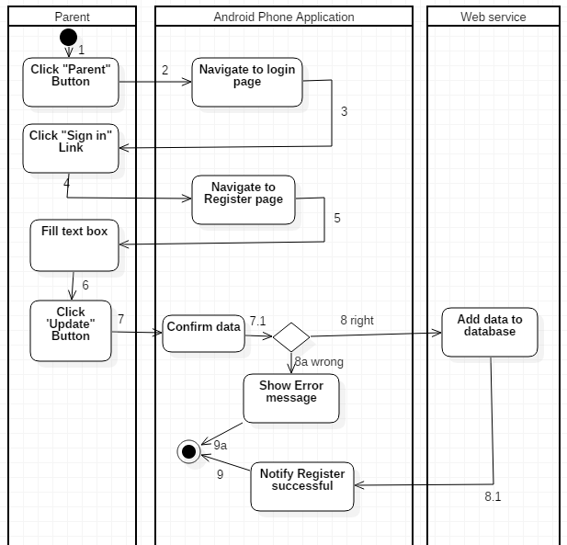

Figure 37: Activity Diagram - <Guest> Register

|  |  |
| --- | --- |
| **Step** | **Description** |
| 1 | Start: Click “Parent” button |
| 2 | Navigate to log in page |
| 3 | Click “Sign Up” Button |
| 4 | Navigate to register page |
| 5 | Fill data in text box |
| 6 | Click “Sign Up” button |
| 7 | Get data |
| 7.1 | Check data |
| 8 | Data is right, add data to database |
| 8.1 | Show notify register successful |
| 8a | Data is wrong, show error message |
| 9 | Finish |
| 9a | Finish |

#### 4.3.2 <Parent> Log In

Summary: This diagram shows process of the parent log in. 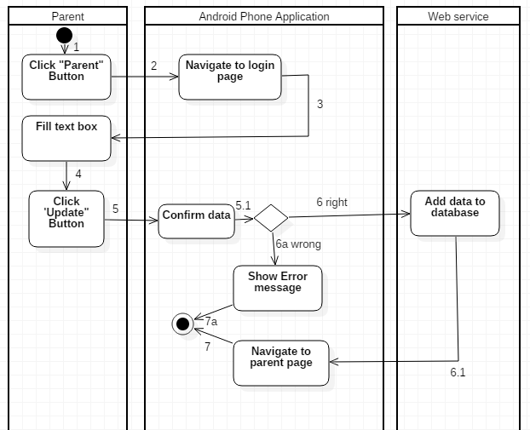

Figure 38: Activity Diagram - <Parent> Login

|  |  |
| --- | --- |
| **Step** | **Description** |
| 1 | Start: Click “Parent” button |
| 2 | Navigate to log in page |
| 3 | Fill data in text box |
| 4 | Click “Log In” button |
| 5 | Get data |
| 5.1 | Check data from text box |
| 6 | Data is right, add data to database |
| 6.1 | Navigate to parent page |
| 6a | Data is wrong, show error message |
| 7 | Finish |
| 7a | Finish |

#### 4.3.3 <Parent> Scan QR code to Add children

Summary: This diagram shows process of scan QR code to add the children.

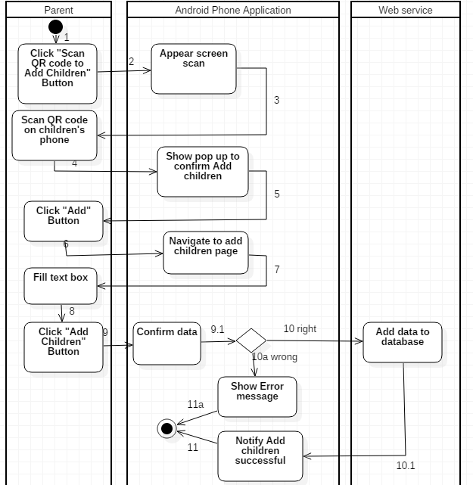

Figure 39: Activity Diagram - <Parent > Scan QR code to add children

|  |  |
| --- | --- |
| **Step** | **Description** |
| 1 | Start: Click “Scan QR code to add children” button |
| 2 | Appear screen scan |
| 3 | Scan QR code from children’s phone |
| 4 | Show pop up confirm add children |
| 5 | Click “Add children” button |
| 6 | Navigate to add children page |
| 7 | Fill data in text box |
| 8 | Click “Add Children” button |
| 9 | Get data |
| 9.1 | Confirm data in text box |
| 10 | Data is right, add data to database |
| 10.1 | Show notify add children successful |
| 10a | Data is wrong, show error message |
| 11 | Finish |
| 11a | Finish |

#### 4.3.4 <Parent> Input QR code to add children

Summary: This diagram shows process of input QR code to add the children.

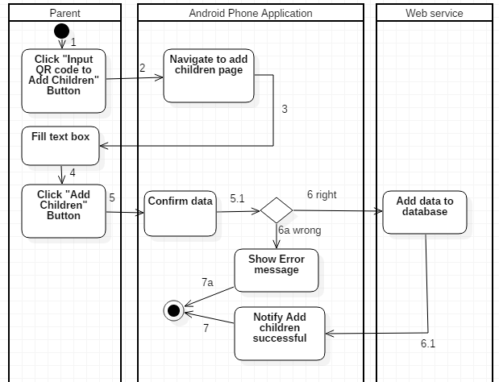

Figure 40: Activity Diagram - <Parent> Input QR code to add children

|  |  |
| --- | --- |
| **Step** | **Description** |
| 1 | Start: Click “Input QR code to add children” button |
| 2 | Navigate to add children page |
| 3 | Fill data in text box |
| 4 | Click “Add children” button |
| 5 | Get data |
| 5.1 | Confirm data in text box |
| 6 | Data is right, add data to database |
| 6a | Data is wrong, show error message |
| 6.1 | Show notify add children successful |
| 7 | Finish |
| 7a | Finish |

#### 4.3.5 <Parent> View list Children

Summary: This diagram shows process of view list children.

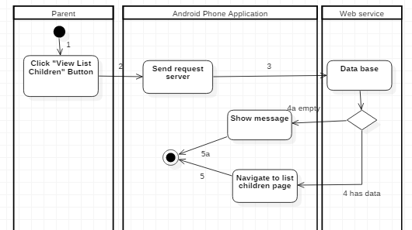

Figure 41: Activity Diagram - <Parent> View list Children

|  |  |
| --- | --- |
| **Step** | **Description** |
| 1 | Start: Click “View list Children” button |
| 2 | Send request to server |
| 3 | Send request |
| 4 | Has data into database, Navigate to list children page |
| 4a | Database is empty, Show message list is empty |
| 5 | Finish |
| 5a | Finish |

#### 4.3.6 <Parent> Update Children

Summary: This diagram shows process of update the children.

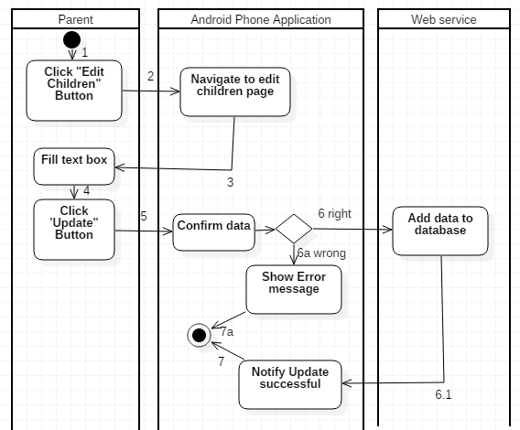

Figure 41: Activity Diagram - <Parent> Update Children

|  |  |
| --- | --- |
| **Step** | **Description** |
| 1 | Start: Click “Edit Children” button |
| 2 | Navigate to update children page |
| 3 | Fill text box |
| 4 | Click “Update” button |
| 5 | Confirm data |
| 6 | Data is right, add data to database |
| 6a | Data is wrong, show error message |
| 6.1 | Show notify update successful |
| 7 | Finish |
| 7a | Finish |

#### 4.3.7 <Parent> Update Parent

Summary: This diagram shows process of update the parent.

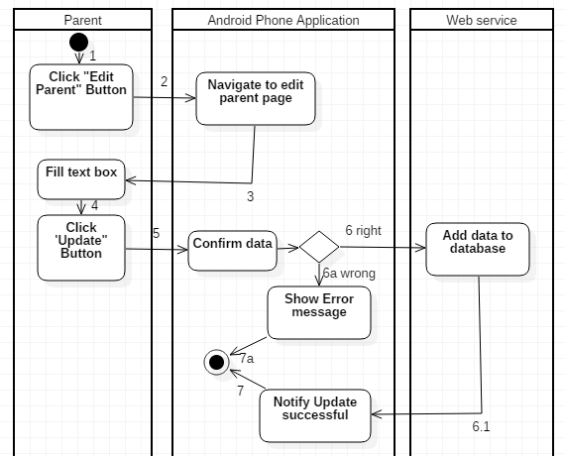

Figure 42: Activity Diagram - <Parent> Update parent

|  |  |
| --- | --- |
| **Step** | **Description** |
| 1 | Start: Click “Edit Parent” button |
| 2 | Navigate to update parent page |
| 3 | Fill text box |
| 4 | Click “Update” button |
| 5 | Confirm data |
| 6 | Data is right, add data to database |
| 6a | Data is wrong, show error message |
| 6.1 | Show notify update successful |
| 7 | Finish |
| 7a | Finish |

#### 4.3.8<Parent> Delete Children

Summary: This diagram shows process delete a children

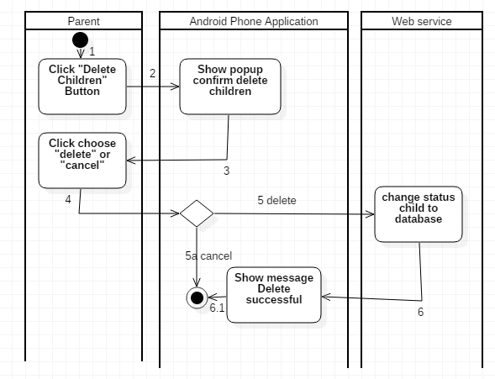

Figure 43: Activity Diagram - <Parent> Delete children

|  |  |
| --- | --- |
| **Step** | **Description** |
| 1 | Start: Click “Delete children” button |
| 2 | Show popup confirm delae children |
| 3 | Click “Delete” or “Cancel” |
| 4 | Confirm clicked |
| 5a | Finish |
| 5 | Cliked delete , change status children to database |
| 6 | Show message delete successful |
| 6.1 | Finish |

#### 4.3.9 <Children> Show image QR code

Summary : This diagram shows process Show image QR code

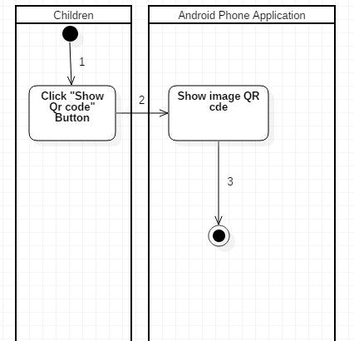

Figure 44: Activity Diagram - <Children> Show QR code

|  |  |
| --- | --- |
| **Step** | **Description** |
| 1 | Start: Click “Show Qr code” button |
| 2 | Show image QR code |
| 3 | Finish |

#### 4.3.10 <Children> Confirm parent manage

Summary: This diagram shows process confirm parent manage

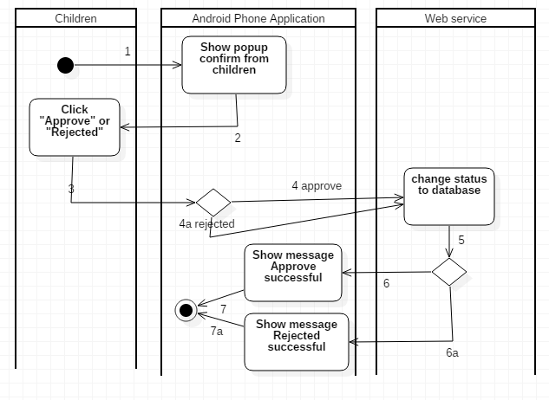

Figure 45: Activity Diagram - <Children> Confirm parent manage

|  |  |
| --- | --- |
| **Step** | **Description** |
| 1 | Show popup confirm from children |
| 2 | Click approve or rejected button |
| 3 | Confirm button clicked |
| 4 | Clickd approve button, change status |
| 4a | Clicked rejected button, change status |
| 5 | Response |
| 6 | Show message approve successful |
| 6a | Show message rejected successful |
| 7 | Finish |
| 7a | Finish |

#### 4.3.11 <Children> View list parent

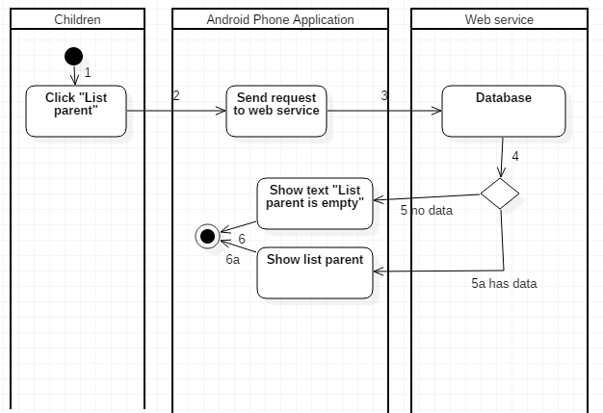

Figure 46: Activity Diagram - <Children> View list parent

|  |  |
| --- | --- |
| **Step** | **Description** |
| 1 | Click ”List parent” button |
| 2 | Clicked “List parent” button |
| 3 | Send request to server |
| 4 | Response |
| 5 | Show text “List is empty” |
| 5a | Show list parent |
| 6 | Finish |
| 6a | Finish |

#### 4.3.12 <Parent> View Current children’s location

Summary: This diagram shows process view Current children’s location.

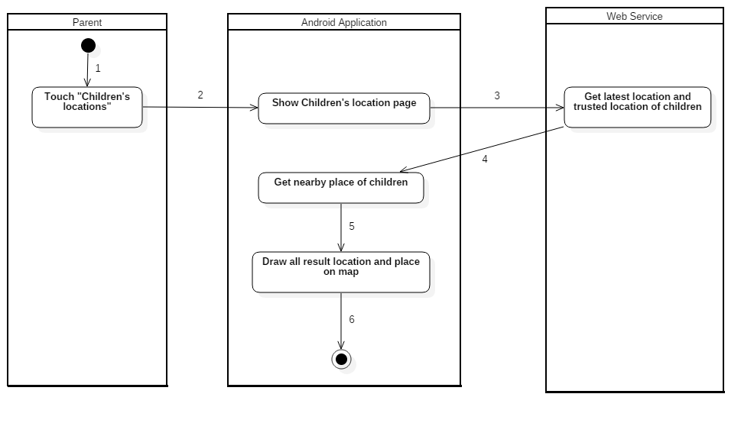

Figure 47: Activity Diagram - <Parent> View Current children’s location

|  |  |
| --- | --- |
| Step | Description |
| 1 | Start |
| 2 | Show children’s location page |
| 3 | Get latest location and trusted location of children from Web Service |
| 4 | Get nearby place of children using Google Places API |
| 5 | Draw latest location, trusted location and near place of children on map |
| 6 | Finish |

#### 4.3.13<Parent> Directions to current children's location

Summary: This diagram shows process Directions to current children's location.

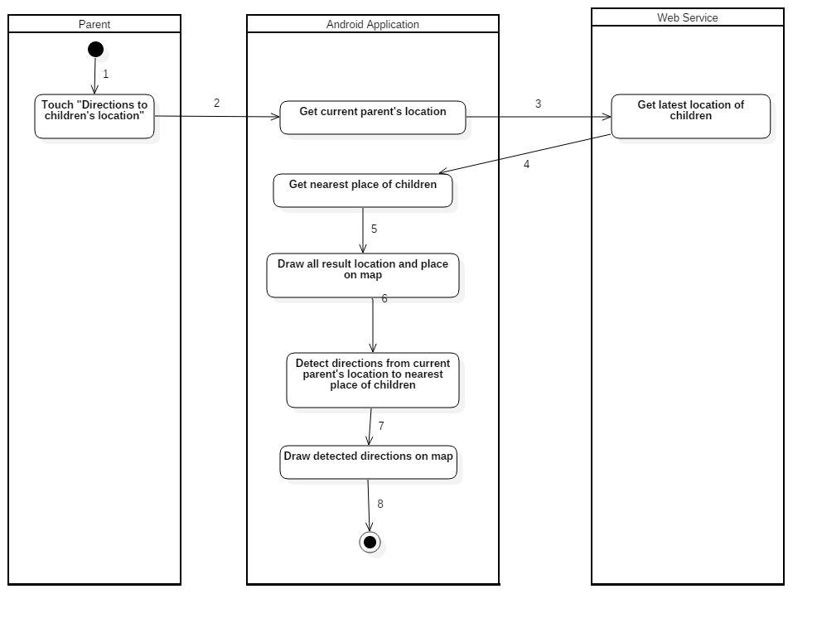

Figure 48: Activity Diagram - <Parent> Directions to current children's location

|  |  |
| --- | --- |
| Step | Description |
| 1 | Start |
| 2 | Get current parent’s location |
| 3 | Get latest location and trusted location of children from Web Service |
| 4 | Get nearest place of children using Google Places API |
| 5 | Draw latest location, trusted location and near place of children on map |
| 6 | Detect directions from current parent's location to nearest place of children using Google Maps Directions API |
| 7 | Draw detected directions on map |
| 8 | Finish |

#### 4.3.14 View list trusted location

Summary: This diagram shows process view list trusted location.

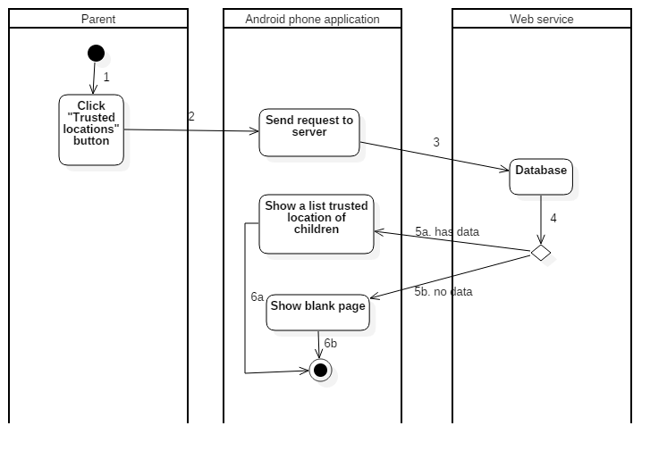

Figure 49: Activity Diagram - <Parent> View list trusted location

|  |  |
| --- | --- |
| **Step** | **Description** |
| 1 | Start: Click “Trusted locations” on children’s information |
| 2 | Send request to server |
| 4 | Check data from database |
| 5a | If children have trusted locations, navigate to trusted location list and show list |
| 5b | If children don’t have any trusted location, navigate to trusted location with message. |
| 6a | Finish |
| 6b | Finish |

#### 4.3.15 Search place to add

Summary: This diagram shows process Search place to add.

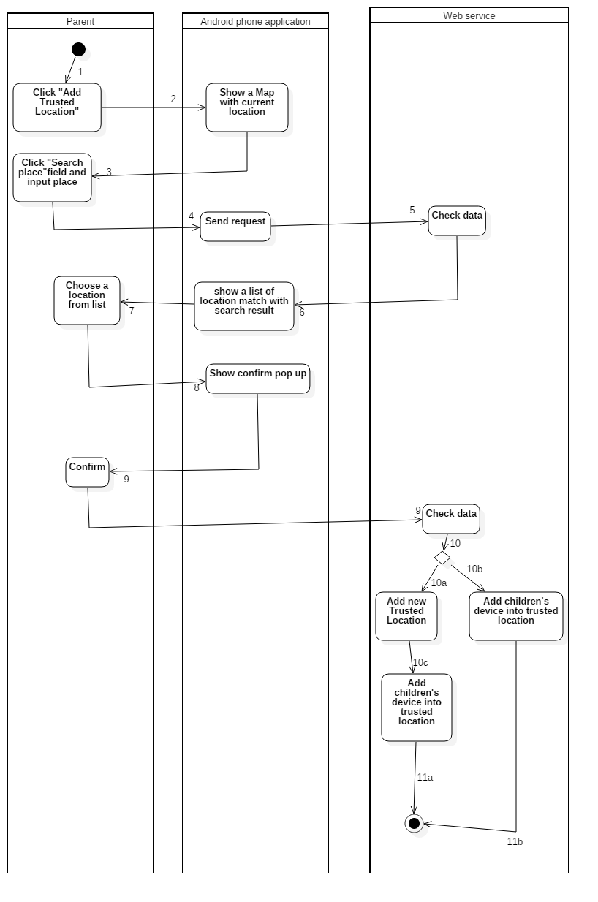

Figure 50: Activity Diagram - <Parent> Search place to add

|  |  |
| --- | --- |
| **Step** | **Description** |
| 1 | Click “Add Trusted Location” button |
| 2 | Show a map with current location of device |
| 3 | Click “Search place” field and input data |
| 4 | Send Request to server |
| 5 | Server check data |
| 6 | Show a list of location match with the value user input |
| 7 | User choose a location from a list |
| 8 | Show confirm pop up to user |
| 9 | User confirm information |
| 10 | Server check data |
| 10b | Add children to that trusted location |
| 10a | Add trusted location to database |
| 10c | Add children to that trusted location |
| 11a | Finish |
| 11b | Finish |

#### 4.3.16 Add trusted location by current place

Summary: This diagram shows process Add trusted location by current place.

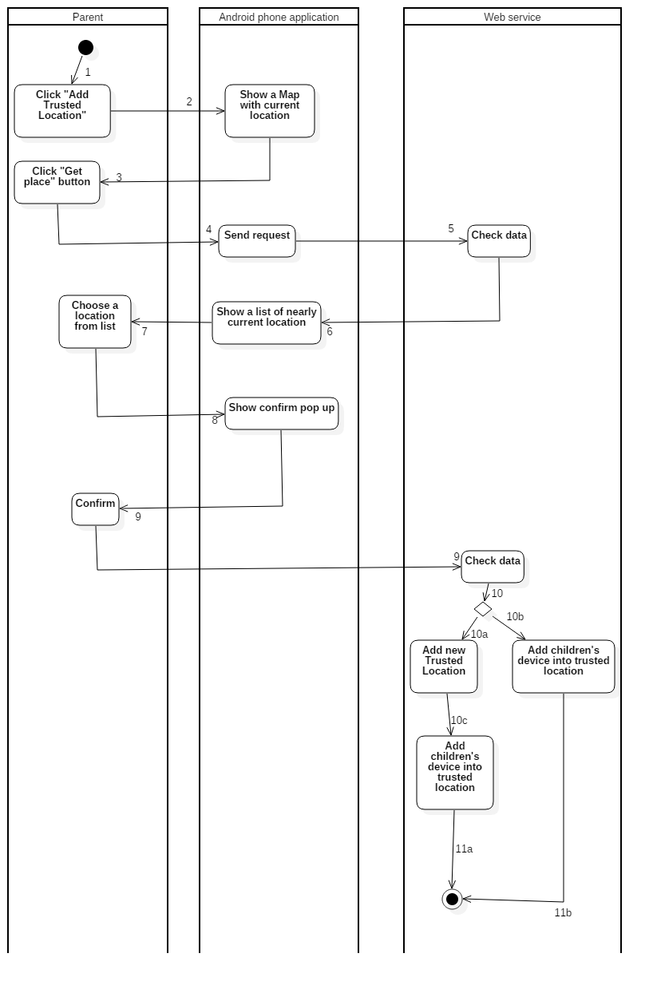

Figure 51: Activity Diagram <Parent> Add trusted location by current place

|  |  |
| --- | --- |
| **Step** | **Description** |
| 1 | Click “Add Trusted Location” button |
| 2 | Show a map with current location of device |
| 3 | Click “Get place” button |
| 4 | Send Request to server |
| 5 | Server check data |
| 6 | Show a list nearly location of trusted locations |
| 7 | User choose a location from a list |
| 8 | Show confirm pop up to user |
| 9 | User confirm information |
| 10 | Server check data |
| 10b | Add children to that trusted location |
| 10a | Add trusted location to database |
| 10c | Add children to that trusted location |
| 11a | Finish |
| 11b | Finish |

#### 4.3.17 Get All Contact

Summary: This diagram shows process Get All Contact.

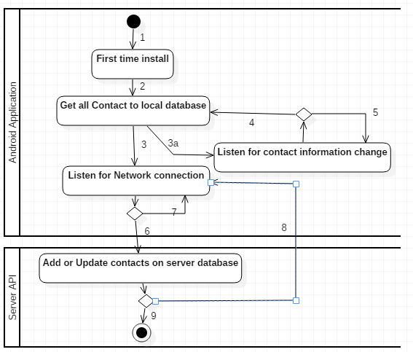

Figure 52: Activity Diagram - <Parent> Get all Contact

|  |  |
| --- | --- |
| **Step** | **Description** |
| 1 | Start |
| 2 | Get all Contact to local database |
| 3 | Listen for Network connection |
| 3a | Listen for contact information change |
| 4 | Contact information change |
| 5 | No change |
| 6 | Have internet connection |
| 7 | No internet connection |
| 8 | Add or update contacts successful |
| 9 | Add or update contacts unsuccessful |

#### 4.3.18 Get all call log

Summary: This diagram shows process Get all call log.

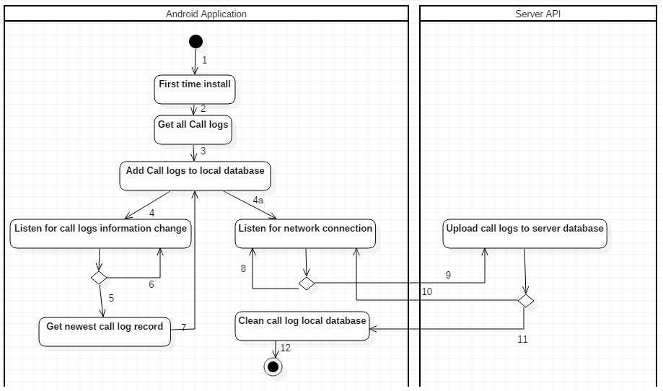

Figure 53: Activity Diagram - <Parent> Get all call logs

|  |  |
| --- | --- |
| **Step** | **Description** |
| 1 | Start |
| 2 | Get all Call Log |
| 3 | Add Call logs to local database |
| 4 | Listen for Network connection |
| 4a | Listen for Call logs information change |
| 5 | Call logs information change |
| 6 | No change |
| 7 | Add call logs to local database |
| 8 | No internet connection |
| 9 | Have internet connection |
| 10 | Upload Call logs unsuccessful |
| 11 | Upload Call logs successful |
| 12 | Finish |

#### 4.3.19 Get all Message

Summary: This diagram shows process Get all Message.

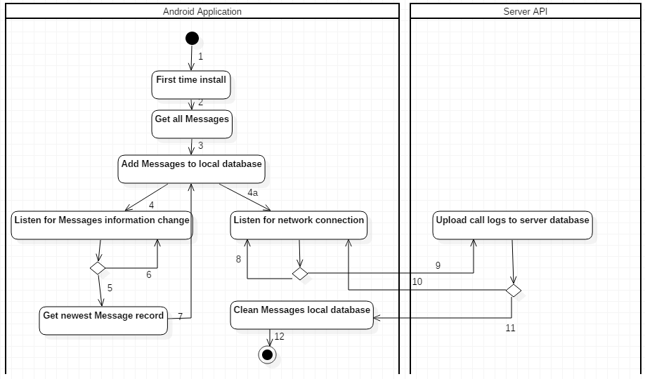

Figure 54: Activity Diagram - <Parent> Get all Message

|  |  |
| --- | --- |
| **Step** | **Description** |
| 1 | Start |
| 2 | Get all Messages |
| 3 | Add Messages to local database |
| 4 | Listen for Network connection |
| 4a | Listen for Messages information change |
| 5 | Messages information change |
| 6 | No change |
| 7 | Add Messages to local database |
| 8 | No internet connection |
| 9 | Have internet connection |
| 10 | Upload Messages unsuccessful |
| 11 | Upload Messages successful |
| 12 | finish |

#### 4.3.20 View Contact

Summary: This diagram shows process View Contact.

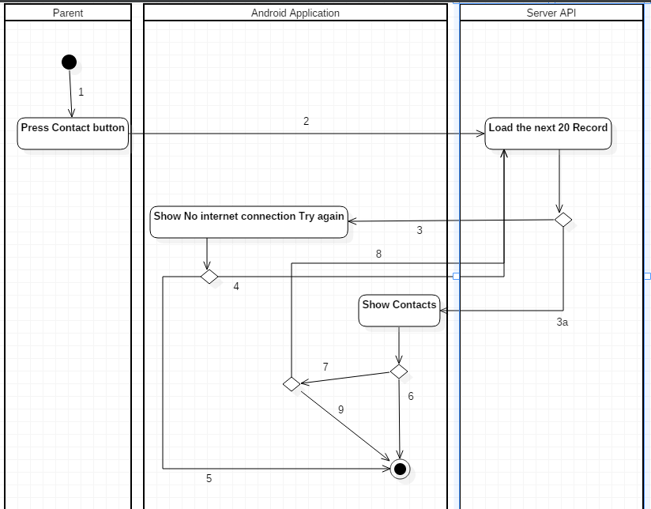

Figure 55: Activity Diagram - <Parent> View Contacts

|  |  |
| --- | --- |
| **Step** | **Description** |
| 1 | Start |
| 2 | Load the next 20 Contact Record |
| 3 | Load fail |
| 3a | Load successful |
| 4 | Press try again |
| 5 | Press back button |
| 6 | Meet the end of contact records |
| 7 | Does not meet the end of contact records |
| 8 | Scroll to the end of list |
| 9 | Press Back button |

#### 4.3.21 View List Message

Summary: This diagram shows process View List Message.

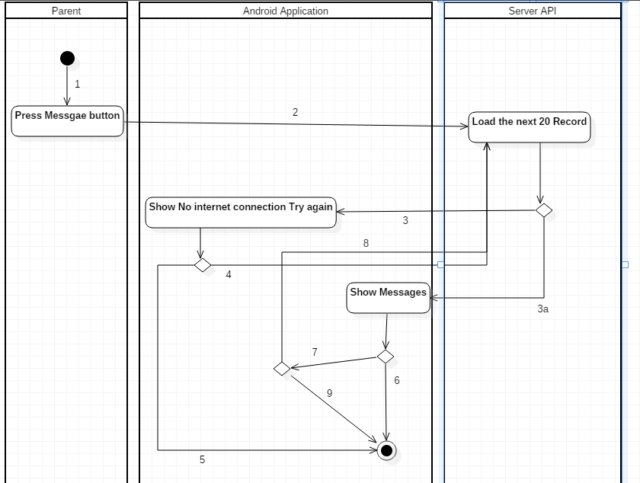

Figure 56: Activity Diagram - <Parent> View List Message

|  |  |
| --- | --- |
| **Step** | **Description** |
| 1 | Start |
| 2 | Load the next 20 Message Record |
| 3 | Load fail |
| 3a | Load successful |
| 4 | Press try again |
| 5 | Press back button |
| 6 | Meet the end of Message records |
| 7 | Does not meet the end of Messages records |
| 8 | Scroll to the end of list |
| 9 | Press Back button |

#### 4.3.22 View Call logs

Summary: This diagram shows process View Call logs.

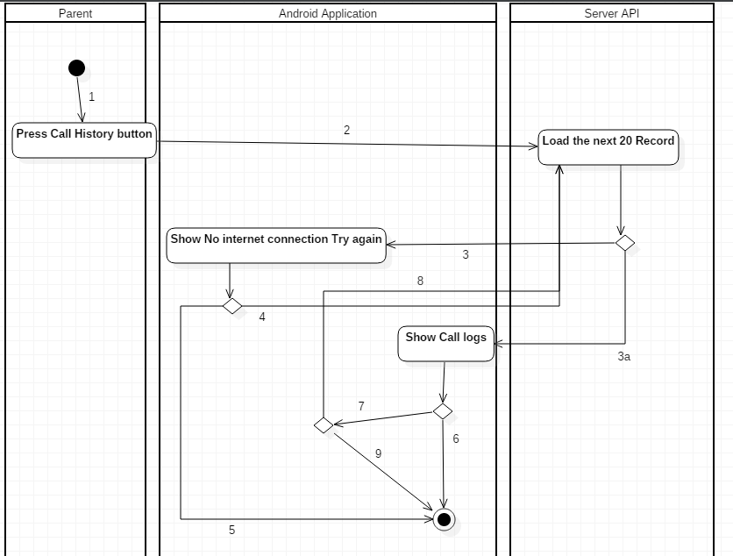

Figure 57: Activity Diagram - <Parent> View Call Logs

|  |  |
| --- | --- |
| **Step** | **Description** |
| 1 | Start |
| 2 | Load the next 20 Call Log Record |
| 3 | Load fail |
| 3a | Load successful |
| 4 | Press try again |
| 5 | Press back button |
| 6 | Meet the end of Call Logs records |
| 7 | Does not meet the end of Call Logs records |
| 8 | Scroll to the end of list |
| 9 | Press Back button |

#### 4.3.23 View message Detail

Summary: This diagram shows process View message Detail.

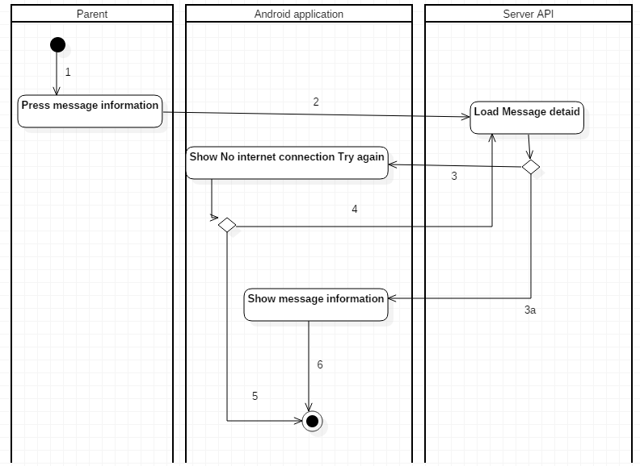

Figure 58: Activity Diagram - <Parent> View message Detail

|  |  |
| --- | --- |
| **Step** | **Description** |
| 1 | Start |
| 2 | Load Message Detail |
| 3 | Load fail |
| 3a | Load successful |
| 4 | Press try again |
| 5 | Press back button |
| 6 | Finish |

#### 4.3.24 <Parent> View contact’s detail

Summary: This diagram shows process View contact’s detail.

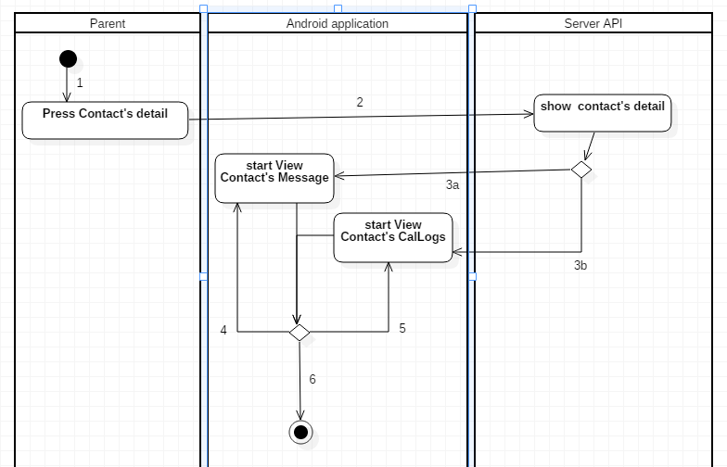

Figure 59: Activity Diagram - <Parent> View contact’s detail

|  |  |
| --- | --- |
| **Step** | **Description** |
| 1 | Start |
| 2 | Show contact’s detail |
| 3a | Start View Contact’s Messages |
| 3b | Start View Contact’s CallLogs |
| 4 | Press button Message |
| 5 | Press button Call Log |
| 6 | Press back |

#### 4.3.24 <Parent> View contact’s message

Summary: This diagram shows process of view Contact’s message.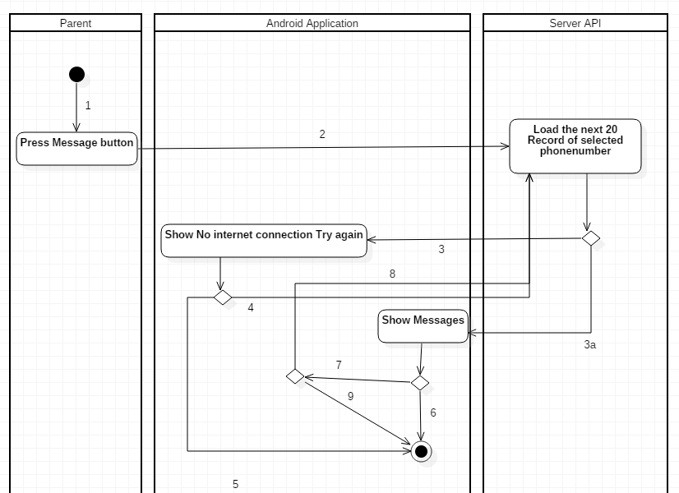

Figure 60: Activity Diagram - <Parent> View contact’s message

|  |  |
| --- | --- |
| **Step** | **Description** |
| 1 | Start |
| 2 | Load the next 20 Message Record |
| 3 | Load fail |
| 3a | Load successful |
| 4 | Press try again |
| 5 | Press back button |
| 6 | Meet the end of Message records |
| 7 | Does not meet the end of Message records |
| 8 | Scroll to the end of list |
| 9 | Press Back button |

#### 4.3.25 <Parent> View contact’s Call Log

Summary: This diagram shows process of view Contact’s Call log.

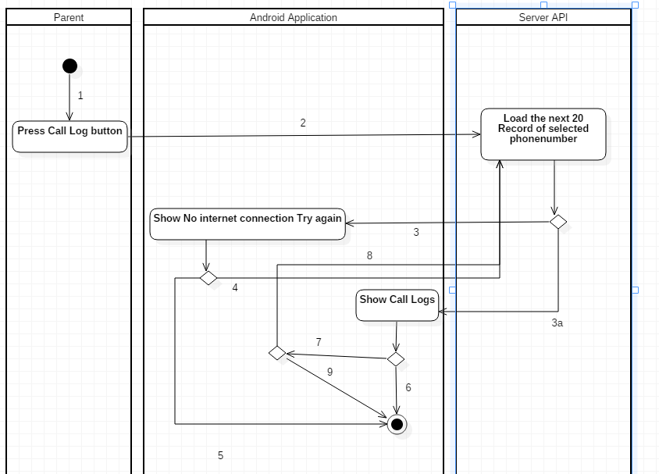

Figure 61: Activity Diagram - <Parent> View contact’s Call Log

|  |  |
| --- | --- |
| **Step** | **Description** |
| 1 | Start |
| 2 | Load the next 20 Call Logs Record |
| 3 | Load fail |
| 3a | Load successful |
| 4 | Press try again |
| 5 | Press back button |
| 6 | Meet the end of Call Logs records |
| 7 | Does not meet the end of Call Logs records |
| 8 | Scroll to the end of list |
| 9 | Press Back button |

#### 4.3.26 <Parent> View Trusted Location

Summary: This diagram shows process View Trusted Location.

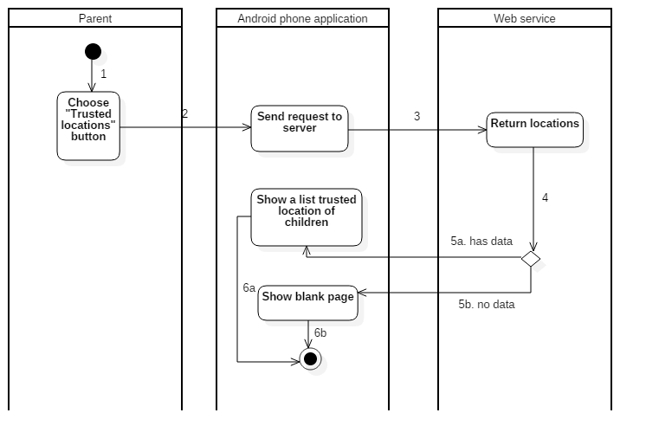

Figure 62: Activity Diagram - <Parent> View Trusted Location

|  |  |
| --- | --- |
| **Step** | **Description** |
| 1 | Start: Click “Trusted locations” on children’s information |
| 2 | Send request to server |
| 4 | Check data from database |
| 5a | If children have trusted locations, navigate to trusted location list and show list |
| 5b | If children don’t have any trusted location, navigate to trusted location with message. |
| 6a | Finish |
| 6b | Finish |

#### 4.3.27 <Parent> Add a new trusted location

Summary: This diagram shows process Add a new trusted location.

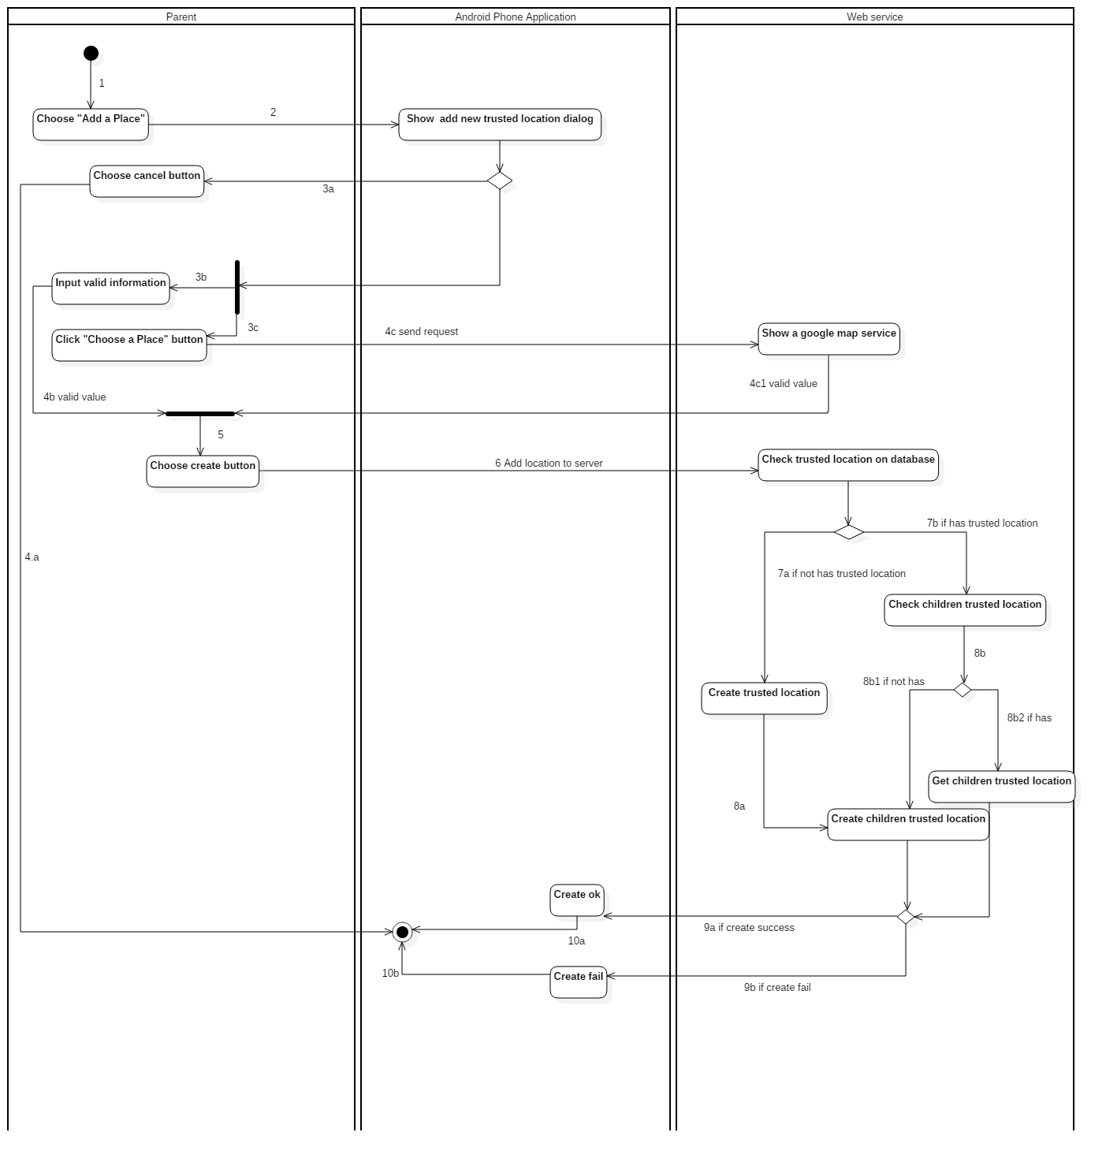

Figure 63: Activity Diagram - <Parent> Add a new trusted location

|  |  |
| --- | --- |
| **Step** | **Description** |
| 1 | Start: Click “Add a place” on “Trusted locations” page |
| 2 | Show add new location dialog |
| 3a | Choose cancel button |
| 4a | Finish |
| 3b | Input name and floor for location |
| 4b | Validate value user input |
| 4c | Send request to google service |
| 4c1 | Get a chosen place |
| 5 | Finish 4b and 4c1, click “Create” button |
| 6 | Add location to server |
| 7a | If database didn’t have that location, Create new trusted location |
| 8a | Create “Children Trusted Location” |
| 7b | If database already have that location, check “Children Trusted Location” |
| 8b1 | If database didn’t have that “Children Trusted Location”, Create new “Children Trusted Location” |
| 8b2 | If database already have that “Children Trusted Location”, return that “Children Trusted Location” |
| 9a | Show message “Create ok” |
| 10a | Finish |
| 9b | Show message “Create fail” |
| 10b | Finish |

#### 4.3.28 <Parent> Delete a Trusted Location

Summary: This diagram shows process Delete a Trusted Location.

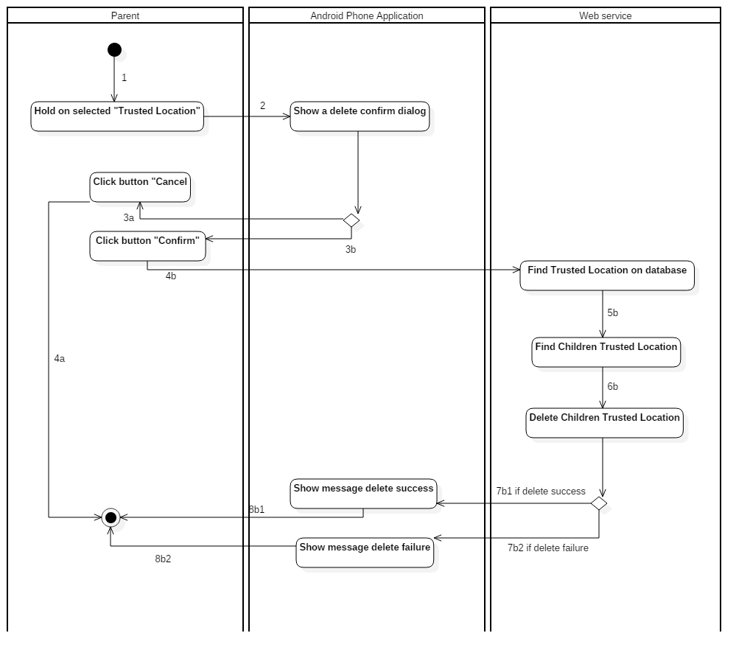

Figure 64: Activity Diagram - <Parent> Delete a Trusted Location

|  |  |
| --- | --- |
| **Step** | **Description** |
| 1 | Start: Hold selected “Trusted Location” on Trusted Locations Page |
| 2 | Show a delete confirm dialog |
| 3a | Click button “Cancel” |
| 4a | Finish |
| 3b | Click “Confirm” button |
| 4b | Find trusted location |
| 5b | Find children trusted location |
| 6b | Delete children trusted location |
| 7b1 | If delete success, show message delete success |
| 8b1 | Finish |
| 7b2 | If delete fail, show message delete failure |
| 8b2 | Finish |

#### 4.3.29 <Parent> View All Schedule

Summary: This diagram shows process View All Schedule.

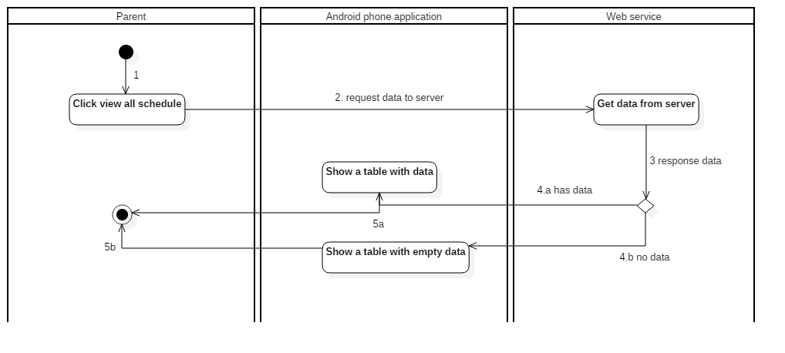

Figure 65: Activity Diagram - <Parent> View All Schedule

|  |  |
| --- | --- |
| **Step** | **Description** |
| 1 | Start: Choose “View All Schedule” on navigator bar on “Trusted locations” page or “List schedule” page |
| 2 | Request data to server |
| 3 | Response data |
| 4a | If has data go to “All Schedule” page, show a table with data |
| 5a | Finish |
| 4b | If no data go to “All Schedule” page, show a table with empty data |
| 5b | Finish |

#### 4.3.30 <Parent> Add new Schedule

Summary: This diagram shows process Add new Schedule.

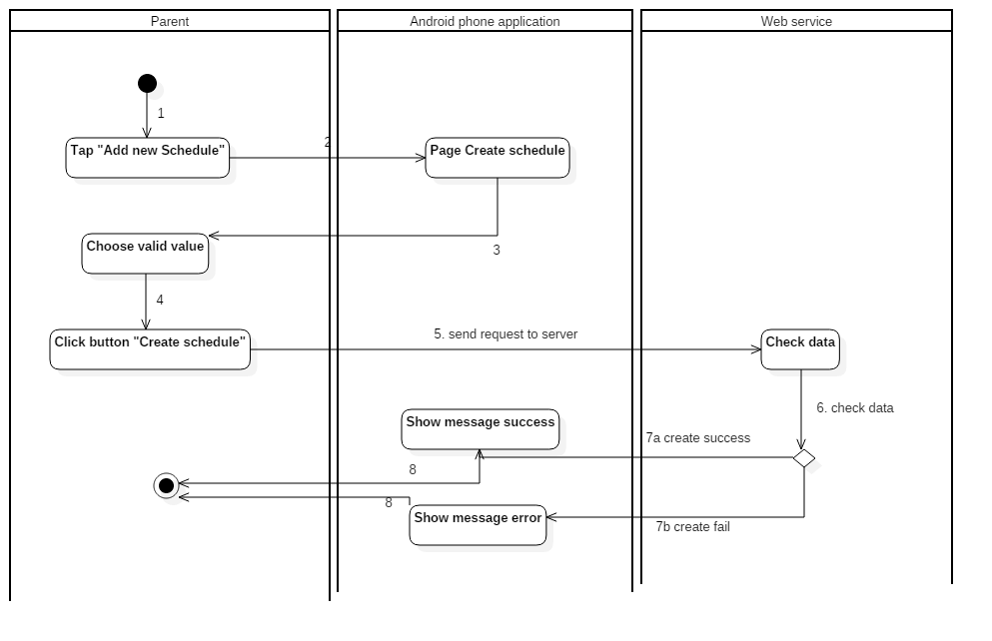

Figure 66: Activity Diagram - <Parent> Add new Schedule

|  |  |
| --- | --- |
| **Step** | **Description** |
| 1 | Start: Click “Add new Schedule” on “list schedule” |
| 2 | Go to page “Create schedule” |
| 3 | Choose weekday, from time, to time |
| 4 | Click button “Create schedule” |
| 5 | Send request to server |
| 6 | Check data from server |
| 7a | If time range is valid, create success, show message Create Success |
| 8a | Finish |
| 7b | If time range is invalid, create fail, show message Error |
| 8b | Finish |

#### 4.3.31 <Parent> Update a schedule

Summary: This diagram shows process Update a schedule.

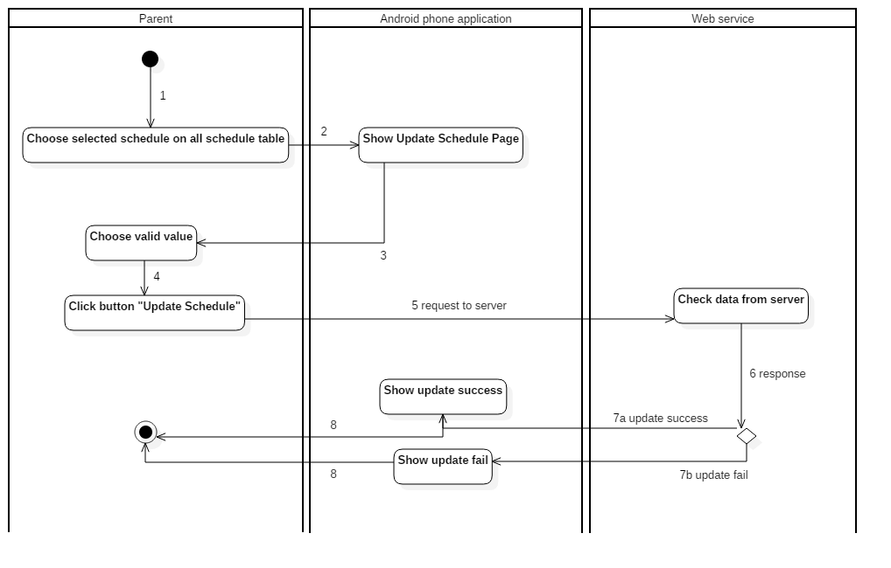

Figure 67: Activity Diagram - <Parent> Update a schedule

|  |  |
| --- | --- |
| **Step** | **Description** |
| 1 | Start: Choose selected schedule on all schedule table |
| 2 | Go to page “Update schedule” |
| 3 | Choose weekday, from time, to time |
| 4 | Click button “Update schedule” |
| 5 | Send request to server |
| 6 | Check data from server |
| 7a | If time range is valid, update success, show message Update Success |
| 8a | Finish |
| 7b | If time range is invalid, update fail, show message Error |
| 8b | Finish |

#### 4.3.32 <Parent> Delete a schedule

Summary: This diagram shows process Delete a schedule.

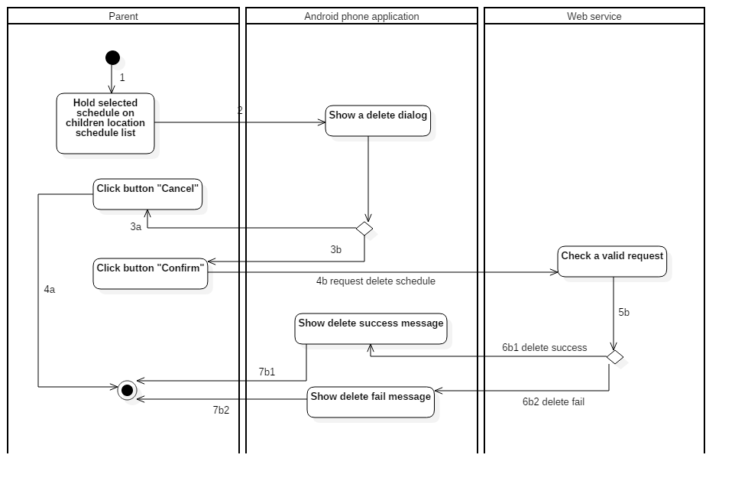

Figure 68: Activity Diagram - <Parent> Delete a schedule

|  |  |
| --- | --- |
| **Step** | **Description** |
| 1 | Start: Hold selected “Schedule” on Schedule Page |
| 2 | Show a delete confirm dialog |
| 3a | Click button “Cancel” |
| 4a | Finish |
| 3b | Click “Confirm” button |
| 4b | Request delete schedule |
| 5b | Response |
| 6b1 | If delete success, show message delete success |
| 7b1 | Finish |
| 6b2 | If delete fail, show message delete failure |
| 7b2 | Finish |

#### 4.3.33 <Parent> View Schedule of Trusted Location

Summary: This diagram shows process View Schedule of Trusted Location.

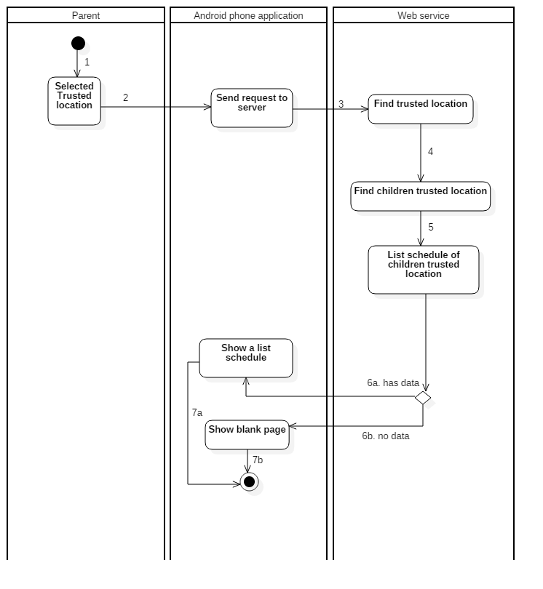

Figure 69: Activity Diagram - <Parent> View Schedule of Trusted Location

|  |  |
| --- | --- |
| **Step** | **Description** |
| 1 | Start: select “Trusted location” on “Trusted locations” page |
| 2 | Send request to server |
| 3 | Find trusted location |
| 4 | Find children trusted location |
| 5 | Get list schedule of children trusted location |
| 6a | If has schedule of children trusted location, show a list schedule |
| 7a | Finish |
| 6b | If no data, return a page detail of trusted location and blank list schedule |
| 7b | Finish |

#### 4.3.34 <Parent> Setting Notifcation

Summary: This diagram shows process Setting Notifcation.

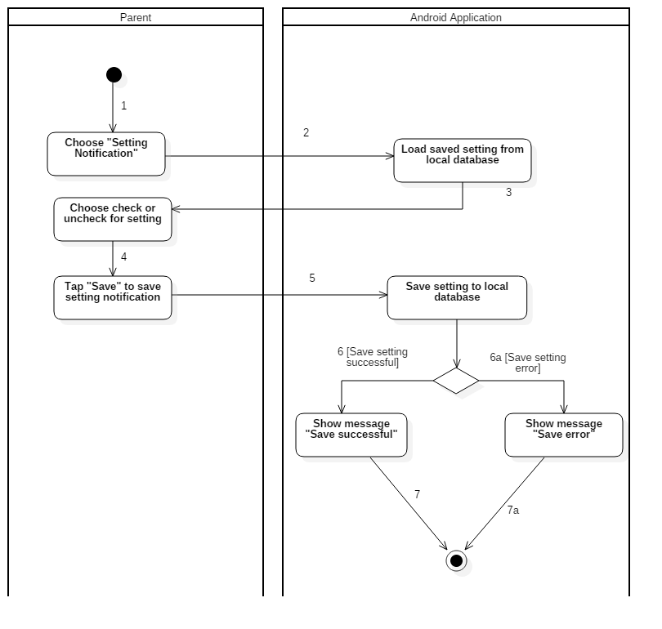

Figure 70: Activity Diagram - <Parent> Setting Notifcation

|  |  |
| --- | --- |
| **Step** | **Description** |
| 1 | Start: Choose "Setting Notification" |
| 2 | Load saved setting from local database |
| 3 | Choose check or uncheck for setting |
| 4 | Tap "Save" to save setting notification |
| 5 | Save setting to local database |
| 6 | Show message "Save successful" |
| 6a | Show message "Save error" |
| 7 | Finish |
| 7a | Finish |

#### 4.3.35 <Parent> View Notification

Summary: This diagram shows process View Notification.

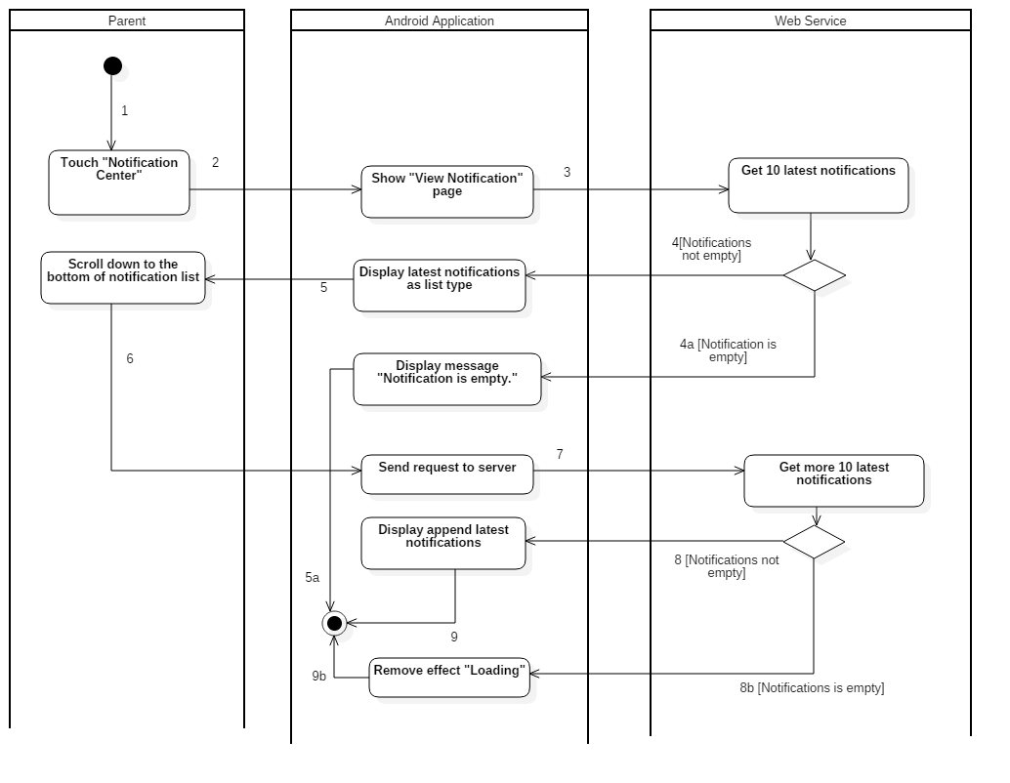

Figure 71: Activity Diagram - <Parent> View Notification

|  |  |
| --- | --- |
| **Step** | **Description** |
| 1 | Start: Touch "Notification Center" |
| 2 | Show "View Notification" page |
| 3 | Get 10 latest notifications |
| 4 | Display latest notifications as list type |
| 4a | Display message "Notification is empty." |
| 5 | Scroll down to the bottom of notification list |
| 5a | Finish |
| 6 | Send request to server |
| 7 | Get more 10 latest notifications |
| 8 | Display append latest notifications |
| 8b | Remove effect "Loading" |
| 9 | Finish |
| 9b | Finish |

#### 4.3.36 <Parent> View Notification Detail

Summary: This diagram shows process View Notification Detail.

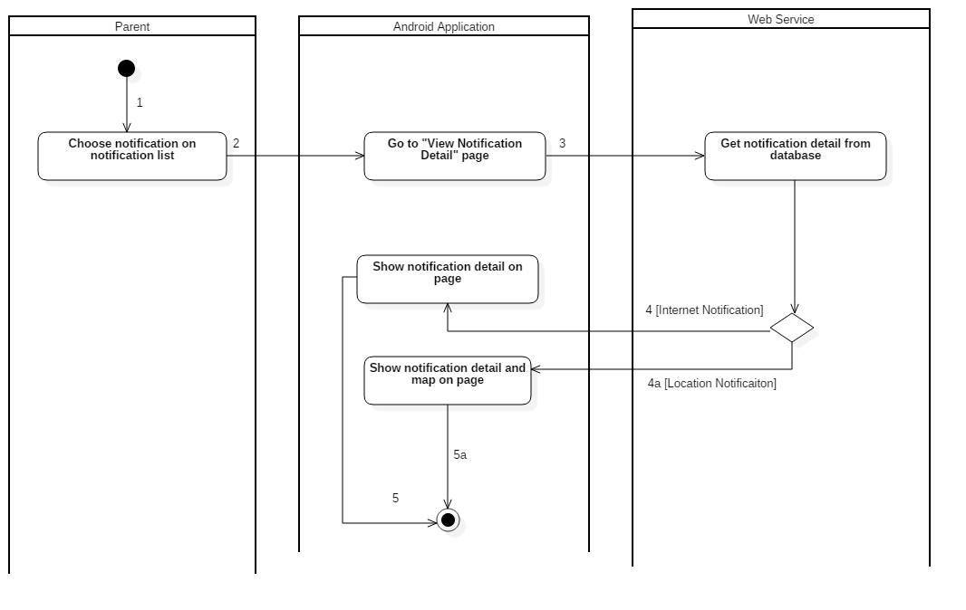

Figure 72: Activity Diagram - <Parent> View Notification Detail

|  |  |
| --- | --- |
| **Step** | **Description** |
| 1 | Start: Choose notification on notification list |
| 2 | Go to "View Notification Detail" page |
| 3 | Get notification detail from database |
| 4 | Show notification detail on page |
| 4a | Show notification detail and map on page |
| 5 | Finish |
| 5a | Finish |

#### 4.3.37 <Parent> View Children Location

Summary: This diagram shows process View Children Location.

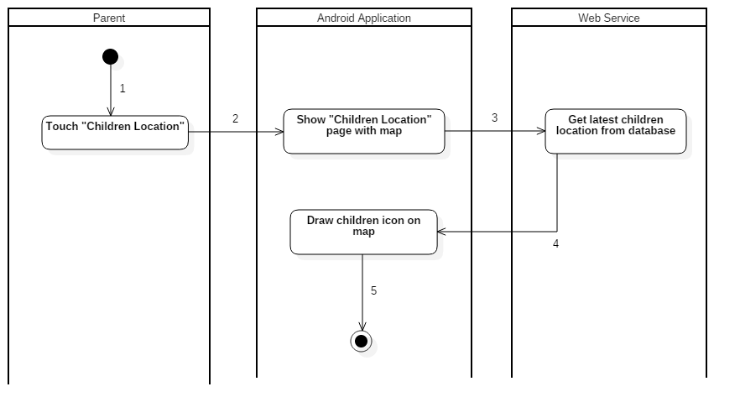

Figure 73: Activity Diagram - <Parent> View Children Location

|  |  |
| --- | --- |
| **Step** | **Description** |
| 1 | Start: Touch "Children Location" |
| 2 | Show "Children Location" page with map |
| 3 | Get latest children location from database |
| 4 | Draw children icon on map |
| 5 | Finish |

#### 4.3.38 <Parent> Direction Route

Summary: This diagram shows process Direction Route.

Figure 74: Acitvity Diagram - <Parent> Direction Route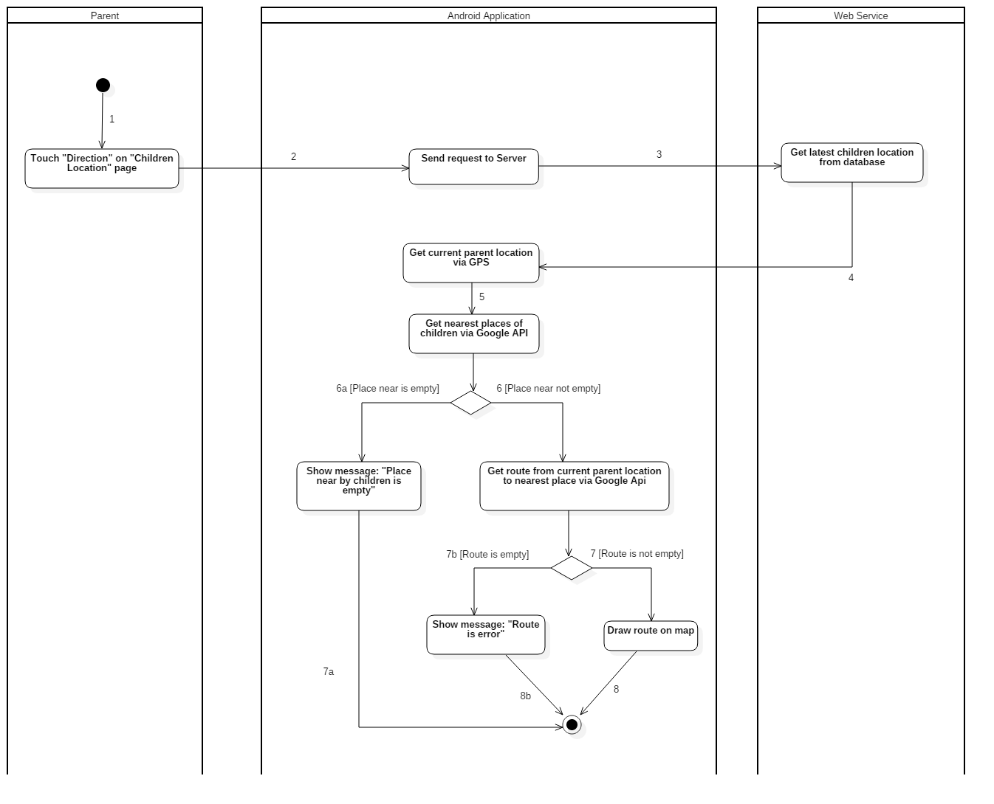

|  |  |
| --- | --- |
| **Step** | **Description** |
| 1 | Start: Touch "Direction" on "Children Location" page |
| 2 | Send request to Server |
| 3 | Get latest children location from database |
| 4 | Get current parent location via GPS |
| 5 | Get nearest places of children via Google API |
| 6 | Get route from current parent location to nearest place via Google Api |
| 6a | Show message: "Place near by children is empty" |
| 7 | Draw route on map |
| 7a | Finish |
| 7b | Show message: "Route is error" |
| 8 | Finish |
| 8b | Finish |

#### 4.3.39 <Children> Log Out

Summary: This diagram shows process log out of the children.

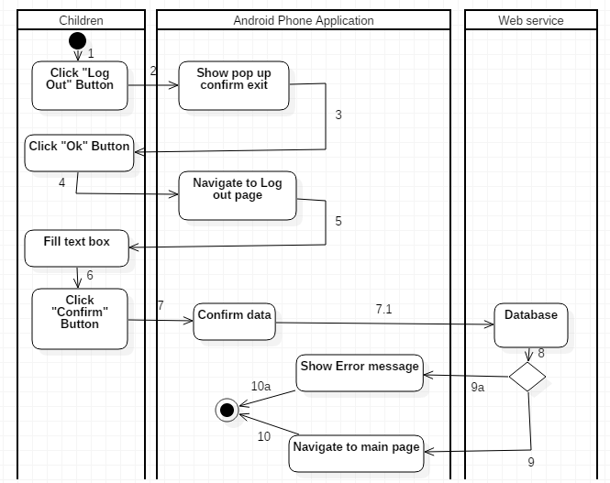

Figure 75: Activity Diagram - <Children> Log Out

|  |  |
| --- | --- |
| **Step** | **Description** |
| 1 | Start: Click “Log out” button |
| 2 | Show pop up confirm exit |
| 3 | Click “Ok” button |
| 4 | Navigate to log out page |
| 5 | Fill data in text box |
| 6 | Click “Confirm” button |
| 7 | Confirm data |
| 7.1 | Send data to server |
| 8 | Response |
| 9 | Navigate to main page |
| 9a | Show error message |
| 10 | Finish |
| 10a | Finish |

## 5. Interface

### 5.1 Android Interface Design

#### 5.1.1 Main Page

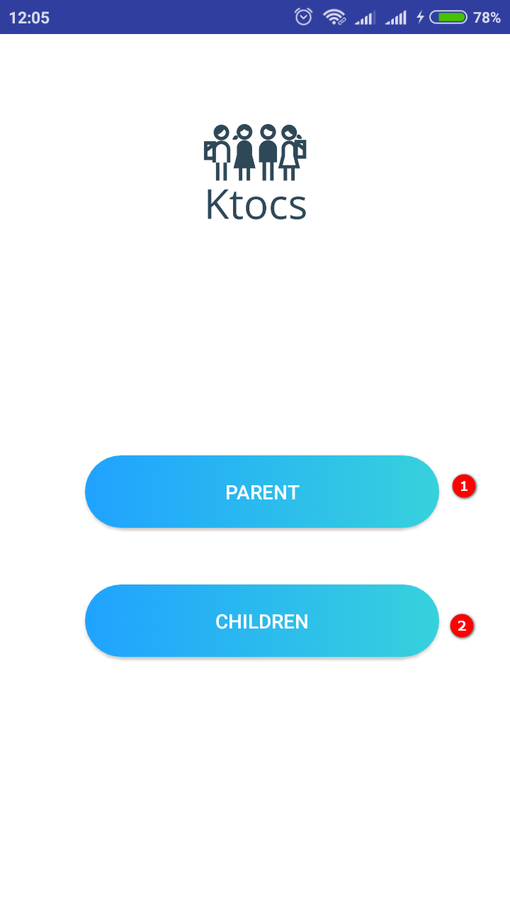

Figure 76: Main page

**Buttons/Hyperlinks**

|  |  |  |  |  |
| --- | --- | --- | --- | --- |
| **No** | **Function** | **Description** | **Validation** | **Outcome** |
| 1 | Choose role Parent | Choose role Parent | N/A | Navigate to login page |
| 2 | Choose role Children | Choose role Children | N/A | Navigate to children page |

#### 5.1.2 Login page

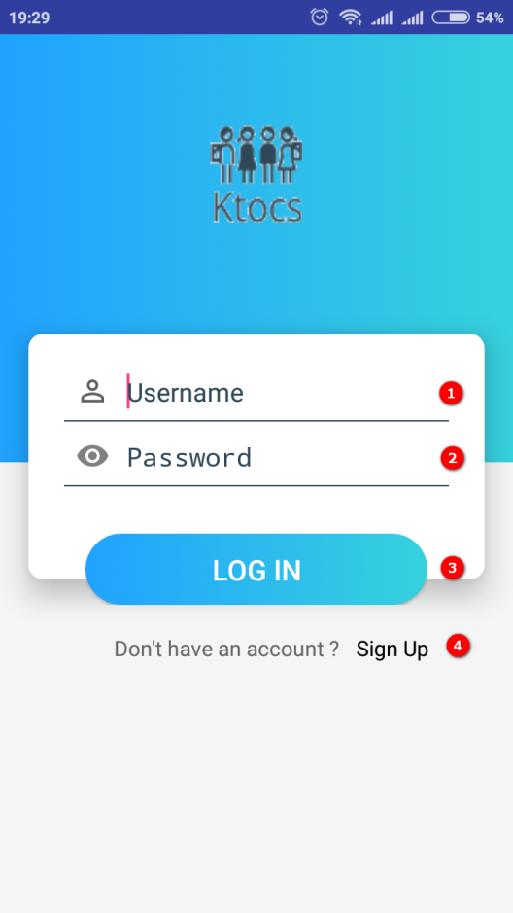

Figure 77 Login page

Fields

|  |  |  |  |  |  |  |  |
| --- | --- | --- | --- | --- | --- | --- | --- |
| **No** | **Field Name** | **Description** | **Read Only** | **Mandatory** | **Control Type** | **Data Type** | **Length** |
| 1 | Username  text | Fill in to login | No | Yes | Text box | String | 6-20 |
| 2 | Password text | Fill in to login | No | Yes | Text box | String | 6-20 |

**Buttons/Hyperlinks**

|  |  |  |  |  |
| --- | --- | --- | --- | --- |
| **No** | **Function** | **Description** | **Validation** | **Outcome** |
| 3 | Login | Login to parent’s account | N/A | Navigate to parent page |
| 4 | Sign up | Register a new account | N/A | Navigate to register page |

#### 5.1.3 Register page

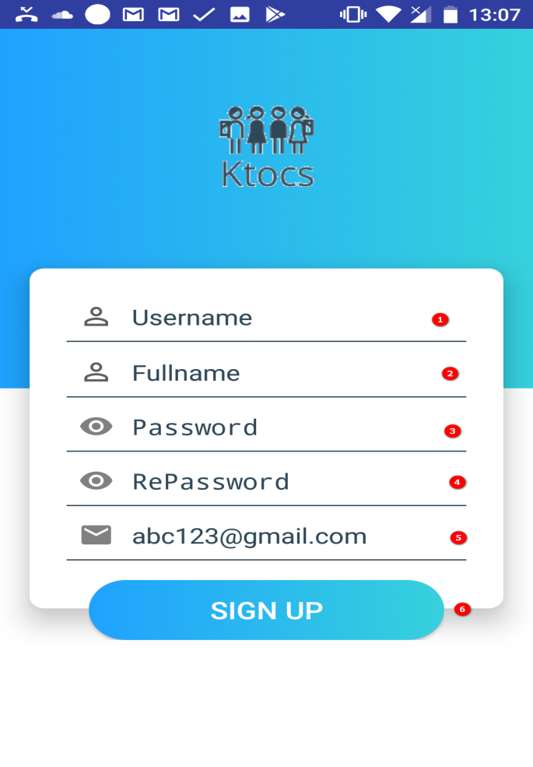

Figure 78 Register page

**Fields**

|  |  |  |  |  |  |  |  |
| --- | --- | --- | --- | --- | --- | --- | --- |
| **No** | **Field Name** | **Description** | **Read Only** | **Mandatory** | **Control Type** | **Data Type** | **Length** |
| 1 | Username  text | Fill in to register | No | Yes | Text box | String | 6-20 |
| 2 | Fullname text | Fill in to register | No | Yes | Text box | String | 6-20 |
| 3 | Password text | Fill in to register | No | Yes | Text box | String | 6-20 |
| 4 | RePassword text | Fill in to register | No | Yes | Text box | String | 6-20 |
| 5 | Email text | Fill in to register | No | Yes | Text box | String | N/A |

**Buttons/Hyperlinks**

|  |  |  |  |  |
| --- | --- | --- | --- | --- |
| **No** | **Function** | **Description** | **Validation** | **Outcome** |
| 6 | Sign up | Register a new account | N/A | Navigate to login page |

#### 5.1.4 Parent page

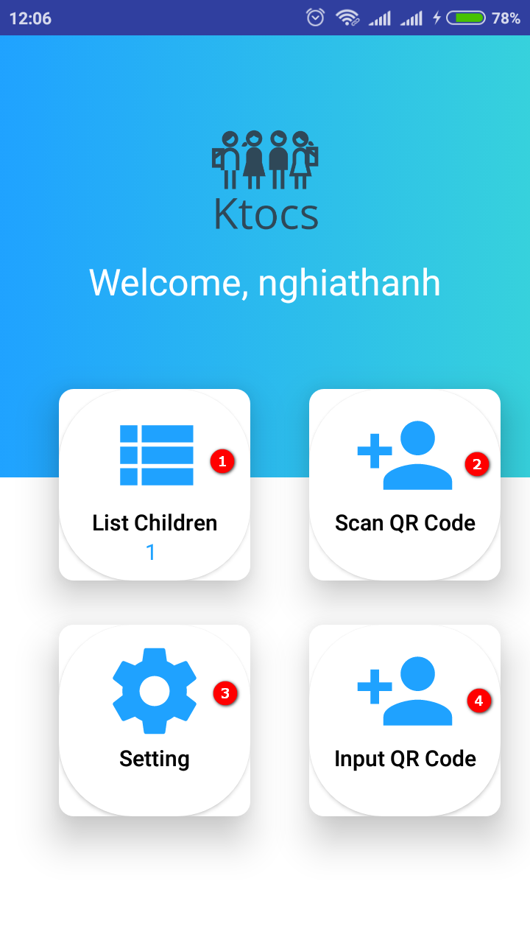

Figure 79 Parent page

**Buttons/Hyperlinks**

|  |  |  |  |  |
| --- | --- | --- | --- | --- |
| **No** | **Function** | **Description** | **Validation** | **Outcome** |
| 1 | View list children | View all list children | N/A | Navigate to list children page |
| 2 | Scan QR code | Scan QR code to add new children | N/A | Show scan screen |
| 3 | Setting | Setting information of parent | N/A | Navigate to list settings page |
| 4 | Input QR code | Add new children, don’t need scan QR code | N/A | Navigate to add children page |

#### 5.1.5 Setting page

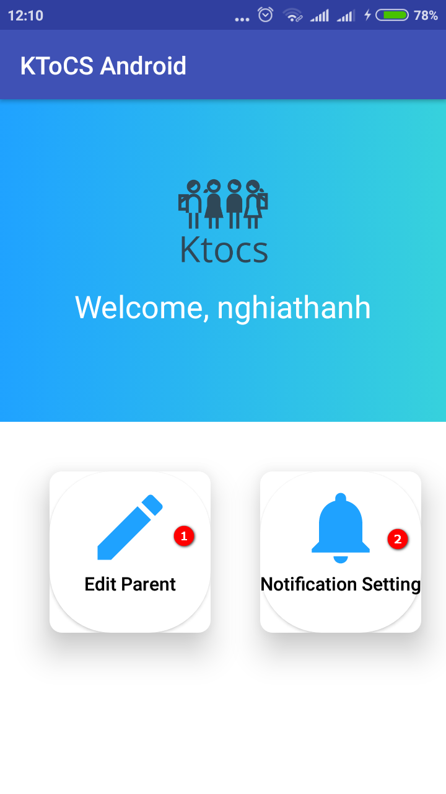

Figure 80 Setting page

**Buttons/Hyperlinks**

|  |  |  |  |  |
| --- | --- | --- | --- | --- |
| **No** | **Function** | **Description** | **Validation** | **Outcome** |
| 1 | Edit parent | Edit parent’s information | N/A | Navigate to update parent page |
| 2 | Notification | Setting notify when children out of trusted location and no internet | N/A | Navigate to notification page |

#### 5.1.6 Notification setting page

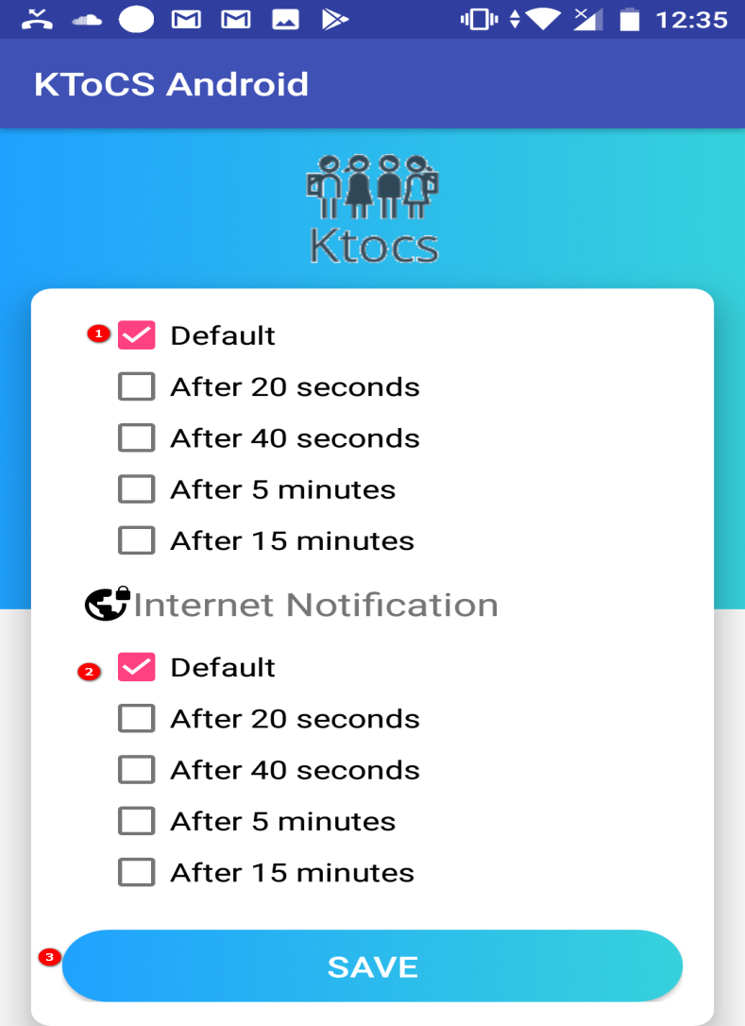

Figure 81 Notification setting page

**Fields**

|  |  |  |  |  |  |  |  |
| --- | --- | --- | --- | --- | --- | --- | --- |
| **No** | **Field Name** | **Description** | **Read Only** | **Mandatory** | **Control Type** | **Data Type** | **Length** |
| 1 | Time to notification | Time to notify when out of trusted location | No | Yes | Check box | N/A | N/A |
| 1 | Time to notification | Time to notify when no internet | No | Yes | Check box | N/A | N/A |

**Buttons/Hyperlinks**

|  |  |  |  |  |
| --- | --- | --- | --- | --- |
| **No** | **Function** | **Description** | **Validation** | **Outcome** |
| 3 | Save | Save internet notification and out trusted location notification has been chosen | N/A | Show message save successful |

#### 5.1.7 Edit information of parent page

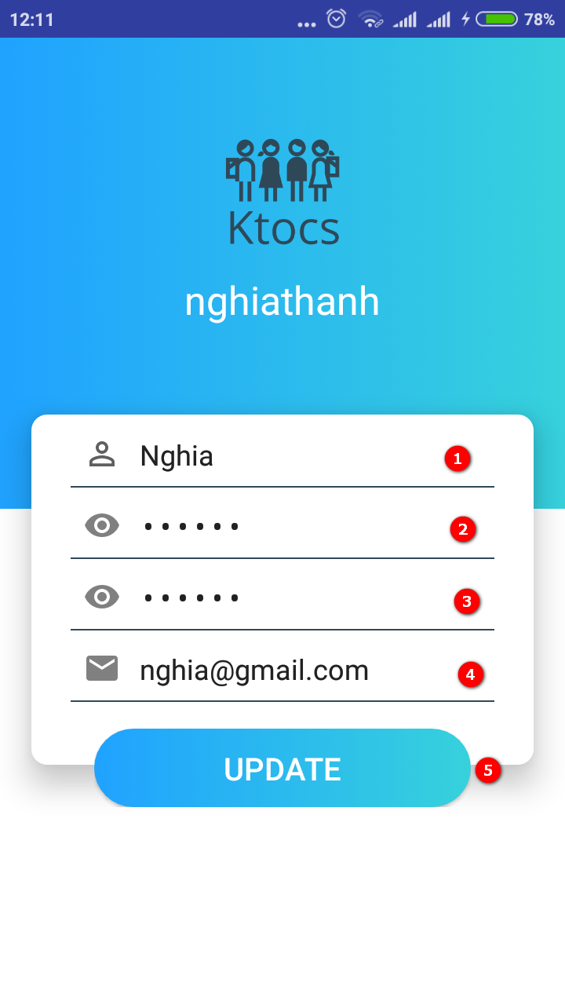

Figure 82 Edit information of parent page

**Fields**

|  |  |  |  |  |  |  |  |
| --- | --- | --- | --- | --- | --- | --- | --- |
| **No** | **Field Name** | **Description** | **Read Only** | **Mandatory** | **Control Type** | **Data Type** | **Length** |
| 1 | Fullname text | Fill in to update | No | Yes | Text box | String | 6-20 |
| 2 | Password text | Fill in to update | No | Yes | Text box | String | 6-20 |
| 3 | RePassword text | Fill in to update | No | Yes | Text box | String | 6-20 |
| 4 | Email text | Fill in to update | No | Yes | Text box | String | N/A |

**Buttons/Hyperlinks**

|  |  |  |  |  |
| --- | --- | --- | --- | --- |
| **No** | **Function** | **Description** | **Validation** | **Outcome** |
| 5 | Update | Save parent’s information updated | N/A | Navigate to parent page and show message “Upadate successful” |

#### 5.1.8 Add new children page

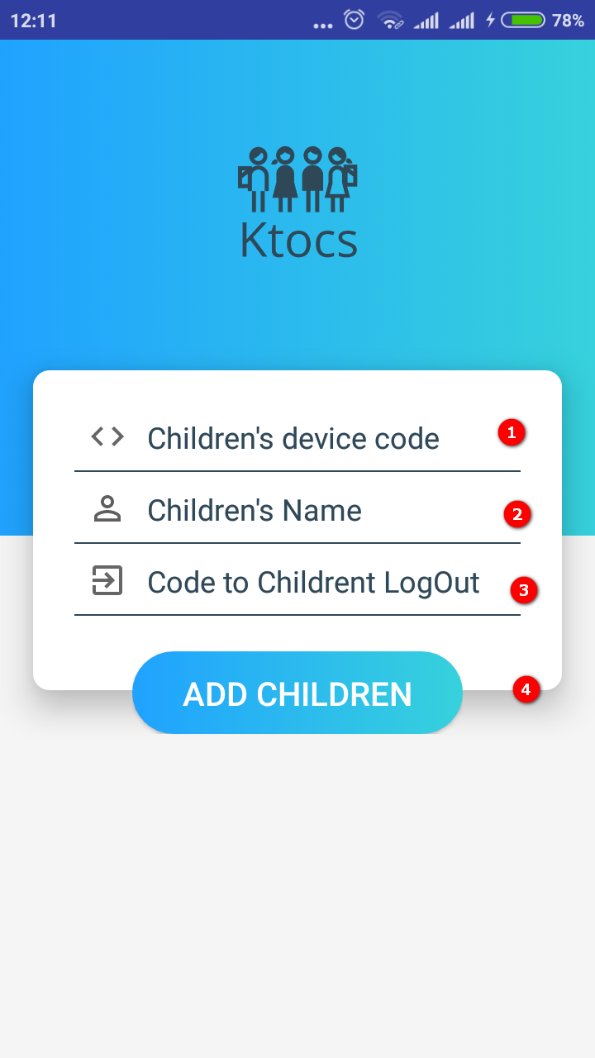

Figure 83 Add new children page

**Fields**

|  |  |  |  |  |  |  |  |
| --- | --- | --- | --- | --- | --- | --- | --- |
| **No** | **Field Name** | **Description** | **Read Only** | **Mandatory** | **Control Type** | **Data Type** | **Length** |
| 1 | Device’s code | Fill in to add | No | Yes | Text box | String | N/A |
| 2 | Children’s name | Fill in to add | No | Yes | Text box | String | 6-20 |
| 3 | Code to exit | Fill in to add | No | Yes | Text box | String | 6-20 |

**Buttons/Hyperlinks**

|  |  |  |  |  |
| --- | --- | --- | --- | --- |
| **No** | **Function** | **Description** | **Validation** | **Outcome** |
| 4 | Add children | Save children’s information added | N/A | Navigate to parent page and show message “Waiting for approve from children” |

#### 5.1.9 View list children page

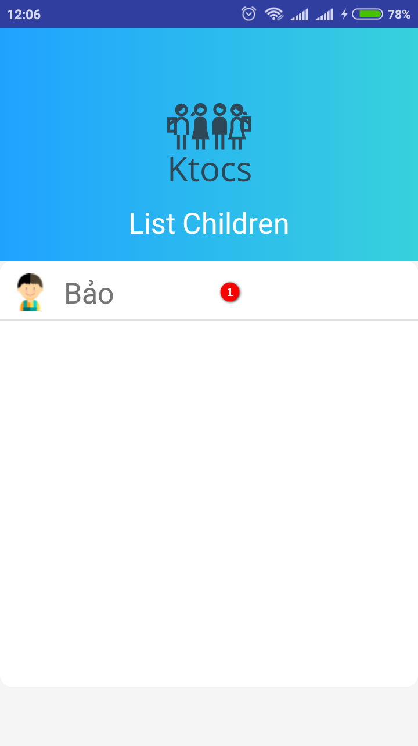

Figure 84 View list children page

**Fields**

|  |  |  |  |  |  |  |  |
| --- | --- | --- | --- | --- | --- | --- | --- |
| **No** | **Field Name** | **Description** | **Read Only** | **Mandatory** | **Control Type** | **Data Type** | **Length** |
| 1 | List | Show list childrens | Yes | Yes | List | List Items | N/A |

#### 5.1. 10 Edit children page

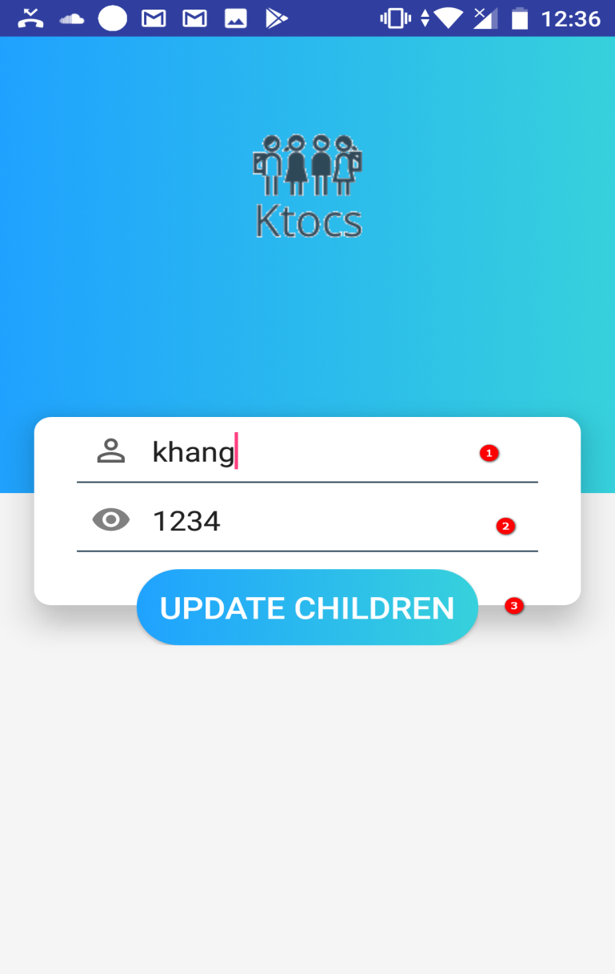

Figure 85 Edit children page

**Fields**

|  |  |  |  |  |  |  |  |
| --- | --- | --- | --- | --- | --- | --- | --- |
| **No** | **Field Name** | **Description** | **Read Only** | **Mandatory** | **Control Type** | **Data Type** | **Length** |
| 1 | Children’s name | Fill in to add | No | Yes | Text box | String | 6-20 |
| 2 | Code to exit | Fill in to add | No | Yes | Text box | String | 6-20 |

**Buttons/Hyperlinks**

|  |  |  |  |  |
| --- | --- | --- | --- | --- |
| **No** | **Function** | **Description** | **Validation** | **Outcome** |
| 3 | Update children | Save children’s information edited | N/A | Navigate to option page and show message “update is successful” |

#### 5.1.11 Children page

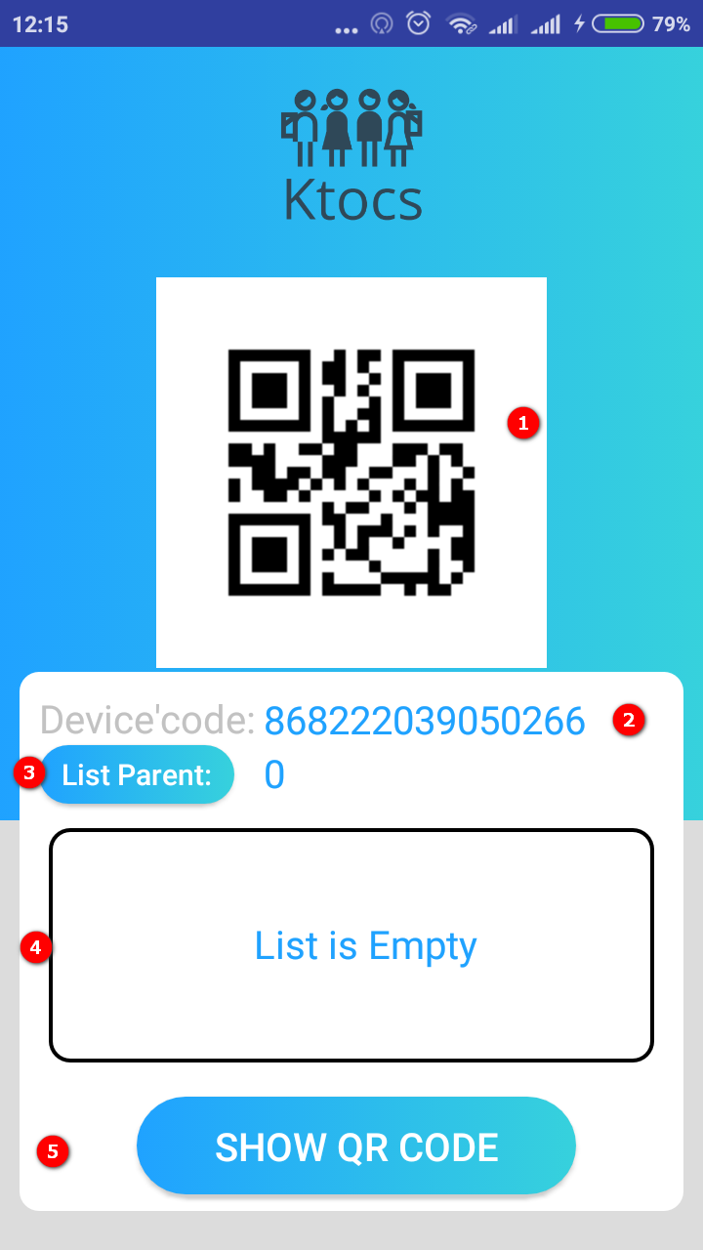

Figure 86 Children page

**Fields**

|  |  |  |  |  |  |  |  |
| --- | --- | --- | --- | --- | --- | --- | --- |
| **No** | **Field Name** | **Description** | **Read Only** | **Mandatory** | **Control Type** | **Data Type** | **Length** |
| 1 | Image | Show QR code from Imeinumber in children’ phone | No | Yes | Image View | N/A | N/A |
| 2 | Textview | Show device’s code | Yes | No | Text view | String | N/A |
| 4 | List | Show list parent managing children | Yes | Yes | List | List Items | N/A |

**Buttons/Hyperlinks**

|  |  |  |  |  |
| --- | --- | --- | --- | --- |
| **No** | **Function** | **Description** | **Validation** | **Outcome** |
| 3 | Show list parent | Show list parent managing chindren | N/A | Show list parent managing children if has and show text “list is empty” if no |
| 5 | Show QR code | Show QR code to parent add children when scan Qr code | N/A | Show image QR code |

#### 5.1.12 Option page

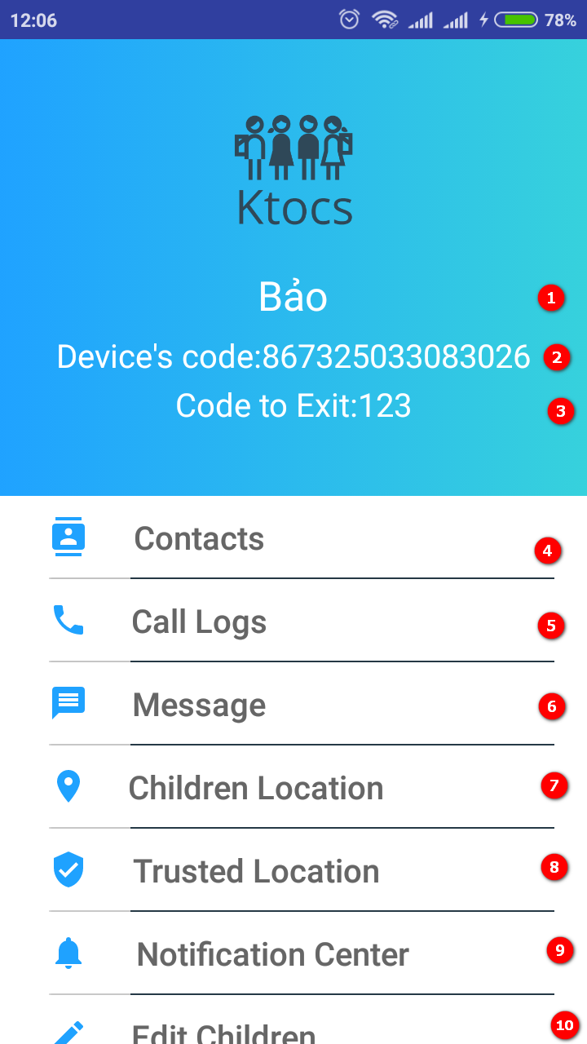

Figure 87 Option page

**Fields**

|  |  |  |  |  |  |  |  |
| --- | --- | --- | --- | --- | --- | --- | --- |
| **No** | **Field Name** | **Description** | **Read Only** | **Mandatory** | **Control Type** | **Data Type** | **Length** |
| 1 | Children’s name | View name of children | Yes | Yes | Textview | String | N/A |
| 2 | Device’s code on children’s phone | View device’s code | Yes | Yes | Textview | String | N/A |
| 3 | Code to exit for children | View code to exit | Yes | Yes | Textview | String | N/A |

**Buttons/ Hyperlinks**

|  |  |  |  |  |
| --- | --- | --- | --- | --- |
| **No** | **Function** | **Description** | **Validation** | **Outcome** |
| 4 | View contacts | Get all contacts on children’s phone | N/A | Navigate contacts page |
| 5 | View Call logs | Get all call logs in children’s phone | N/A | Navigate to view call logs page |
| 6 | View message | Get all message in children’s phone | N/A | Navigate to message page |
| 7 | Children locations | Determined current location of children’s phone | N/A | Navigate to map page |
| 8 | Trusted location | View trusted location of children | N/A | Naviagte to trusted location page |
| 9 | Notification center | View all notify when children’phone out of trusted location or no internet or unknown number phone | N/A | Navigate to notification center page |
| 10 | Edit children | Edit information of children | N/A | Navigate to edit children page |

#### 5.1.13 View Conacts page

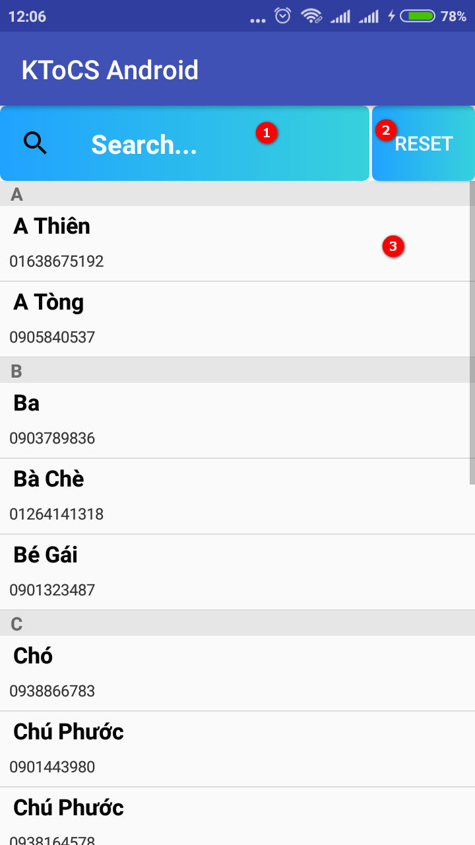

Figure 88 View Conacts page

**Fields**

|  |  |  |  |  |  |  |  |
| --- | --- | --- | --- | --- | --- | --- | --- |
| **No** | **Field Name** | **Description** | **Read Only** | **Mandatory** | **Control Type** | **Data Type** | **Length** |
| 3 | List | List contacts in children’s phone | Yes | Yes | List | List Items | N/A |

**Buttons/ Hyperlinks**

|  |  |  |  |  |
| --- | --- | --- | --- | --- |
| **No** | **Function** | **Description** | **Validation** | **Outcome** |
| 1 | Search contacts | Search contacts | N/A | Appear popup to search |
| 2 | Reset contacts page | Reset contacts page to update new contacts | N/A | Update all contatcs |

#### 5.1.14 View detail phone number in contacts

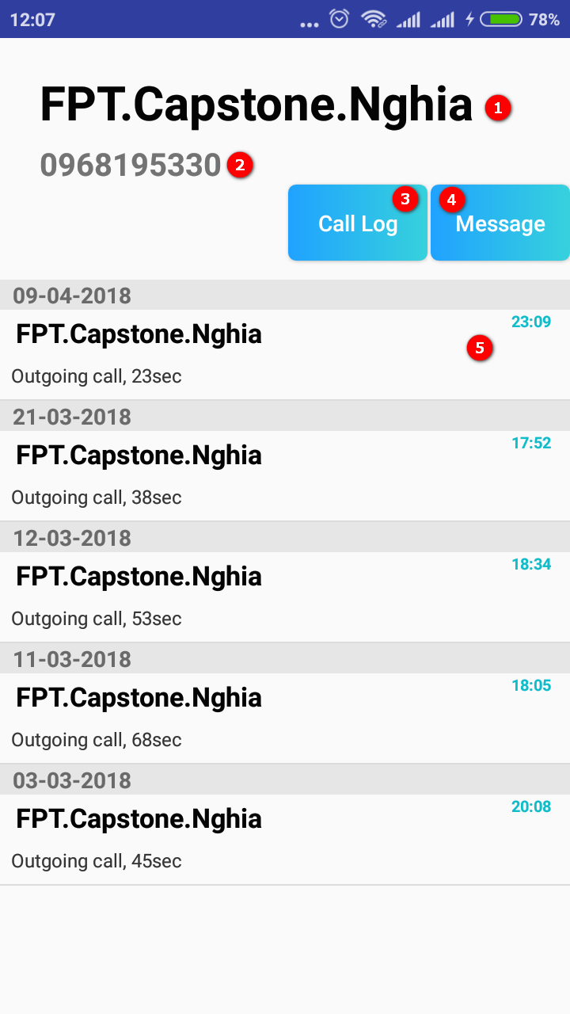

Figure 89 View detail phone number in contacts

**Fields**

|  |  |  |  |  |  |  |  |
| --- | --- | --- | --- | --- | --- | --- | --- |
| **No** | **Field Name** | **Description** | **Read Only** | **Mandatory** | **Control Type** | **Data Type** | **Length** |
| 1 | Name in contacts | Name of phone number | Yes | Yes | Text view | String | N/A |
| 2 | Phone number | Phone number in contacts | Yes | Yes | Text view | String | N/A |
| 5 | List history of phone number | Show list history of this phone | Yes | Yes | List Items | String | N/A |

**Buttons/ Hyperlinks**

|  |  |  |  |  |
| --- | --- | --- | --- | --- |
| **No** | **Function** | **Description** | **Validation** | **Outcome** |
| 3 | Search call logs | Search all call logs of this phone number | N/A | Show result of search |
| 4 | Search message | Search all message of this phone number | N/A | Show result of search |

#### 5.1.15 View Call Logs

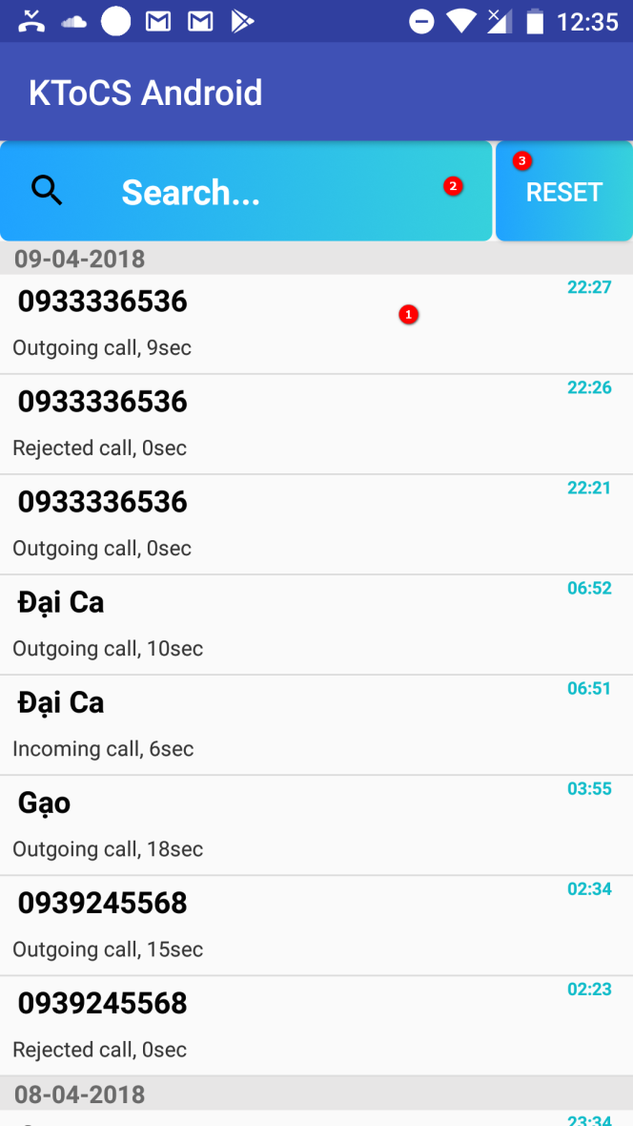

Figure 90 View call logs page

**Fields**

|  |  |  |  |  |  |  |  |
| --- | --- | --- | --- | --- | --- | --- | --- |
| **No** | **Field Name** | **Description** | **Read Only** | **Mandatory** | **Control Type** | **Data Type** | **Length** |
| 1 | List | List call logs in children’s phone | Yes | Yes | List | List Items | N/A |

**Buttons/ Hyperlinks**

|  |  |  |  |  |
| --- | --- | --- | --- | --- |
| **No** | **Function** | **Description** | **Validation** | **Outcome** |
| 1 | Search call logs | Search call logs | N/A | Appear popup to search |
| 2 | Reset call logs page | Reset message page to update new message | N/A | Update all message |

#### 5.1.16 View Message Logs

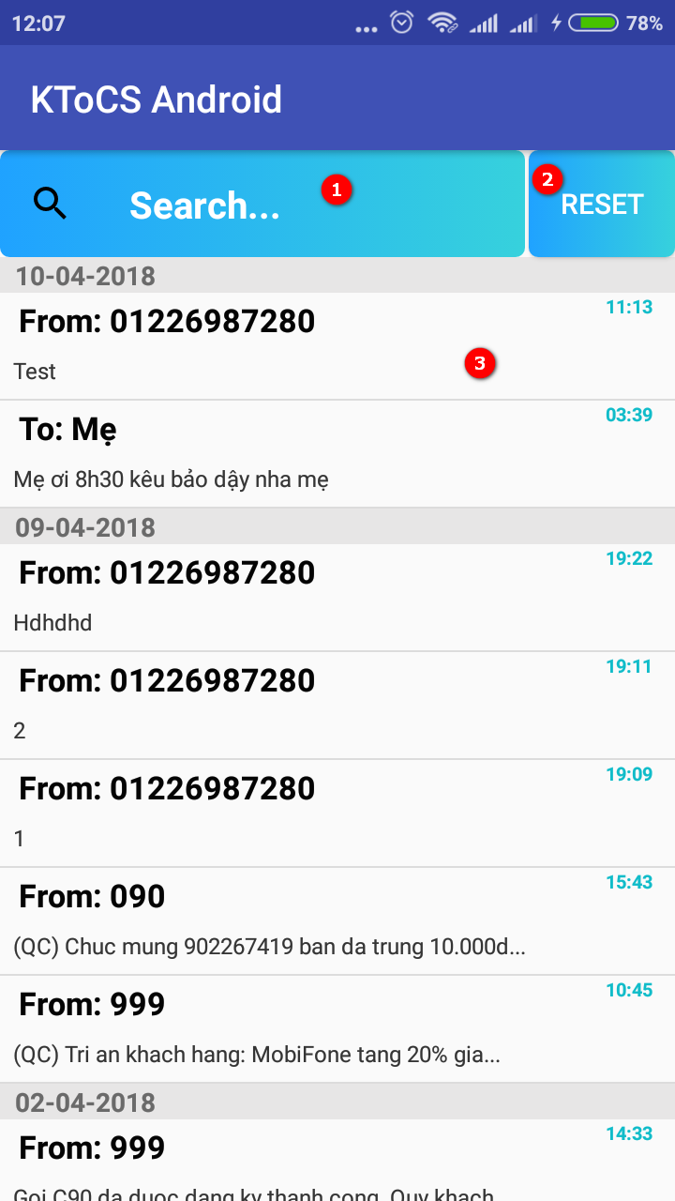

Figure 91 View message logs page

**Fields**

|  |  |  |  |  |  |  |  |
| --- | --- | --- | --- | --- | --- | --- | --- |
| **No** | **Field Name** | **Description** | **Read Only** | **Mandatory** | **Control Type** | **Data Type** | **Length** |
| 3 | List | List message logs in children’s phone | No | Yes | List | List Items | N/A |

**Buttons/ Hyperlinks**

|  |  |  |  |  |
| --- | --- | --- | --- | --- |
| **No** | **Function** | **Description** | **Validation** | **Outcome** |
| 1 | Search message | Search message | N/A | Appear popup to search |
| 2 | Reset message page | Reset message page to update new message | N/A | Update all message |

#### 5.1.17 View Detail message

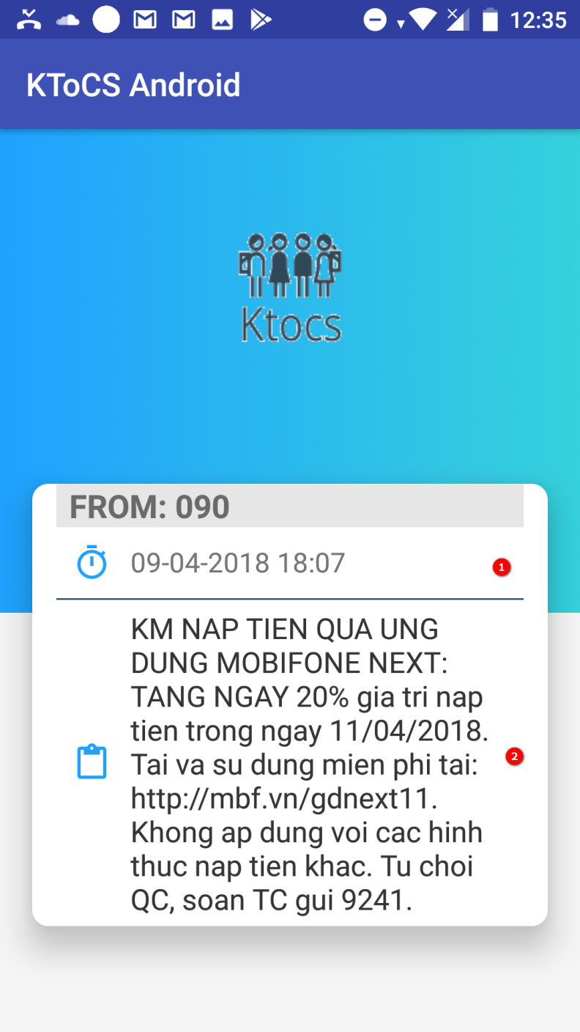

Figure 92 View detail message page

**Fields**

|  |  |  |  |  |  |  |  |
| --- | --- | --- | --- | --- | --- | --- | --- |
| **No** | **Field Name** | **Description** | **Read Only** | **Mandatory** | **Control Type** | **Data Type** | **Length** |
| 1 | Text view | Show time | Yes | Yes | Text view | String | N/A |
| 2 | Text | Show contain message | Yes | Yes | Text | String | N/A |

#### 5.1.18 Search contacts

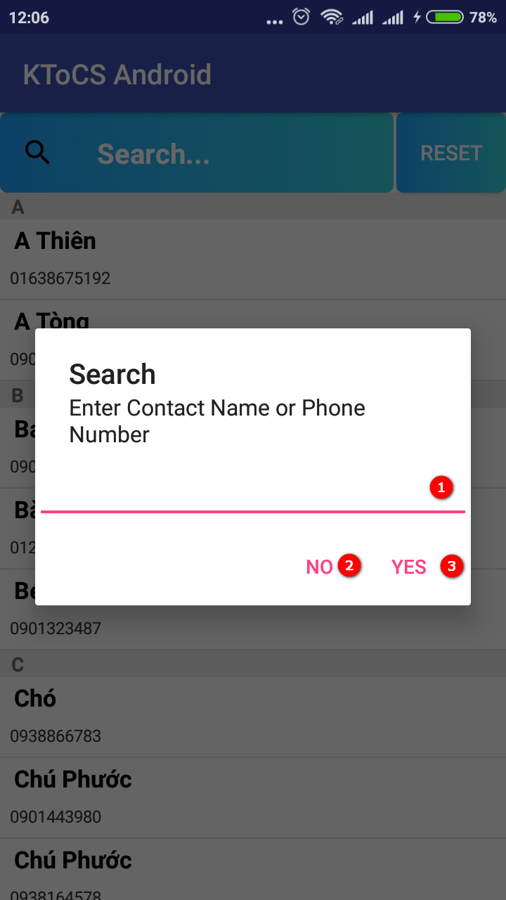

Figure 93 Search contacts

**Fields**

|  |  |  |  |  |  |  |  |
| --- | --- | --- | --- | --- | --- | --- | --- |
| **No** | **Field Name** | **Description** | **Read Only** | **Mandatory** | **Control Type** | **Data Type** | **Length** |
| 1 | Text search | Input contacts or phonenumber to search | No | Yes | Text box | String | N/A |

**Buttons/ Hyperlinks**

|  |  |  |  |  |
| --- | --- | --- | --- | --- |
| **No** | **Function** | **Description** | **Validation** | **Outcome** |
| 2 | Yes | Search contacts or numberphone inputed | N/A | Show result of search |
| 3 | No | Turn off popup | N/A | Turn off popup |

#### 5.1.119 Search call logs

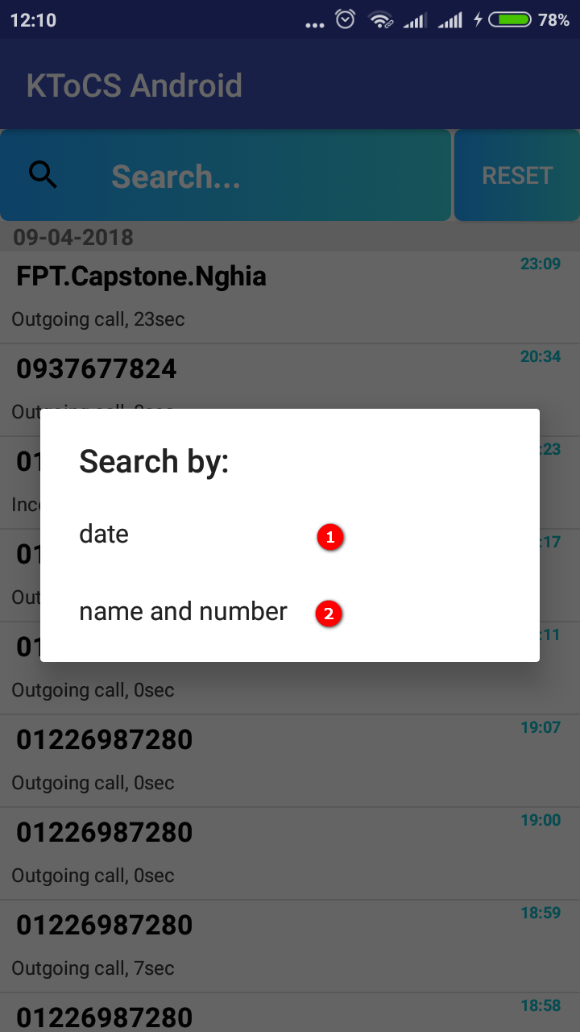

Figure 94 Search call logs

**Buttons/ Hyperlinks**

|  |  |  |  |  |
| --- | --- | --- | --- | --- |
| **No** | **Function** | **Description** | **Validation** | **Outcome** |
| 1 | Search by date | Search call logs by date | N/A | Appear pop up calendar |
| 2 | Search by name and number | Search call logs by name and number | N/A | Appear popup to input search text |

#### 5.1.20 Search call logs by calendar

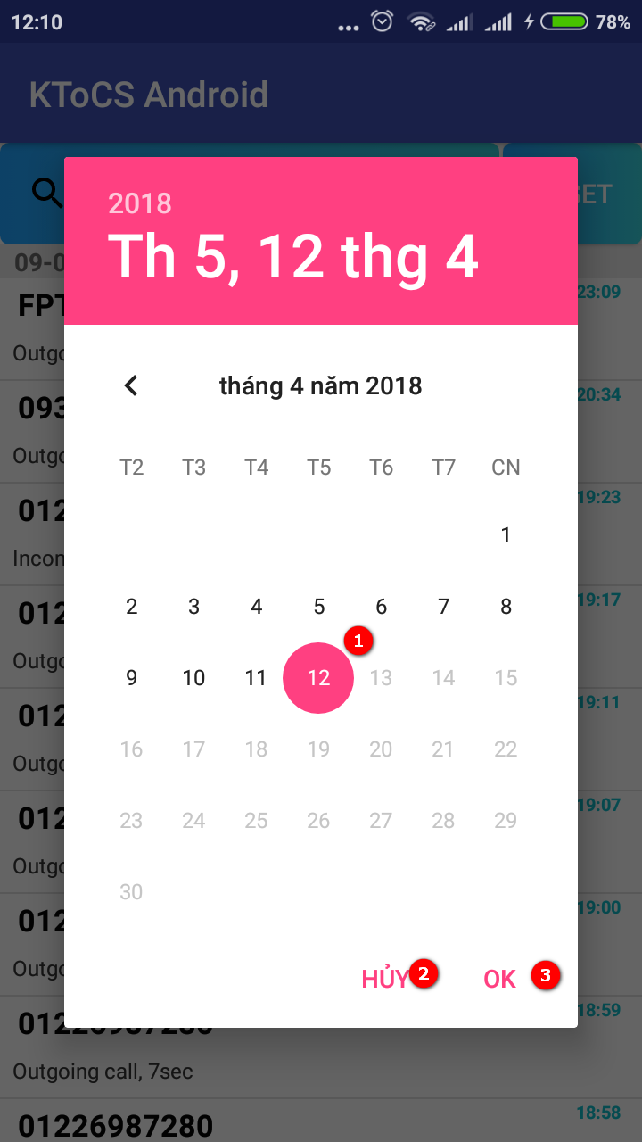

Figure 95 Search call logs by calendar

**Fields**

|  |  |  |  |  |  |  |  |
| --- | --- | --- | --- | --- | --- | --- | --- |
| **No** | **Field Name** | **Description** | **Read Only** | **Mandatory** | **Control Type** | **Data Type** | **Length** |
| 1 | Time to search | Choose time to search call logs | No | Yes | calendar | String | N/A |

**Buttons/ Hyperlinks**

|  |  |  |  |  |
| --- | --- | --- | --- | --- |
| **No** | **Function** | **Description** | **Validation** | **Outcome** |
| 2 | Cancel | Turn off popup | N/A | Turn off popup |
| 3 | Ok | Search time | N/A | Show result of search |

#### 5.1.21 Notification center page

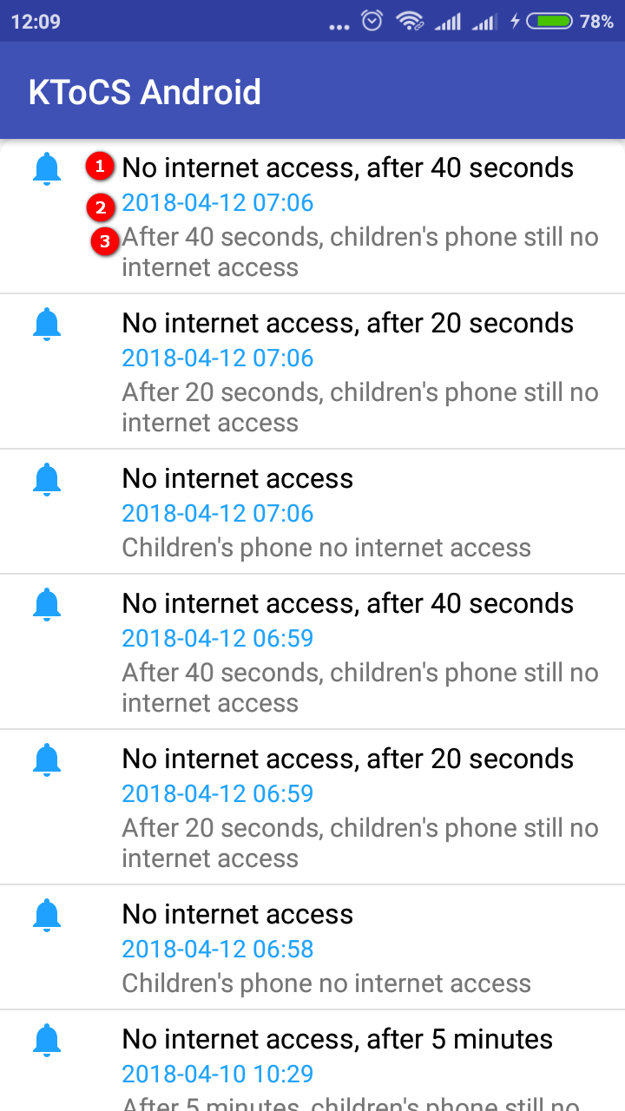

Figure 96 Notification center page

**Fields**

|  |  |  |  |  |  |  |  |
| --- | --- | --- | --- | --- | --- | --- | --- |
| **No** | **Field Name** | **Description** | **Read Only** | **Mandatory** | **Control Type** | **Data Type** | **Length** |
| 1 | Title notify | Show title of notification | Yes | Yes | Text view | String | N/A |
| 2 | Time | Show time of notification | Yes | Yes | Text view | String | N/A |
| 3 | Content notify | Show content of notification | Yes | Yes | Text view | String | N/A |

#### 5.1.22 View detail no internet notification page

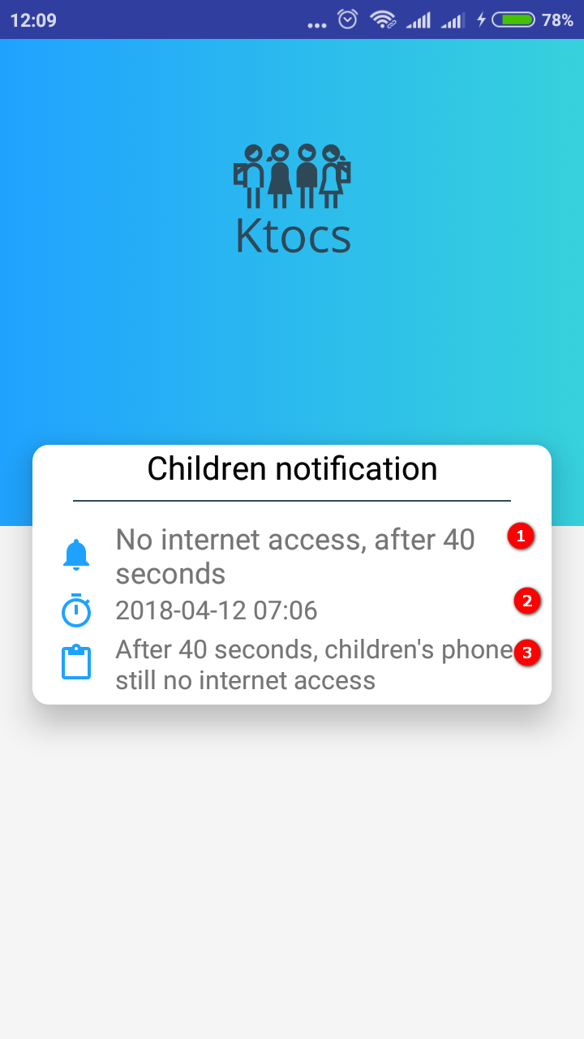

Figure 97 View detail no internet notification page

**Fields**

|  |  |  |  |  |  |  |  |
| --- | --- | --- | --- | --- | --- | --- | --- |
| **No** | **Field Name** | **Description** | **Read Only** | **Mandatory** | **Control Type** | **Data Type** | **Length** |
| 1 | Title notify | Show title of notification | Yes | Yes | Text view | String | N/A |
| 2 | Time | Show time of notification | Yes | Yes | Text view | String | N/A |
| 3 | Content notify | Show content of notification | Yes | Yes | Text view | String | N/A |

#### 5.1.23 View detail out of trusted location notification page

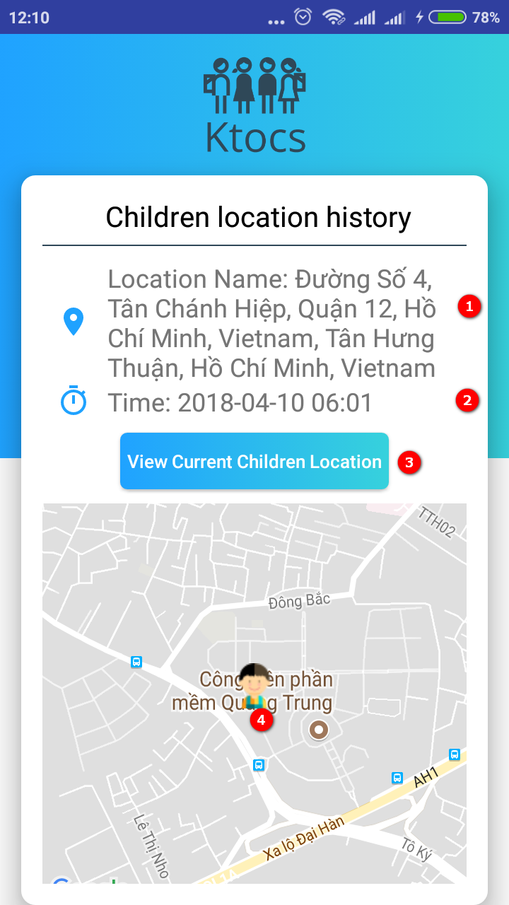

Figure 98 View detail out of trusted location notification page

**Fields**

|  |  |  |  |  |  |  |  |
| --- | --- | --- | --- | --- | --- | --- | --- |
| **No** | **Field Name** | **Description** | **Read Only** | **Mandatory** | **Control Type** | **Data Type** | **Length** |
| 1 | Time | Show time of notification | Yes | Yes | Text view | String | N/A |
| 2 | Content notify | Show content of notification | Yes | Yes | Text view | String | N/A |

**Buttons/Hyperlinks**

|  |  |  |  |  |
| --- | --- | --- | --- | --- |
| **No** | **Function** | **Description** | **Validation** | **Outcome** |
| 3 | View current children’s location | View current children’s location | N/A | Show children’s location on map |

#### 5.2.24 View trusted location page

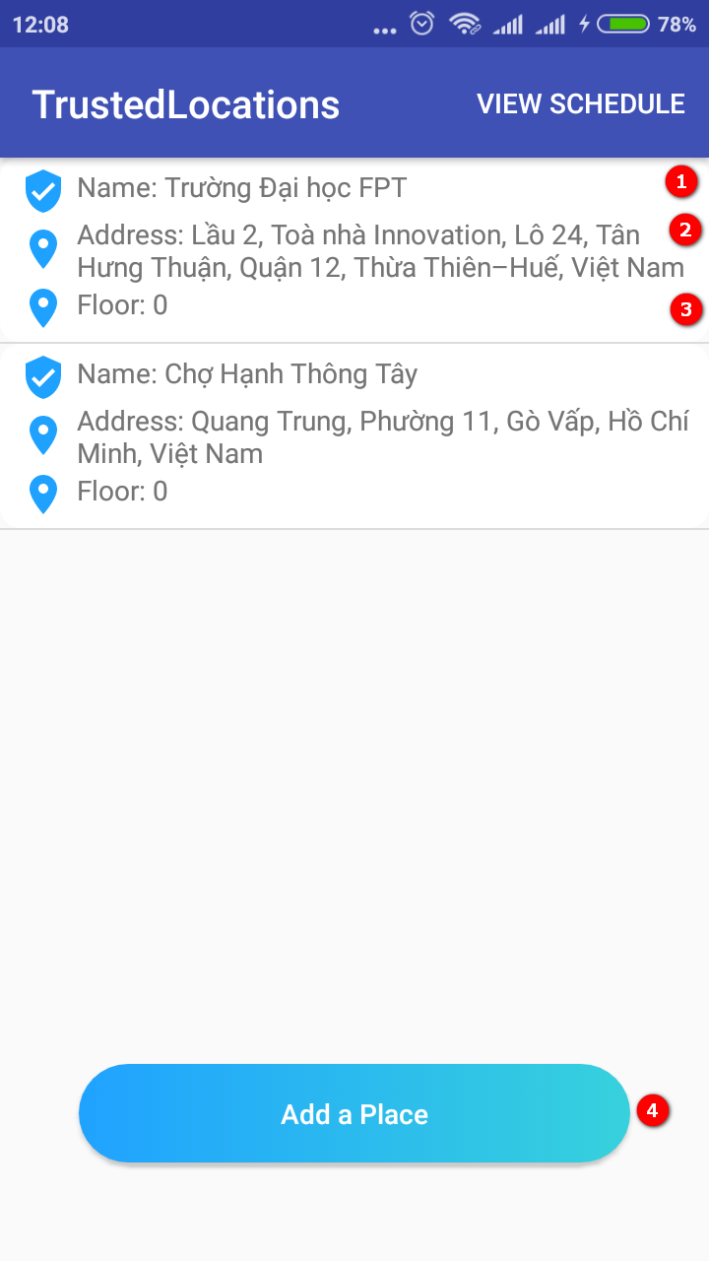

Figure 99 View trusted location page

**Fields**

|  |  |  |  |  |  |  |  |
| --- | --- | --- | --- | --- | --- | --- | --- |
| **No** | **Field Name** | **Description** | **Read Only** | **Mandatory** | **Control Type** | **Data Type** | **Length** |
| 1 | Name | Show name of location | Yes | Yes | Text view | String | N/A |
| 2 | Address | Show address of location | Yes | Yes | Text view | String | N/A |
| 3 | Floor | Show floor of building | Yes | Yes | Text view | String | N/A |

**Buttons/Hyperlinks**

|  |  |  |  |  |
| --- | --- | --- | --- | --- |
| **No** | **Function** | **Description** | **Validation** | **Outcome** |
| 4 | Add a place | Add new place trusted location for children | N/A | Show pop up to add trused location |

#### 5.1.25 Pop up to add a place

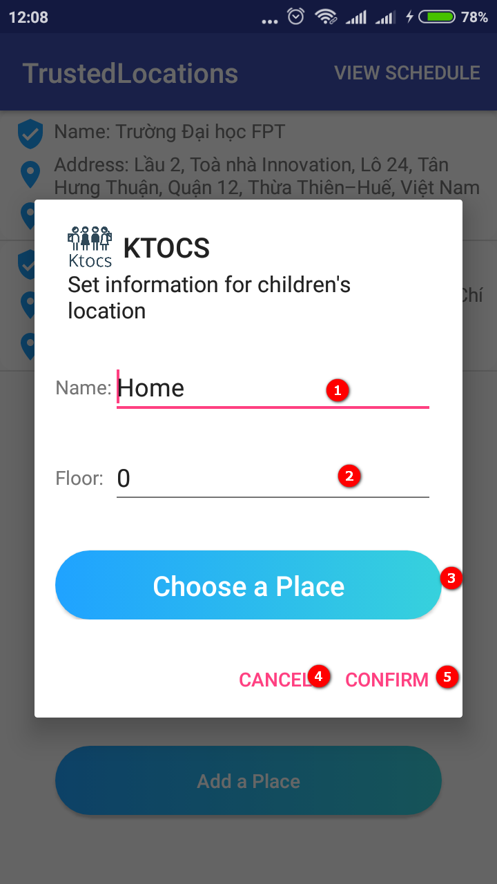

Figure 100 : Pop up to add a place

**Fields**

|  |  |  |  |  |  |  |  |
| --- | --- | --- | --- | --- | --- | --- | --- |
| **No** | **Field Name** | **Description** | **Read Only** | **Mandatory** | **Control Type** | **Data Type** | **Length** |
| 1 | Name | Input name for location | Yes | Yes | Text view | String | N/A |
| 2 | Floor | Input floor | Yes | Yes | Text view | String | N/A |

**Buttons/Hyperlinks**

|  |  |  |  |  |
| --- | --- | --- | --- | --- |
| **No** | **Function** | **Description** | **Validation** | **Outcome** |
| 3 | Choose a place | Choose a place to set trusted location | N/A | Appear map to choose a plcae |
| 4 | Cancel | Cancel to turn off popup | N/A | Turn of pop up |
| 5 | Confirm | Confrim place chosen to set trusted location | N/A | Turn of pop up and show notify “Add trusted location successful” |

#### 5.1.26 Map page to choose a place set trusted location

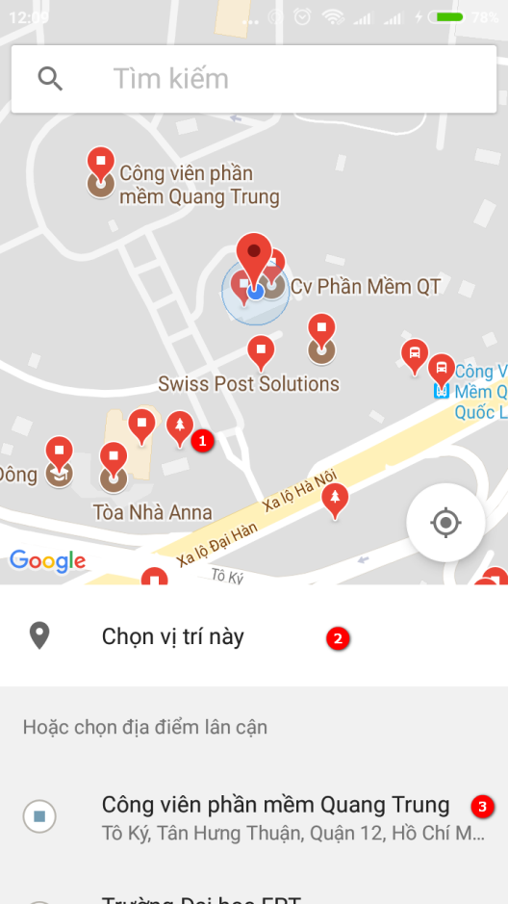

Figure 101 : Map page to choose a place set trusted location

**Fields**

|  |  |  |  |  |  |  |  |
| --- | --- | --- | --- | --- | --- | --- | --- |
| **No** | **Field Name** | **Description** | **Read Only** | **Mandatory** | **Control Type** | **Data Type** | **Length** |
| 1 | Locaions | Show locations in map | No | Yes | N/A | N/A | N/A |
| 2 | Title | View title | Yes | Yes | Text view | String | N/A |

**Buttons/Hyperlinks**

|  |  |  |  |  |
| --- | --- | --- | --- | --- |
| **No** | **Function** | **Description** | **Validation** | **Outcome** |
| 3 | Choose a place | Choose a place to set trusted location | N/A | Appear pop up confirm choose this place |

#### 5.1.27 Pop up place chosen

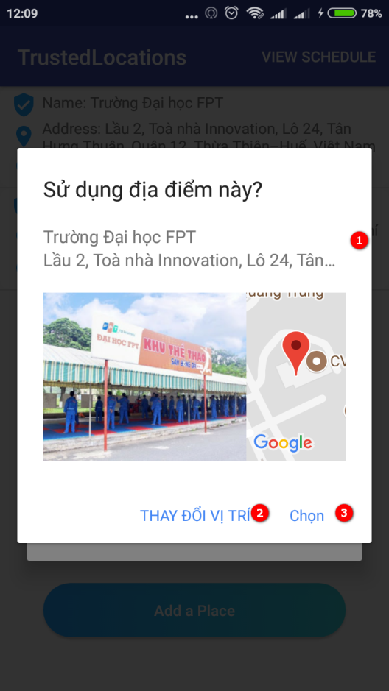

Figure 102: Pop up place chosen

**Fields**

|  |  |  |  |  |  |  |  |
| --- | --- | --- | --- | --- | --- | --- | --- |
| **No** | **Field Name** | **Description** | **Read Only** | **Mandatory** | **Control Type** | **Data Type** | **Length** |
| 2 | Address | Show address of place | Yes | Yes | Text view | String | N/A |

**Buttons/Hyperlinks**

|  |  |  |  |  |
| --- | --- | --- | --- | --- |
| **No** | **Function** | **Description** | **Validation** | **Outcome** |
| 2 | Change location | Change different location | N/A | Appear pop up map to choose |
| 3 | Save | Save this place | N/A | Turn off pop up |

#### 5.1.28 Schedule for trusted location page

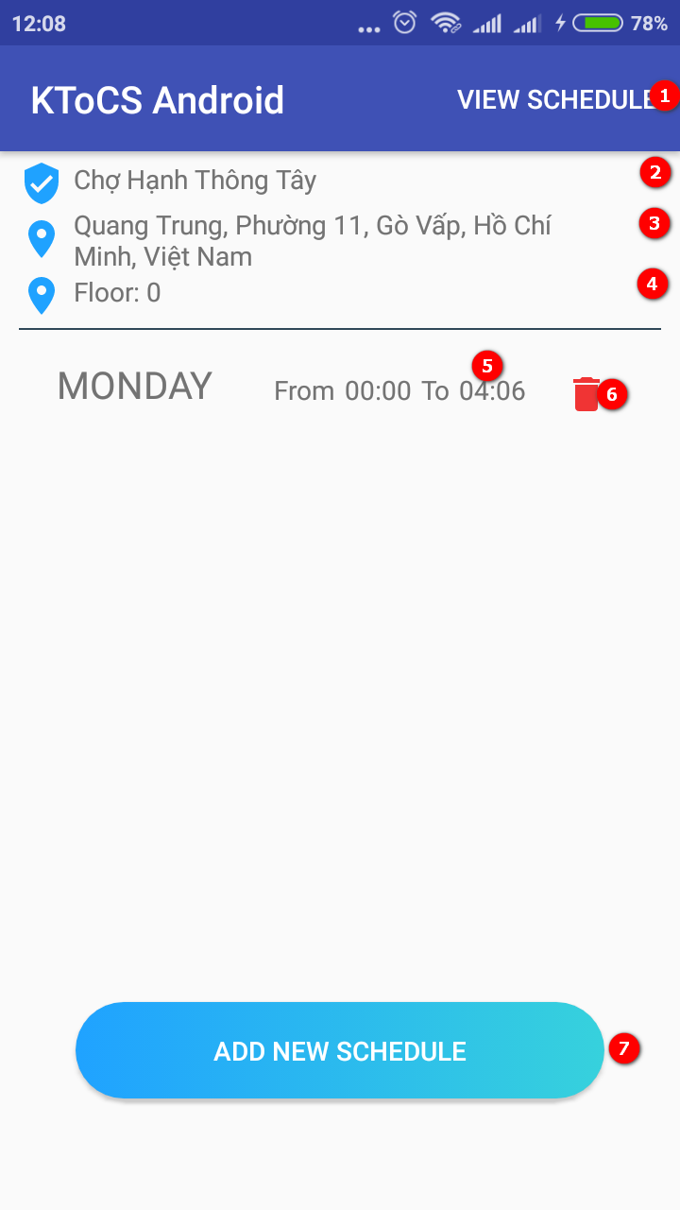

Figure 103: Schedule for trusted location page

**Fields**

|  |  |  |  |  |  |  |  |
| --- | --- | --- | --- | --- | --- | --- | --- |
| **No** | **Field Name** | **Description** | **Read Only** | **Mandatory** | **Control Type** | **Data Type** | **Length** |
| 2 | Name | Show name of location | Yes | Yes | Text view | String | N/A |
| 3 | Address | Show address of location | Yes | Yes | Text view | String | N/A |
| 4 | Floor | Show floor of building | Yes | Yes | Text view | String | N/A |
| 5 | Schedule | Show time and day of trusted location | Yes | Yes | List items | String | N/A |

**Buttons/Hyperlinks**

|  |  |  |  |  |
| --- | --- | --- | --- | --- |
| **No** | **Function** | **Description** | **Validation** | **Outcome** |
| 1 | View schedule | View all schedule of all trusted location | N/A | Navigate view all schedule page |
| 6 | Delete | Delete this schedule | N/A | Appear pop up confirm delete |
| 7 | Add new schedule | Add new schedule for this trusted location | N/A | Navigate schedule page |

#### 5.1.29 Pop up delete a schedule

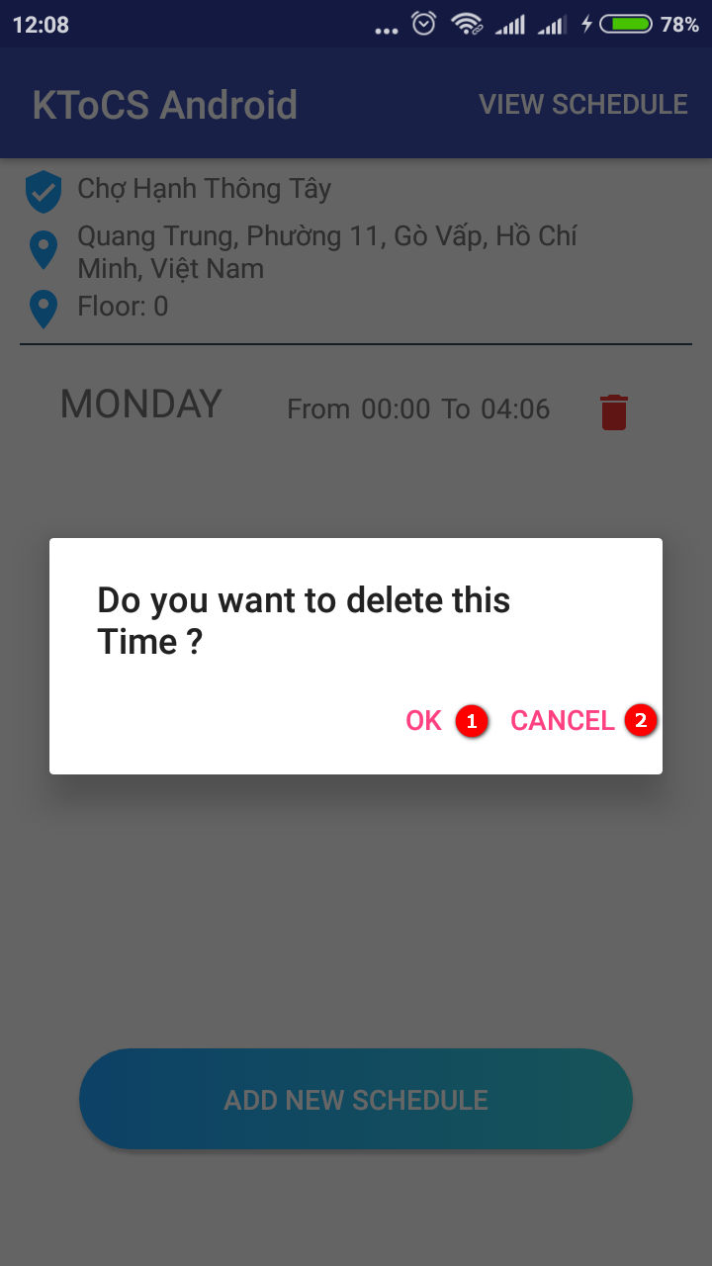

Figure 104: Pop up delete a schedule

**Buttons/Hyperlinks**

|  |  |  |  |  |
| --- | --- | --- | --- | --- |
| **No** | **Function** | **Description** | **Validation** | **Outcome** |
| 1 | Ok | Confirm delete this schedule | N/A | Turn of pop up and show message “delete is successful” |
| 2 | Cancel | Turn of pop up | N/A | Turn off pop up |

#### 5.1.30 View Children location

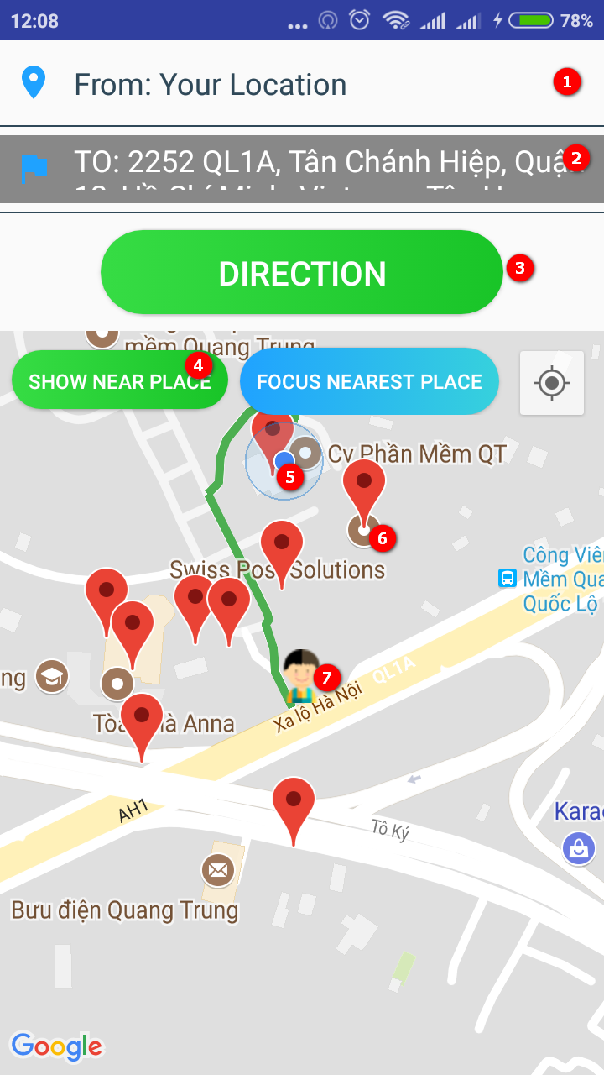

Figure 105: View Children location

**Fields**

|  |  |  |  |  |  |  |  |
| --- | --- | --- | --- | --- | --- | --- | --- |
| **No** | **Field Name** | **Description** | **Read Only** | **Mandatory** | **Control Type** | **Data Type** | **Length** |
| 1 | Text location | Location current of parent | Yes | Yes | Text view | String | N/A |
| 2 | Text location | Location current of children | Yes | Yes | Text view | String | N/A |
| 5 | Parent’ location | Show parent’s location on map | Yes | Yes | N/A | N/A | N/A |
| 6 | Locations is near children’s location | Show all location is near children’s location | No | Yes | N/A | N/A | N/A |
| 7 | Children’s location | Show children’s location on map | No | Yes | N/A | N/A | N/A |

**Buttons/Hyperlinks**

|  |  |  |  |  |
| --- | --- | --- | --- | --- |
| **No** | **Function** | **Description** | **Validation** | **Outcome** |
| 3 | Direction | Find road from parent’s location to children’s location | N/A | Draw road from parent to children |
| 4 | Show near place | Find all near location around children’s location | N/A | Show all location is near children’s location |

## 6. **Database Design**

### 6.1 **Web Service Logical Diagram**

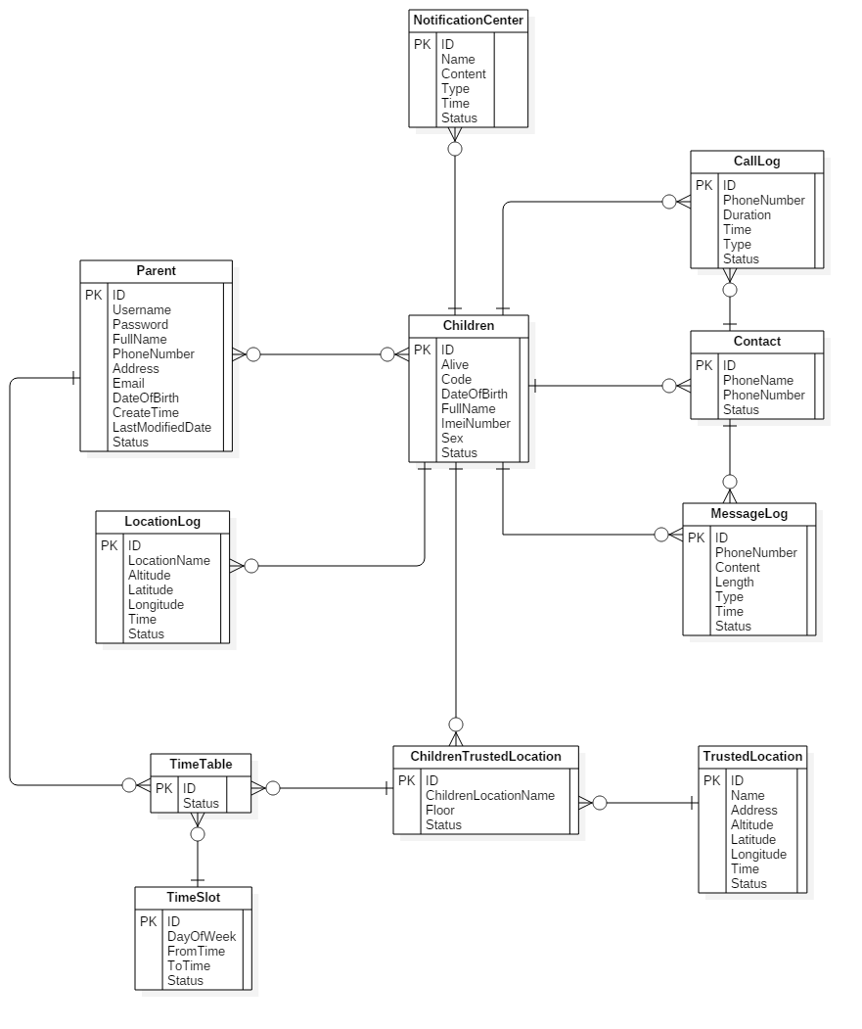Figure 106: Logical Diagram

### 6.2. **Web Service Data Dictionary**

|  |  |
| --- | --- |
| **Entity Data dictionary: describe content of all entities** | |
| **Entity Name** | **Description** |
| Parent | Describe all parent in the system |
| Children | Describe all child in the system |
| Notification Center | Describe all notification for mobile application in the system |
| Location Logs | Describe all location logs in the system |
| Contact | Describe all contact in the system |
| Call Logs | Describe all call logs in the system |
| Message Logs | Describe all message logs in the system |
| Trusted Location | Describe all trusted location in the system |
| Children Trusted Location | Describe all children trusted location in the system |
| Time Slot | Describe all time slot in the system |
| Time Table | Describe all time table in the system |

Table 70: Table Web Entity Data Dictionary

|  |  |  |  |  |
| --- | --- | --- | --- | --- |
| **Entity name** | **Attributes** | **Description** | **Domain** | **Null** |
| Parents | ID{PK} | Unique  identifier of  each parent | INTEGER | No |
| Username | Username of parent | VARCHAR(20) | No |
| Password | Password of parent | VARCHAR(40) | No |
| FullName | Name of parent | VARCHAR(MAX) | No |
| DateOfBirth | BirthDay of parent | DATETIME | Yes |
| Sex | Sex of parent | CHAR(1) | Yes |
| Email | Email of parent | VARCHAR(1000) | No |
| PhoneNumber | Phone Number of parent | VARCHAR(12) | Yes |
| CreateTime | Time parent has created | DATETIME | No |
| LastModifiedDate | Time parent has modified | DATETIME | No |
| Status | Status of parent | INTEGER | No |
| Children | ID{PK} | Unique  identifier of  each children | INTEGER | No |
| Alive | Time children’device last connect to server | DATETIME | No |
| Code | Code logout of children | VARCHAR(20) | Yes |
| FullName | Name of child | VARCHAR(MAX) | No |
| Sex | Sex of children | CHAR(1) | No |
| DateOfBirth | Birthday of children | DATETIME | No |
| IMEINumber | IMEI Number of phones children. | VARCHAR(20) | No |
| Status | Status of children | INTEGER | No |
| Notification Center | ID{PK} | Unique  identifier of  notification center | INTEGER | No |
| Name | Title of notification nenter | VARCHAR(MAX) | No |
| Content | Priority of notification center | INTEGER | No |
| Time | Time notification center has created | DATETIME | No |
| Type | Type notification center has created | INTEGER | No |
| Status | Status of notification center | INTEGER | No |
| Location Logs | ID{PK} | Unique  identifier of  location logs | INTEGER | No |
| LocationName | Location Name of location logs | VARCHAR(MAX) | Yes |
| Altitude | Altitude of location logs | VARCHAR(200) | No |
| Latitude | Latitude of location logs | VARCHAR(200) | No |
| Longitude | Longitude of location logs | VARCHAR(200) | No |
| Time | Time of location logs | DATETIME | No |
| Status | Status of notification center | INTEGER | No |
| Contact | ID{PK} | Unique  identifier of  contact | INTEGER | No |
| PhoneNumber | Phone Number of contact | VARCHAR(12) | No |
| PhoneName | Phone Name of contact | VARCHAR(MAX) | No |
| Status | Status of contact | INTEGER | No |
| Call Logs | ID{PK} | Unique  identifier of  call logs | INTEGER | No |
| PhoneNumber | Phone Number of call logs | VARCHAR(12) | No |
| Duration | Duration of call logs | INTEGER | No |
| Type | Type of call logs | INTEGER | No |
| Time | Time call logs has created | DATETIME | No |
| Status | Status of call logs | INTEGER | No |
| Message Logs | ID{PK} | Unique  identifier of  message logs | INTEGER | No |
| PhoneNumber | Phone Number of message logs | VARCHAR(12) | No |
| Content | Content of message logs | VARCHAR(MAX) | No |
| Type | Type of message logs | INTEGER | No |
| Time | Time message logs has created | DATETIME | No |
| Status | Status of message logs | INTEGER | No |

|  |  |  |  |  |
| --- | --- | --- | --- | --- |
| Trusted Location | ID{PK} | Unique  identifier of  trusted location | VARCHAR(255) | No |
| Name | Location Name of trusted location | VARCHAR(MAX) | No |
| Address | Address of trusted location | VARCHAR(3000) | No |
| Altitude | Altitude of trusted location | VARCHAR(250) | No |
| Latitude | Latitude of trusted location | VARCHAR(250) | No |
| Longitude | Longitude of trusted location | VARCHAR(250) | No |
| Time | Time trusted location has created | DATETIME | No |
| Status | Status of trusted location | INTEGER | No |
| Children Trusted Location | ID{PK} | Unique  identifier of  Children Trusted Location | INTEGER | No |
| ChildrenLocationName | Location Name of children trusted location | VARCHAR(255) | No |
| Floor | Floor of children trusted location | INTEGER | No |
| Status | Status of children trusted location | INTEGER | No |
| Time Table | ID{PK} | Unique  identifier of  Time Table | INTEGER | No |
| Status | Status of Time Table | INTEGER | No |
| Time Slot | ID{PK} | Unique  identifier of  Time Slot | INTEGER | No |
| DayOfWeek | Day of Week of  Time Slot | VARCHAR(20) | No |
| FromTime | From Time of Time Slot | VARCHAR(20) | No |
| ToTime | To Time of Time Slot | VARCHAR(20) | No |
| Status | Status of Time Slot | INTEGER | No |

Table 71: Table Detail Web Entity Data Dictionary

## **7.Algorithms**

### **7.1** Notify parent if children move out or move in of trusted location

#### **7.1.1** Definition

Notify parent if children move out or move in of trusted location. Trusted location where children are frequently such as their school, their home or their grandparents’ home.

#### **7.1.2** Define Problem

When children move and determined current location by GPS. system has to calculate whether children move out the trusted location

#### **7.1.3** Solution

To solve this problem, we follow these steps:

* Step 1: Children’s device sync list trusted location with schedule.
  + If list trusted location with schedule is empty, delay 7s and try sync list trusted location again.
  + If list trusted location with schedule not empty, use current time to get current trusted location from list.
* Step 2: For each children change location. Use GPS get latitude and longitude.
  + If latitude and longitude not valid and distance from current children location to current trusted location is -1
  + If latitude and longitude valid, calculate distance from current children location to current trusted location.
* Step 3: Check distance from current children location to current trusted location.
  + If distance > 100, children’s device send notification to server with status = 1( publish)
  + If distance < 0, do no thing.
* Step 4: Parent’s device sync notifications with status = 1(publish) from server.
  + If notifications not empty, notify to parent and update status notification = 2 (seen)
  + If notifications empty, do no thing.

#### **7.1.4 Flow Chart**

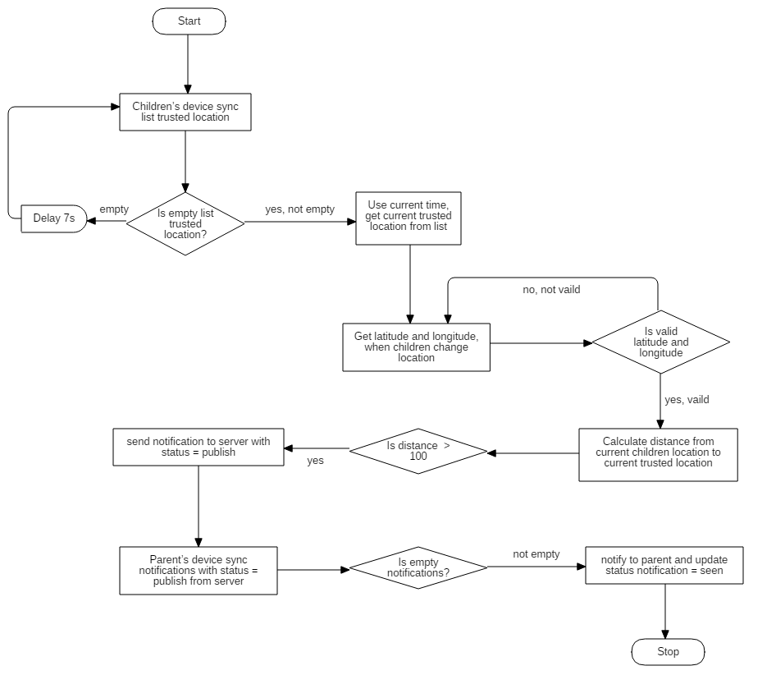

Figure 107: Flow chart

### 7.2 Notify parent if children don’t have internet access

#### **7.2.1 Definition**

Notify parent if children don’t have internet access and internet access back.

#### **7.2.2 Define Problem**

When children turn off 3G/4G internet, WIFI or turn off the phone. Parent’s devices will have notification.

#### **7.2.3 Solution**

To solve this problem, we follow these steps:

* Step 1: For each 7s, Children’s device has connected to server to notify device have internet. Server after receive request from children’s device, update time ( time: is current time on server) in “alive” attribute in children table on database.
* Step 2: For each 7s, Parent’s device has requested to API Server. This API will get current time to server and convert it to long format and get time in alive attribute in children table and convert it to database.
  + Step 2.1: The API Calculate the time period time from current time and alive time.
* Period time = current time on server – alive time in children table
  + If period time > 15, notify to parent: children’s device no internet

#### **7.2.4 Flow chart**

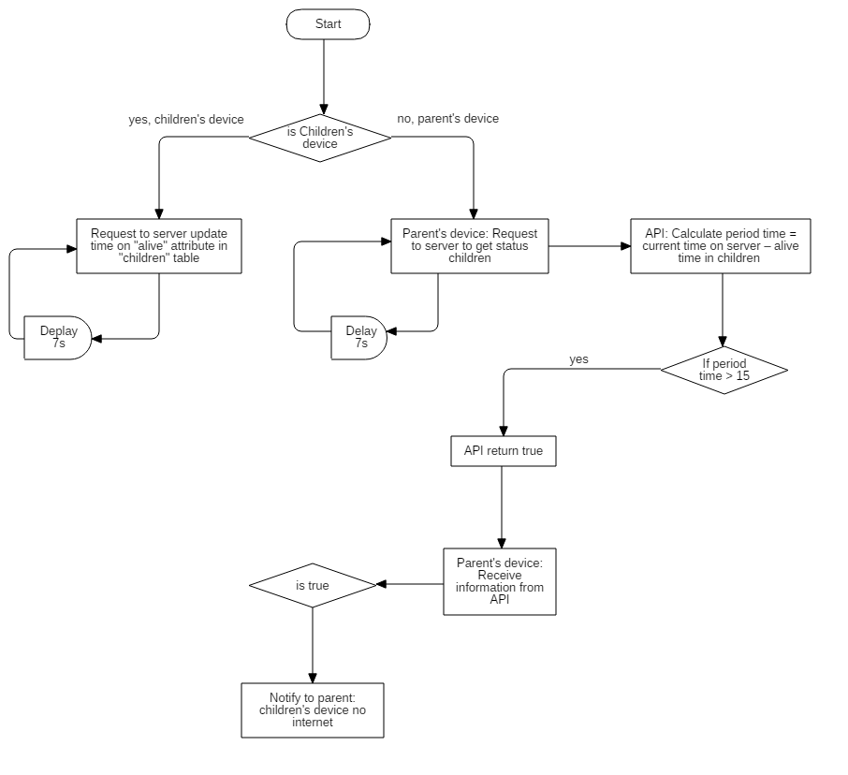

# E. System Implementation & Test

## 1. Introduction

### 1.1 Overview

This section provides in details all necessary information about implementation information and testing procedure of KTOCS includes test plan, test cases, test result and risks estimations.

### 1.2 Test Approach

We use system test approach because to estimate our keeping track of children system quality, tester to aware of what KTOCS should do but does not have the knowledge of how it does it. If tester had knowledge about the technical inside it, testing process won’t be objectivity.

## 2. Database Relationship Diagram

### 2.1 Physical Diagram

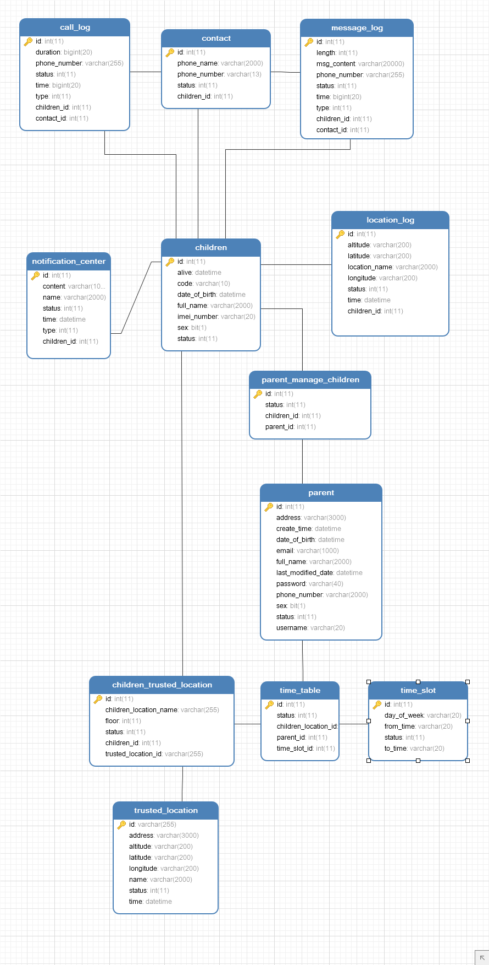

Figure 108: Web Service Physical Diagram

### 2.2 Data Dictionary

|  |  |
| --- | --- |
| **Entity Data dictionary: describe content of all entities** | |
| **Entity Name** | **Description** |
| Parent | Describe all parent in the system |
| Children | Describe all child in the system |
| Parent Manage Children | Describe all parent manage child in the system |
| Notification Center | Describe all notification for mobile application in the system |
| Location Logs | Describe all location logs in the system |
| Contact | Describe all contact in the system |
| Call Logs | Describe all call logs in the system |
| Message Logs | Describe all message logs in the system |
| Trusted Location | Describe all trusted location in the system |
| Children Trusted Location | Describe all children trusted location in the system |
| Time Slot | Describe all time slot in the system |
| Time Table | Describe all time table in the system |

Table 72: Data Dictionary

|  |  |  |  |  |
| --- | --- | --- | --- | --- |
| **Entity name** | **Attributes** | **Description** | **Domain** | **Null** |
| Parents | ID{PK} | Unique  identifier of  each parent | INTEGER | No |
| Username | Username of parent | VARCHAR(20) | No |
| Password | Password of parent | VARCHAR(40) | No |
| FullName | Name of parent | VARCHAR(2000) | No |
| Address | Address of parent | VARCHAR(3000) | Yes |
| DateOfBirth | BirthDay of parent | DATETIME | Yes |
| Sex | Sex of parent | CHAR(1) | Yes |
| Email | Email of parent | VARCHAR(1000) | No |
| PhoneNumber | Phone Number of parent | VARCHAR(12) | Yes |
| CreateTime | Time parent has created | DATETIME | No |
| LastModifiedDate | Time parent has modified | DATETIME | No |
| Status | Status of parent | INTEGER | No |
| Children | ID{PK} | Unique  identifier of  each children | INTEGER | No |
| Alive | Time children’device last connect to server | DATETIME | No |
| Code | Code logout of children | VARCHAR(10) | Yes |
| FullName | Name of child | VARCHAR(2000) | No |
| Sex | Sex of children | CHAR(1) | No |
| DateOfBirth | Birthday of children | DATETIME | No |
| IMEINumber | IMEI Number of phones children. | VARCHAR(20) | No |
| Status | Status of children | INTEGER | No |
| Notification Center | ID{PK} | Unique  identifier of  notification center | INTEGER | No |
| Name | Title of notification nenter | VARCHAR(MAX) | No |
| Content | Priority of notification center | INTEGER | No |
| Time | Time notification center has created | DATETIME | No |
| Type | Type notification center has created | INTEGER | No |
| Status | Status of notification center | INTEGER | No |
| Children ID{FK} | ID of Children | INTEGER | No |
| Location Logs | ID{PK} | Unique  identifier of  location logs | INTEGER | No |
| LocationName | Location Name of location logs | VARCHAR(MAX) | Yes |
| Altitude | Altitude of location logs | VARCHAR(200) | No |
| Latitude | Latitude of location logs | VARCHAR(200) | No |
| Longitude | Longitude of location logs | VARCHAR(200) | No |
| Time | Time of location logs | DATETIME | No |
| Status | Status of notification center | INTEGER | No |
| Children ID{FK} | ID of Children | INTEGER | No |
| Contact | ID{PK} | Unique  identifier of  contact | INTEGER | No |
| PhoneNumber | Phone Number of contact | VARCHAR(255) | No |
| PhoneName | Phone Name of contact | VARCHAR(2000) | No |
| Status | Status of contact | INTEGER | No |
| Contact ID{FK} | ID of Contact | INTEGER | No |
| Children ID{FK} | ID of Children | INTEGER | No |
| Call Logs | ID{PK} | Unique  identifier of  call logs | INTEGER | No |
| PhoneNumber | Phone Number of call logs | VARCHAR(255) | No |
| Duration | Duration of call logs | INTEGER | No |
| Type | Type of call logs | INTEGER | No |
| Time | Time call logs has created | DATETIME | No |
| Status | Status of call logs | INTEGER | No |
| Contact ID{FK} | ID of Contact | INTEGER | No |
| Children ID{FK} | ID of Children | INTEGER | No |
| Message Logs | ID{PK} | Unique  identifier of  message logs | INTEGER | No |
| PhoneNumber | Phone Number of message logs | VARCHAR(12) | No |
| Content | Content of message logs | VARCHAR(MAX) | No |
| Type | Type of message logs | INTEGER | No |
| Time | Time message logs has created | DATETIME | No |
| Status | Status of message logs | INTEGER | No |
| Contact ID{FK} | ID of Contact | INTEGER | No |
| Children ID{FK} | ID of Children | INTEGER | No |
| Trusted Location | ID{PK} | Unique  identifier of  trusted location | VARCHAR(255) | No |
| Name | Location Name of trusted location | VARCHAR(255) | No |
| Address | Address of trusted location | VARCHAR(3000) | No |
| Altitude | Altitude of trusted location | VARCHAR(250) | No |
| Latitude | Latitude of trusted location | VARCHAR(250) | No |
| Longitude | Longitude of trusted location | VARCHAR(250) | No |
| Time | Time trusted location has created | DATETIME | No |
| Status | Status of trusted location | INTEGER | No |
| Children ID{FK} | ID of Children | INTEGER | No |
| Children Trusted Location | ID{PK} | Unique  identifier of  Children Trusted Location | INTEGER | No |
| ChildrenLocationName | Location Name of children trusted location | VARCHAR(255) | No |
| Floor | Floor of children trusted location | INTEGER | No |
| Status | Status of children trusted location | INTEGER | No |
| Children ID{FK} | ID of Children | INTEGER | No |
| Trusted Location ID | ID of Trusted Location ID | VARCHAR(255) | No |
| Time Table | ID{PK} | Unique  identifier of  Time Table | INTEGER | No |
| Status | Status of Time Table | INTEGER | No |
| Children Location ID{FK} | ID of Children Lcoation | INTEGER | No |
| Parent ID{FK} | ID of Parent | INTEGER | No |
| Time Slot ID {FK} | ID of Time Slot ID | INTEGER | No |
| Time Slot | ID{PK} | Unique  identifier of  Time Slot | INTEGER | No |
| DayOfWeek | Day of Week of  Time Slot | VARCHAR(20) | No |
| FromTime | From Time of Time Slot | VARCHAR(20) | No |
| ToTime | To Time of Time Slot | VARCHAR(20) | No |
| Status | Status of Time Slot | INTEGER | No |

Table 73: Attribute data dictionary

### 3. Performance Measures

#### 3.1 Show list result of children’s logs performance

In general, each search, show list take less than 1 second to perform.

#### 3.2 Notification performance

In general, the speed of Notification when children have suspicious action is accurate for less than 3 second.

#### 3.3 Location performance

Locations action would have measurement uncertainty for less than 1 meter.

#### 3.4 Get children’s device data performance

Should be able to get activity of children when network is off and send to server successful when network is availabe

### 4. Test Plan

The purpose of this section is to verify and ensure that KTOCS meets its design specification and other requirements from user. The following part will describe which features to be tested and which is not.

Test plan will only focus on mobile application.

#### 4.1 Features to be tested

- Action for guest

- Action for parent

- Service for children

## 5. System Testing Test Case

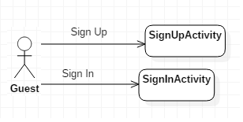

Figure 109: Guest Activity Flow

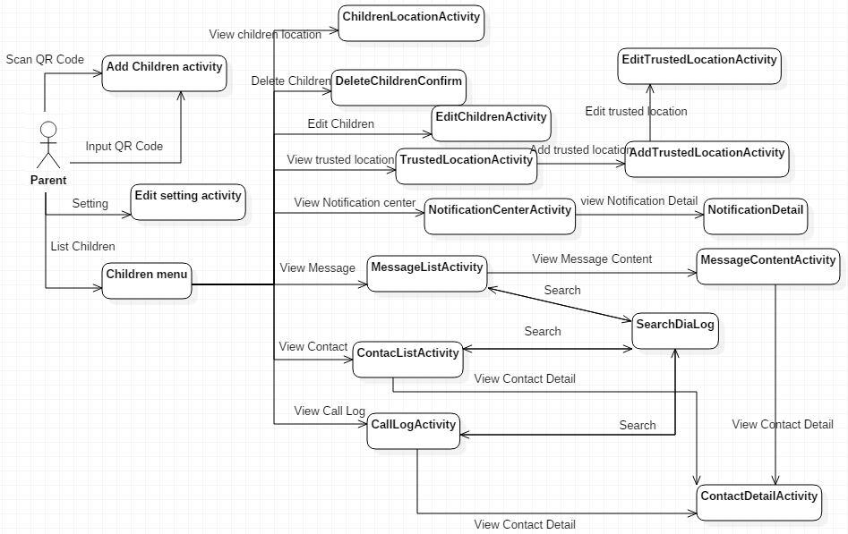

Figure 110: Parent activity flow

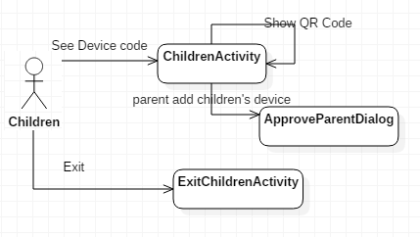

Figure 111: Children activity flow

### 5.1 Android Application Test case:

#### 5.1.1 <Guest> Register

|  |  |  |  |  |  |
| --- | --- | --- | --- | --- | --- |
| **ID** | **Test Case Description** | **Test Case Procedure** | **Expected output** | **Result** | **Test Date** |
| **GR01** | Test guest register new account with valid information | 1. Click “Parent” button  2. Click “Sign up” link  3. Go to register page  4. Enter personal information  - Username: Anhduy  _ Fullname: Nguyễn Anh Duy  - Password: 12346789  - Repassword: 123456789  - Email: [anhduy@gmail.com](mailto:anhduy@gmail.com)  5. Click “Sign up” button | Navigate to Login page and show notify register successful | Pass: 15  Fail: 5 | From 01/04/2018  To  10/04/2018 |
| **GR02** | Test guest register new account with invalid information | 1. Click “Parent” button  2. Click “Sign up” link  3. Go to register page  4. Enter personal information  - Username: Anhduy  _ Fullname: duy  - Password: 1234  - Repassword: 123456  - Email: [duy@11gmail.com](mailto:duy@11gmail.com)  5. Click “Sign up” button | Show error message:  - Username: is existed  _ Fullname: minimum 6 characters  - Password: minimum 6 characters  - Repassword: is not match password  - Email: is not valid format | Pass: 20  Fail: 6 | From 01/04/2018  To  10/04/2018 |

#### 5.1.2 <Parent> Login

|  |  |  |  |  |  |
| --- | --- | --- | --- | --- | --- |
| **ID** | **Test Case Description** | **Test Case Procedure** | **Expected output** | **Result** | **Test Date** |
| **PL01** | Test parent login with right account | 1. Click “Parent” button  2. Enter account:  -Username: Anhduy  -Password: 123456789 | Go to Parent page | Pass: 20  Fail: 7 | From 01/04/2018  To  10/04/2018 |
| **PL02** | Test parent login with wrong account | 1. Click “Parent” button  2. Enter account:  -Username: nhduy  -Password: 123 | Show error message: “Username or password is not valid” | Pass: 20  Fail: 4 | From 01/04/2018  To  10/04/2018 |

#### 5.1.3 <Parent> View list children

|  |  |  |  |  |  |
| --- | --- | --- | --- | --- | --- |
| **ID** | **Test Case Description** | **Test Case Procedure** | **Expected output** | **Result** | **Test Date** |
| **PVLC01** | Test parent click “List Children” with network is available | 1. Click “List children” button | Go to List children page and show list children if has or show text notify “list is empty” if no has | Pass: 20  Fail: 3 | From 01/04/2018  To  10/04/2018 |
| **PVLC02** | Test parent click “List Children” with network is not available | 1. Click “List children” button | Show error message: “Network is not available ” | Pass: 10  Fail: 2 | From 01/04/2018  To  10/04/2018 |

#### 5.1.4 <Parent> Scan QR code

|  |  |  |  |  |  |
| --- | --- | --- | --- | --- | --- |
| **ID** | **Test Case Description** | **Test Case Procedure** | **Expected output** | **Result** | **Test Date** |
| **PSQC01** | Test parent click “Scan QR code” | 1. Click “Scan QR code” button | Appear scan screen | Pass: 20  Fail: 0 | From 01/04/2018  To  10/04/2018 |

#### 5.1.5 <Parent> Input QR code

|  |  |  |  |  |  |
| --- | --- | --- | --- | --- | --- |
| **ID** | **Test Case Description** | **Test Case Procedure** | **Expected output** | **Result** | **Test Date** |
| **PSQC01** | Test parent click “Input QR code” | 1. Click “Input QR code” button | Go to add new children page | Pass: 15  Fail: 0 | From 01/04/2018  To  10/04/2018 |

#### 5.1.6 <Parent> View Trusted location

|  |  |  |  |  |  |
| --- | --- | --- | --- | --- | --- |
| **ID** | **Test Case Description** | **Test Case Procedure** | **Expected output** | **Result** | **Test Date** |
| **PTL01** | Test parent click “Trusted location” button with network is available | 1. Click “Trusted location” button | Go to trusted location page and show list location of children if has. If no has empty page. | Pass: 10  Fail: 0 | From 01/04/2018  To  10/04/2018 |
| **PTL01** | Test parent click “Trusted location” button with network is not available | 1.Click “Trusted location” button | Show notify “Network is not available” | Pass: 5  Fail: 0 | From 01/04/2018  To  10/04/2018 |

#### 5.1.7 <Parent> Add a Place

|  |  |  |  |  |  |
| --- | --- | --- | --- | --- | --- |
| **ID** | **Test Case Description** | **Test Case Procedure** | **Expected output** | **Result** | **Test Date** |
| **PAP01** | Test parent click “Add a place” button | 1. Click “Add a place” button | Show popup to add a new place | Pass: 20  Fail: 0 | From 01/04/2018  To  10/04/2018 |
| **PAP02** | Test parent add a new place with valid information | 1. Click “Add a place” button  2. Enter :  - Name: home  - Floor : 1  3. Click “Choose a place” | Go to map page and select location  When selected location will come back popup add a new place | Pass: 20  Fail: 3 | From 01/04/2018  To  10/04/2018 |
| **PAP03** | Test parent add a new place with valid information | 1. Click “Confirm” | Turn off popup and show place added and show notify “add successful” | Pass: 20  Fail: 5 | From 01/04/2018  To  10/04/2018 |
| **PAP04** | Test parent Click “Confirm” when not click “Choose a place” | 1. Click “Add a place” button  2. Enter :  - Name: home  - Floor : 1  3. Click “Confirm” | Show notify “You need Choose a place before Click Confirm” | Pass: 20  Fail: 2 | From 01/04/2018  To  10/04/2018 |
| **PAP05** | Test parent Click “Cancel” in popup | 1.Click “Cancel” button | Turn off popup | Pass: 20  Fail: 0 | From 01/04/2018  To  10/04/2018 |

#### 5.1.8 <Parent> View Location Schedule

|  |  |  |  |  |  |
| --- | --- | --- | --- | --- | --- |
| **ID** | **Test Case Description** | **Test Case Procedure** | **Expected output** | **Result** | **Test Date** |
| **PWLS01** | Test parent Click “View location Schedule” with network is available | 1. Choose a location in list trusted location | Go to children location schedule page | Pass: 10  Fail: 2 | From 01/04/2018  To  10/04/2018 |
| **PWLS02** | Test parent Click “View location Schedule” with network is not available | 1. Choose a location in list trusted location | Show notify “Network is not available” | Pass: 10  Fail: 0 | From 01/04/2018  To  10/04/2018 |

#### 5.1.9 <Parent>Add Schedule

|  |  |  |  |  |  |
| --- | --- | --- | --- | --- | --- |
| **ID** | **Test Case Description** | **Test Case Procedure** | **Expected output** | **Result** | **Test Date** |
| **PAS01** | Test parent Click “Add Schedule” | 1. Click “Add Schedule” | Go to add new schedule page | Pass: 20  Fail: 5 | From 01/04/2018  To  10/04/2018 |
| **PAS02** | Test parent choose schedule is valid | 1.Roll choose schedule:  - Locations: home  - Week days: Monday  - From time: 12-12  - To time: 20-20  2.Click “Create” | Show notify “create the new schedule successful” | Pass: 30  Fail: 10 | From 01/04/2018  To  10/04/2018 |
| **PAS03** | Test parent choose schedule is duplicate | 1.Roll choose schedule:  - Locations: home  - Week days: Monday  - From time: 12-12  - To time: 20-20  2.Click “Create” | Show notify “Schedule is existed” | Pass: 30  Fail: 15 | From 01/04/2018  To  10/04/2018 |
| **PAS04** | Test parent choose schedule is under 15 minutes | 1.Roll choose schedule:  - Locations: home  - Week days: Monday  - From time: 12-12  - To time: 12-20  2.Click “Create” | Show notify “time has to over 15 minutes” | Pass: 30  Fail: 15 | From 01/04/2018  To  10/04/2018 |

#### 5.1.10 <Parent>Delete Trusted Location

|  |  |  |  |  |  |
| --- | --- | --- | --- | --- | --- |
| **ID** | **Test Case Description** | **Test Case Procedure** | **Expected output** | **Result** | **Test Date** |
| **PDTL01** | Test parent Click “Delete” trusted location | 1. Click keep a trusted location | Appear popup ask “Do you want delete this trusted location” | Pass: 20  Fail: 5 | From 01/04/2018  To  10/04/2018 |
| **PDTL02** | Test parent Click “Delete” trusted location with network is available | 1.Click “Delete” button | Show notify “delete trusted location successful” | Pass: 20  Fail: 5 | From 01/04/2018  To  10/04/2018 |
| **PDTL03** | Test parent Click “Delete” trusted location with network is not available | 1.Click “Delete” button | Show notify “Network is not available” | Pass: 20  Fail: 5 | From 01/04/2018  To  10/04/2018 |
| **PDTL04** | Test parent Click “cancel” | 1.Click “Cancel” button | Turn of pop up | Pass: 20  Fail: 0 | From 01/04/2018  To  10/04/2018 |

#### 5.1.11 <Parent>Delete Schedule

|  |  |  |  |  |  |
| --- | --- | --- | --- | --- | --- |
| **ID** | **Test Case Description** | **Test Case Procedure** | **Expected output** | **Result** | **Test Date** |
| **PDS01** | Test parent Click “Delete” schedule | 1. Choose a schedule and click | Appear popup ask “Do you want delete this schedule” | Pass: 20  Fail: 5 | From 01/04/2018  To  10/04/2018 |
| **PDS02** | Test parent Click “Delete” schedule with network is available | 1. Choose a schedule and click | Show notify “delete Schedule successful” | Pass: 20  Fail: 5 | From 01/04/2018  To  10/04/2018 |
| **PDS03** | Test parent Click “Delete” schedule | 11. Choose a schedule and click | Show notify “Network is not available” | Pass: 20  Fail: 5 | From 01/04/2018  To  10/04/2018 |
| **PDS04** | Test parent Click “cancel” | 1.Click “Cancel” button | Turn of pop up | Pass: 20  Fail: 0 | From 01/04/2018  To  10/04/2018 |

#### 5.1.12 <Parent>View all Schedule

|  |  |  |  |  |  |
| --- | --- | --- | --- | --- | --- |
| **ID** | **Test Case Description** | **Test Case Procedure** | **Expected output** | **Result** | **Test Date** |
| **PWAS01** | Test parent Click “View Schedule” trusted location | 1. Click “View Schedule” | Go to all schedule page | Pass: 20  Fail: 5 | From 01/04/2018  To  10/04/2018 |
| **PWAS02** | Test parent Click “View Schedule” trusted location with network is not available | 1. Click “View Schedule | Go to all schedule page  and show notify “Don’t have schedule” | Pass: 20  Fail: 5 | From 01/04/2018  To  10/04/2018 |

#### 5.1.13 <Parent>Update a Schedule

|  |  |  |  |  |  |
| --- | --- | --- | --- | --- | --- |
| **ID** | **Test Case Description** | **Test Case Procedure** | **Expected output** | **Result** | **Test Date** |
| **PUS01** | Test parent update a schedule in list schedule | 1. Click a schedule in list | Go to add new schedule page | Pass: 20  Fail: 5 | From 01/04/2018  To  10/04/2018 |
| **PUS02** | Test parent choose schedule is valid | 1.Roll choose schedule:  - Locations: home  - Week days: Monday  - From time: 12-12  - To time: 20-20  2.Click “Create” | Show notify “create the new schedule successful” | Pass: 30  Fail: 10 | From 01/04/2018  To  10/04/2018 |
| **PUS03** | Test parent choose schedule is duplicate | 1.Roll choose schedule:  - Locations: home  - Week days: Monday  - From time: 12-12  - To time: 20-20  2.Click “Create” | Show notify “Schedule is existed” | Pass: 30  Fail: 10 | From 01/04/2018  To  10/04/2018 |
| **PUS04** | Test parent choose schedule is under 15 minutes | 1.Roll choose schedule:  - Locations: home  - Week days: Monday  - From time: 12-12  - To time: 12-20  2.Click “Create” | Show notify “time has to over 15 minutes” | Pass: 30  Fail: 15 | From 01/04/2018  To  10/04/2018 |

#### 5.1.14 <Parent> Setting Notification

|  |  |  |  |  |  |
| --- | --- | --- | --- | --- | --- |
| **ID** | **Test Case Description** | **Test Case Procedure** | **Expected output** | **Result** | **Test Date** |
| **PSN01** | Test setting notification when children outside trusted location and children’s device not connect network | 1. Click “Setting ” button  2. Click “Notification setting” | Go to notification setting page | Pass: 20  Fail: 1 | From 01/04/2018  To  10/04/2018 |
| **PSN02** | Test setting notification when children outside trusted location and children’s device not connect network | 1.Choose time to notify  2. Click “Save” button | Checked box selected if before it don’t selected.  Check box don’t selected if before it selected.  Show message “Save successful” | Pass: 20  Fail: 1 | From 01/04/2018  To  10/04/2018 |

#### 5.1.15 <Parent> Edit Parent

|  |  |  |  |  |  |
| --- | --- | --- | --- | --- | --- |
| **ID** | **Test Case Description** | **Test Case Procedure** | **Expected output** | **Result** | **Test Date** |
| **PEP01** | Test parent update this account with valid information | 1. Click “Setting” button  2. Click “Edit Parent” button  3. Go to update page  4. Enter personal information  _ Fullname: Nguyễn Anh Duy  - Password: 12346789  - Repassword: 123456789  - Email: [anhduy@gmail.com](mailto:anhduy@gmail.com)  5. Click “Update” button | Navigate to parent page and show notify update successful | Pass: 20  Fail: 2 | From 01/04/2018  To  10/04/2018 |
| **PEP02** | Test parent update account with invalid information | 1. Click “Setting” button  2. Click “Edit Parent” button  3. Go to register page  4. Enter personal information  _ Fullname: duy  - Password: 1234  - Repassword: 123456  - Email: [duy@11gmail.com](mailto:duy@11gmail.com)  5. Click “Sign up” button | Show error message:  _ Fullname: minimum 6 characters  - Password: minimum 6 characters  - Repassword: is not match password  - Email: is not valid format | Pass: 30  Fail: 6 | From 01/04/2018  To  10/04/2018 |
| **PEP03** | Test parent update account with network is not available | 1. Click “Setting” button  2. Click “Edit Parent” button | Show notify “Network is not available” | Pass: 10  Fail: 2 | From 01/04/2018  To  10/04/2018 |

#### 5.1.16 <Parent> Add new Children with Scan QR code

|  |  |  |  |  |  |
| --- | --- | --- | --- | --- | --- |
| **ID** | **Test Case Description** | **Test Case Procedure** | **Expected output** | **Result** | **Test Date** |
| **PANC01** | Test parent add new children with information is valid | 1. Click “Scan QR to Add” button  2. Scan QR code  3. Enter information of children:  - Full name: Thanh Nghia  - Code to exit: 1234567  4. Click “Add Children” | Go to parent page and show notify “Waiting approve from children” | Pass: 20  Fail: 2 | From 01/04/2018  To  10/04/2018 |
| **PANC02** | Test parent add new children with information is not valid | 1. Click “Scan QR to Add” button  2. Scan QR code  3. Enter information of children:  - Full name: Thanh  - Code to exit: 1234  4. Click “Add Children” | Show notify :  -full name: minimum 6 characters  - Code to exit : minimum 6 characters | Pass: 10  Fail: 2 | From 01/04/2018  To  10/04/2018 |
| **PANC03** | Test parent add new children with information is not valid | 1. Click “Scan QR to Add” button  2. Scan QR code  3. Enter information of children:  - Full name: Thanh  - Code to exit: 12345678910111213141516  4. Click “Add Children” | Show notify :  -full name: minimum 6 characters  - Code to exit : maximum 20 characters | Pass: 10  Fail: 2 | From 01/04/2018  To  10/04/2018 |
| **PANC04** | Test parent add new children with information is valid and network is not available | 1. Click “Scan QR to Add” button  2. Scan QR code  3. Enter information of children:  - Full name: Thanh Nghia  - Code to exit: 1234567  4. Click “Add Children” | Show notify “Network is not available” | Pass: 10  Fail: 0 | From 01/04/2018  To  10/04/2018 |

#### 5.1.17 <Parent> Add new Children with Input QR code

|  |  |  |  |  |  |
| --- | --- | --- | --- | --- | --- |
| **ID** | **Test Case Description** | **Test Case Procedure** | **Expected output** | **Result** | **Test Date** |
| **PANC01** | Test parent add new children with information is valid | 1. Click “Input QR to Add” button  2. Enter information of children:  - Device’s code: 01846582  - Full name: Thanh Nghia  - Code to exit: 1234567  3. Click “Add Children” | Go to parent page and show notify “Waiting approve from children” | Pass: 15  Fail: 2 | From 01/04/2018  To  10/04/2018 |
| **PANC02** | Test parent add new children with information is not valid | 1. Click “Input QR to Add” button  2. Enter information of children:  - Device’s code: 01846582  - Full name: Thanh Nghia  - Code to exit: 1234567  3. Click “Add Children” | Show notify :  -full name: minimum 6 characters  - Device’s code: is not valid  - Code to exit : minimum 6 characters | Pass: 15  Fail: 2 | From 01/04/2018  To  10/04/2018 |
| **PANC03** | Test parent add new children with information is not valid | 1. Click “Input QR to Add” button  2. Enter information of children:  - Device’s code:  - Full name: Thanh  - Code to exit: 12345678910111213141516  3. Click “Add Children” | Show notify :  - Device’s code: enter device’s code  -full name: minimum 6 characters  - Code to exit : maximum 20 characters | Pass: 15  Fail: 2 | From 01/04/2018  To  10/04/2018 |
| **PANC04** | Test parent add new children with information is valid and network is not available | 1. Click “Input QR to Add” button  2. Enter information of children:  - Device’s code: 01846582  - Full name: Thanh Nghia  - Code to exit: 1234567  3. Click “Add Children” | Show notify “Network is not available” | Pass: 10  Fail: 0 | From 01/04/2018  To  10/04/2018 |

#### 5.1.18 <Parent> Edit Children

|  |  |  |  |  |  |
| --- | --- | --- | --- | --- | --- |
| **ID** | **Test Case Description** | **Test Case Procedure** | **Expected output** | **Result** | **Test Date** |
| **PEC01** | Test parent edit information of children | 1.Click a children in list children  2. Click “Edit Children” button  3. Enter information:  - Full name: thanh nghia  - Code to exit: 123456 | Navigate to parent page and show notify update successful | Pass: 10  Fail: 2 | From 01/04/2018  To  10/04/2018 |
| **PEC02** | Test parent edit information of children with information is not valid | 1.Click a children in list children  2. Click “Edit Children” button  3. Enter information:  - Full name: thanh  - Code to exit: 1234567777788889999 | Show notify :  -full name: minimum 6 characters  - Code to exit : maximum 20 characters | Pass: 20  Fail: 2 | From 01/04/2018  To  10/04/2018 |
| **PEC03** | Test parent edit children with information is valid and network is not available | 1.Click a children in list children  2. Click “Edit Children” button  3. Enter information:  - Full name: thanh nghia  - Code to exit: 123456 | Show notify “Network is not available” | Pass: 10  Fail: 0 | From 01/04/2018  To  10/04/2018 |

#### 5.1.19 <Parent> Delete Children

|  |  |  |  |  |  |
| --- | --- | --- | --- | --- | --- |
| **ID** | **Test Case Description** | **Test Case Procedure** | **Expected output** | **Result** | **Test Date** |
| **PDC01** | Test parent delete a children in list children | 1.Click a children in list children  2. Click “Delete Children” button | Appear popup ask “Do you want delete this children” | Pass: 10  Fail: 0 | From 01/04/2018  To  10/04/2018 |
| **PDC02** | Test parent delete a children in list children with network is available | 1.Click a children in list children  2. Click “Delete” button | Show notify “delete children successful” | Pass: 10  Fail: 1 | From 01/04/2018  To  10/04/2018 |
| **PDC03** | Test parent delete a children in list children with network is not available | 1.Click a children in list children  2. Click “Delete” button | Show notify “Network is not available” | Pass: 10  Fail: 1 | From 01/04/2018  To  10/04/2018 |
| **PDC04** | Test parent Click “cancel” | 1.Click “Cancel” button | Turn of pop up | Pass: 5  Fail: 0 | From 01/04/2018  To  10/04/2018 |

#### 5.1.20 <Parent> View Children Location

|  |  |  |  |  |  |
| --- | --- | --- | --- | --- | --- |
| **ID** | **Test Case Description** | **Test Case Procedure** | **Expected output** | **Result** | **Test Date** |
| **PCL01** | Display current children’s location on map | 1.Click “Children location” button | Go to map page and show current children’s location on map | Pass: 40  Fail: 2 | From 01/04/2018  To  10/04/2018 |
| **PCL02** | Display current children’s location on map with network is not available | 1.Click “Children location” button | Go to map page and show “Network is not available” | Pass: 20  Fail: 2 | From 01/04/2018  To  10/04/2018 |
| **PCL03** | Parent clicks “Show near place” on map to show all places near children | 1.Click “Children location” button  2.Click “Show near place” | Appear all places near children’s location | Pass: 30  Fail: 3 | From 01/04/2018  To  10/04/2018 |
| **PCL04** | Parent clicks “Show near place” on map to show all places near children without network | 1.Click “Children location” button  2.Click “Show near place” | Show “Network is not available” | Pass: 10  Fail: 3 | From 01/04/2018  To  10/04/2018 |
| **PCL05** | Test function direction from parent’ location to children’s location | 1.Click “Children location” button  2.Click “Direction” button | Draw a road on map from parent’ location to children’s location | Pass: 30  Fail: 2 | From 01/04/2018  To  10/04/2018 |
| **PCL06** | Test function direction from parent’ location to children’s location when without GPS on parent’s device | 1.Click “Children location” button  2.Click “Direction” button | Show message “Parent’s location not found” | Pass: 20  Fail: 1 | From 01/04/2018  To  10/04/2018 |

#### 5.1.21 <Parent> View Notify when children move out or move of trusted location

|  |  |  |  |  |  |
| --- | --- | --- | --- | --- | --- |
| **ID** | **Test Case Description** | **Test Case Procedure** | **Expected output** | **Result** | **Test Date** |
| **PN01** | Notify when children move out of trusted location when has network | 1.Children move out trusted location | Show notify : “Children has move out trusted location” on parent’s device | Pass: 20  Fail: 2 | From 01/04/2018  To  10/04/2018 |
| **PN02** | Notify when children move in of trusted location when has network | 1.Children move in trusted location | Show notify : “Children has move in trusted location” on parent’s device | Pass: 20  Fail: 2 | From 01/04/2018  To  10/04/2018 |
| **PN03** | Notify when children move out of trusted location when without network | 1.Children move out trusted location | Don’t show notify | Pass: 10  Fail: 2 | From 01/04/2018  To  10/04/2018 |
| **PN04** | Notify when children move in of trusted location when without network | 1.Children move in trusted location | Don’t show notify | Pass: 10  Fail: 2 | From 01/04/2018  To  10/04/2018 |

#### 5.1.22 <Parent> View Notify when children’s device without network or has network

|  |  |  |  |  |  |
| --- | --- | --- | --- | --- | --- |
| **ID** | **Test Case Description** | **Test Case Procedure** | **Expected output** | **Result** | **Test Date** |
| **PN01** | Notify when children’s device without network | 1.Children’s device no internet or shutdown device | Show notify : “Children’s phone no internet access” on parent’s device | Pass: 20  Fail: 2 | From 01/04/2018  To  10/04/2018 |
| **PN02** | Notify when children’s device has network | 1.Children’s device has internet | Show notify : “Device has internet” on parent’s device | Pass: 20  Fail: 2 | From 01/04/2018  To  10/04/2018 |

#### 5.1.23 <Parent> View Notification Center

|  |  |  |  |  |  |
| --- | --- | --- | --- | --- | --- |
| **ID** | **Test Case Description** | **Test Case Procedure** | **Expected output** | **Result** | **Test Date** |
| **PNC01** | View list notification when parent’s device received | 1.Click “Notification Center” button | Show list all notification received | Pass: 20  Fail: 2 | From 01/04/2018  To  10/04/2018 |
| **PNC02** | View list notification when it is empty | 1.Click “Notification Center” button | Show notification is empty | Pass: 10  Fail: 2 | From 01/04/2018  To  10/04/2018 |
| **PNC03** | View list notification when parent’s device received | 1.Click “Notification Center” button | Show “Network is not available” | Pass: 7  Fail: 1 | From 01/04/2018  To  10/04/2018 |
| **PNC04** | View detail internet notification | 1.Click “Notification Center” button  2.Choose the internet notification | Go to view detail internet notification and show detail notification | Pass: 10  Fail: 1 | From 01/04/2018  To  10/04/2018 |
| **PNC05** | View detail location notification | 1.Click “Notification Center” button  2.Choose the location notification | Go to view detail location notification and show detail notification and children’s location move out or move in on map | Pass: 20  Fail: 1 | From 01/04/2018  To  10/04/2018 |
| **PNC06** | View detail unknown phone number contact | 1.Click “Notification Center” button  2.Choose the unknown phone number contact notification | Go to call log page | Pass: 20  Fail: 1 | From 01/04/2018  To  10/04/2018 |
| **PNC07** | View detail unknown phone number message | 1.Click “Notification Center” button  2.Choose the unknown phone number message notification | Go to message page | Pass: 20  Fail: 1 | From 01/04/2018  To  10/04/2018 |

5.1.24 <Parent> View Contacts

|  |  |  |  |  |  |
| --- | --- | --- | --- | --- | --- |
| **ID** | **Test Case Description** | **Test Case Procedure** | **Expected output** | **Result** | **Test Date** |
| **PC01** | View contacts list in children’s device when has internet | 1.Choose a children on list children  2.Click “Contacts” button | Show list all contacts | Pass: 30  Fail: 2 | From 01/04/2018  To  10/04/2018 |
| **PC02** | View contacts list in children’s device when don’t has internet | 1.Choose a children on list children  2.Click “Contacts” button | Show “Network connect unavailable” | Pass: 25  Fail: 4 | From 01/04/2018  To  10/04/2018 |
| **PC03** | Search by contact name or phone number | 1.Choose a children on list children  2.Click “Contacts” button  3.Click “Search”  4.Input name or phone number  5.Click “Yes” button | Show popup then input search and show list of search result or “no result found” | Pass: 30  Fail: 5 | From 01/04/2018  To  10/04/2018 |
| **PC04** | Reset list contacts | 1.Choose a children on list children  2.Click “Contacts” button  3.Click “Reset” | Reset list contacts | Pass: 10  Fail: 1 | From 01/04/2018  To  10/04/2018 |
| **PC05** | View contacts detail | 1.Choose a children on list children  2.Click “Contacts” button  3.Choose a phone number | Go to phone number detail | Pass: 10  Fail: 1 | From 01/04/2018  To  10/04/2018 |
| **PC06** | View contact’s call log | 1.Choose a children on list children  2.Click “Contacts” button  3.Choose a phone number  4.Click “Call log” button | Show contact’s call log list or “no result found” | Pass: 10  Fail: 1 | From 01/04/2018  To  10/04/2018 |
| **PC07** | View contact’s message | 1.Choose a children on list children  2.Click “Contacts” button  3.Choose a phone number  4.Click “Message” button | Show contact’s message list or “no result found” | Pass: 10  Fail: 1 | From 01/04/2018  To  10/04/2018 |

#### 5.1.25 <Parent> View Call Logs

|  |  |  |  |  |  |
| --- | --- | --- | --- | --- | --- |
| **ID** | **Test Case Description** | **Test Case Procedure** | **Expected output** | **Result** | **Test Date** |
| **PCL01** | View call logs list in children’s device when has internet | 1.Choose a children on list children  2.Click “Call Logs” button | Show list all call logs | Pass: 30  Fail: 2 | From 01/04/2018  To  10/04/2018 |
| **PCL02** | View call logs list in children’s device when don’t has internet | 1.Choose a children on list children  2.Click “Call Logs” button | Show “Network connect unavailable” | Pass: 25  Fail: 4 | From 01/04/2018  To  10/04/2018 |
| **PCL03** | Search by date | 1.Choose a children on list children  2.Click “Call Logs” button  3.Click “Search”  4.Choose search by date  5.Choose date want to search  6.Click “Ok” | Show popup to choose option date then show pop up calendar and show list of search result or “no result found” | Pass: 30  Fail: 5 | From 01/04/2018  To  10/04/2018 |
| **PCL04** | Search by name and number | 1.Choose a children on list children  2.Click “Call Logs” button  3.Click “Search”  4.Choose search by name and number  5.Input name or phone number  6.Click “Yes” button | Show popup to choose option name and number then show pop up input search and show list of search result or “no result found” | Pass: 30  Fail: 5 | From 01/04/2018  To  10/04/2018 |
| **PCL05** | Reset list call logs | 1.Choose a children on list children  2.Click “Call Logs” button  3.Click “Reset” | Reset list call logs | Pass: 10  Fail: 1 | From 01/04/2018  To  10/04/2018 |

#### 5.1.26 <Parent> View Message

|  |  |  |  |  |  |
| --- | --- | --- | --- | --- | --- |
| **ID** | **Test Case Description** | **Test Case Procedure** | **Expected output** | **Result** | **Test Date** |
| **PCL01** | View message list in children’s device when has internet | 1.Choose a children on list children  2.Click “Message” button | Show list all call logs | Pass: 30  Fail: 2 | From 01/04/2018  To  10/04/2018 |
| **PCL02** | View message list in children’s device when don’t has internet | 1.Choose a children on list children  2.Click “Message” button | Show “Network connect unavailable” | Pass: 25  Fail: 4 | From 01/04/2018  To  10/04/2018 |
| **PCL03** | Search by date | 1.Choose a children on list children  2.Click “Message” button  3.Click “Search”  4.Choose search by date  5.Choose date want to search  6.Click “Ok” | Show popup to choose option date then show pop up calendar and show list of search result or “no result found” | Pass: 30  Fail: 5 | From 01/04/2018  To  10/04/2018 |
| **PCL04** | Search by name and number | 1.Choose a children on list children  2.Click “Message” button  3.Click “Search”  4.Choose search by name and number  5.Input name or phone number  6.Click “Yes” button | Show popup to choose option name and number then show pop up input search and show list of search result or “no result found” | Pass: 30  Fail: 5 | From 01/04/2018  To  10/04/2018 |
| **PCL05** | Reset list message | 1.Choose a children on list children  2.Click “Message” button  3.Click “Reset” | Reset list call logs | Pass: 10  Fail: 1 | From 01/04/2018  To  10/04/2018 |
| **PCL06** | View detail message | 1.Choose a children on list children  2.Click “Message” button  3.Choose a message | Go to detail message | Pass: 10  Fail: 1 | From 01/04/2018  To  10/04/2018 |

# F. Sotfware User’s Manual

## 1. Installation Guide

### 1.1 Setting up environment at server side

The following software must be installed on the server machine.

#### 1.1.1 Hardware requirements

Personal computers for developing with the minimum configuration:

* CPU Intel Xeon 2.0GHz.
* 2GB of RAM.
* 15GB of hard disk.
* Wi-Fi Internet (> 2Mbps).

#### 1.1.2 Software requirements

* Microsoft Windows Server 2012: Operating system.
* Java Runtime Environment (JRE) 8 and Java Development Kit (JDK) 8.
* MySQL 5.7.21 : used to create and manage the database for web service.
* Web Server: Apache Tomcat 8.5.10 with Spring Boot 1.5.9

#### 1.1.3 Mobile Requirement

* Android 5.0.

### 1.2 Deployment at server side

#### 1.2.1 Prepare Environment Variables

* After install JRE and JDK. Set Environment Variables
* Variable: “**JAVA_HOME**” value: “Path JDK after installed.”
* Variable: “**JRE_HOME**” value: “Path JRE after installed.”

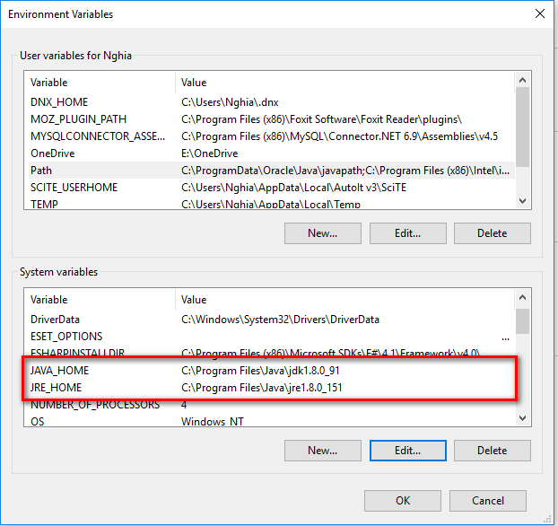

Figure 112: Prepare deployment package

#### 1.2.2 Prepare deployment packed

* Rename deployment packed.war to **ROOT.war**

#### 1.2.3 Prepare database for web service

* Install MySQL
* Setup Port for MySQL: 3306

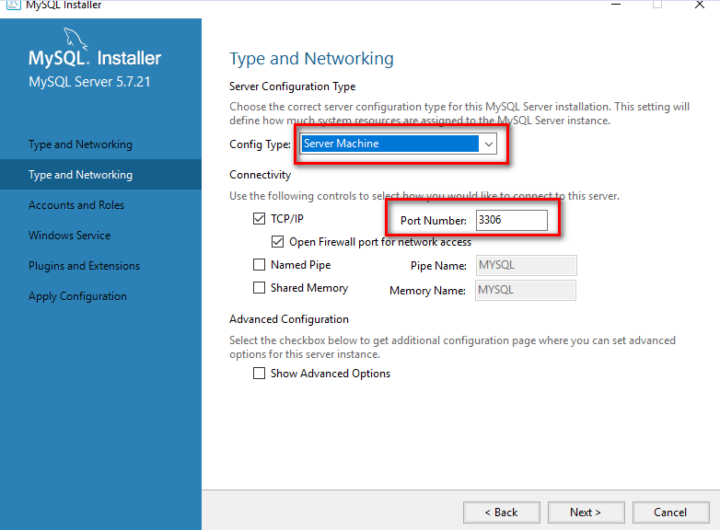

Figure 113: Setup port for MySQL

* Setup Username/Password for MySQL: root/123456( Default password for Web Service Packed)

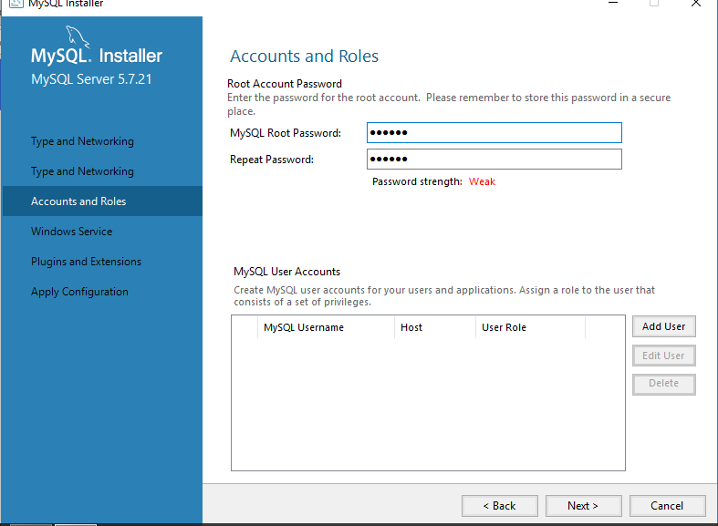

Figure 114: Setup username/password for MySQL

* If want connect with other options:
  + Rename Web Service .war packed to Web Service.zip
  + Modified file: **WEB-INF/classes/application.properties** in Web Service.zip packed.
  + Rename Web Service .zip packed to Web Service.war

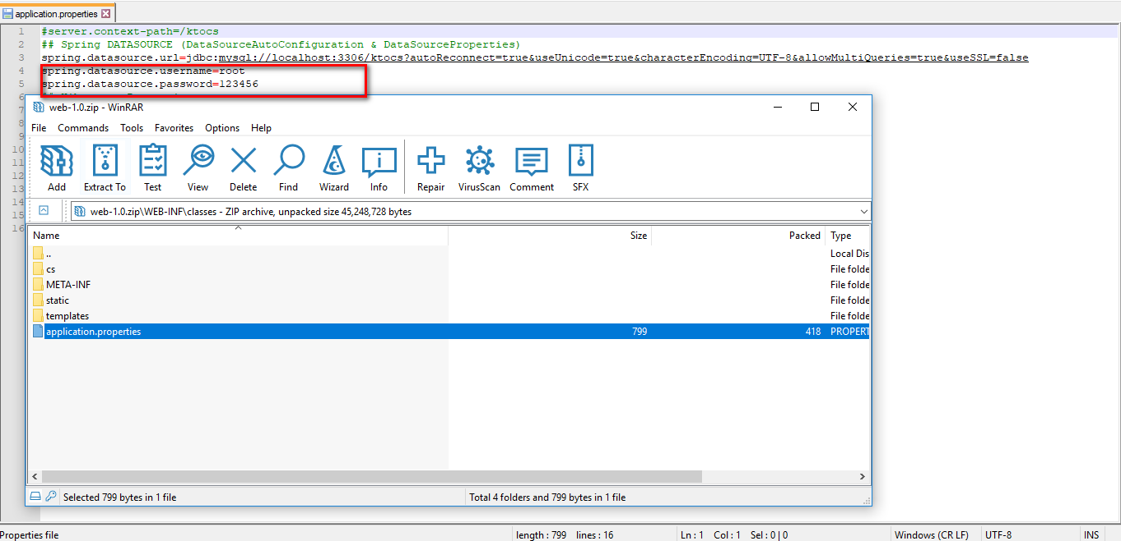

Figure 115: Connect database with other username and password

#### 1.2.4 Deploy database

* After, deploy WebService.war on Apache TomCat.
* Database will automatic deploy.

#### 1.2.5 Deploy web application on server

* Download Web Service packed: <https://drive.google.com/file/d/1Gfd2U3P_OAthK0NLSqa9bV8V5_YiUDOq/view?usp=sharing>
* Unzip apache-tomcat-8.5.10.zip

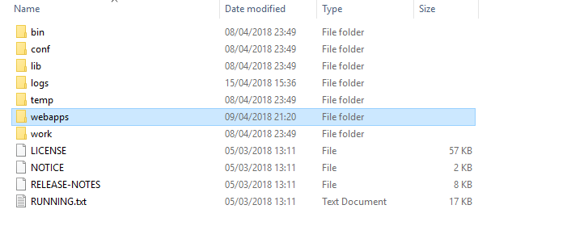

Figure 116: After unzip apache-tomcat-8.5.10.zip

* Goto: apache-tomcat-8.5.10/bin
* Run: **startup.bat** to start apache tomcat – Run: *shutdown.bat* to stop

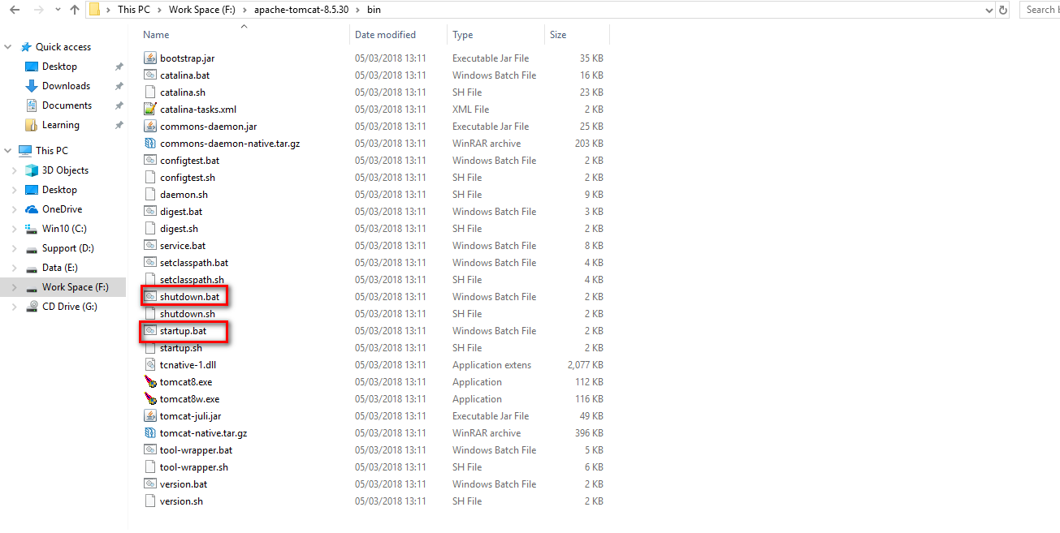

Figure 117: startup.bat to start and shutdown.bat to stop

* Click startup.bat to run Apache Tomcat

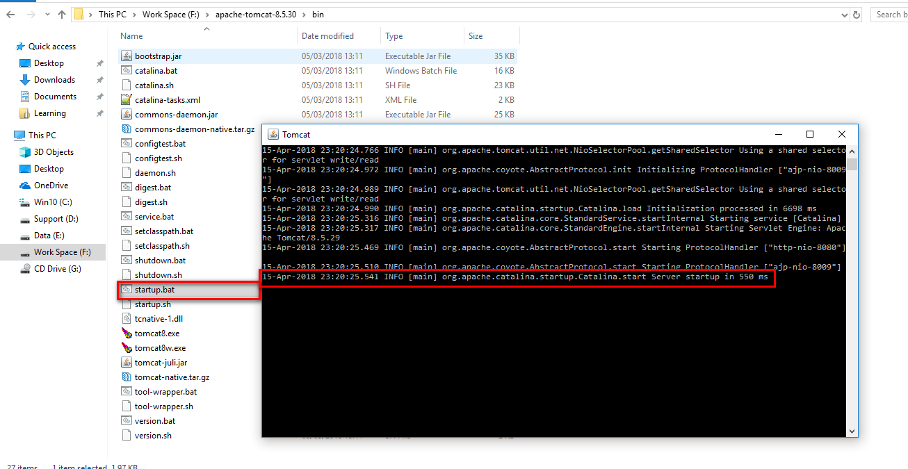

Figure 118: Run Apache Tomcat

* Copy ROOT.war to **apache-tomcat-8.5.10/** **webapps** to deploy Web Serivce

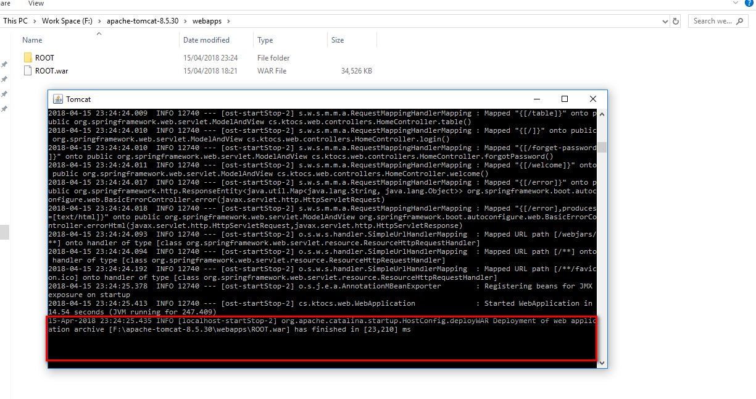

Figure 119: Deploy web service

* Web Service will deploy with database.

**1.3 Setting up the environment at client side**

#### 1.3.1 Setting up for computer

The client devices need to have one of the following browsers to access the website htpp://localhost:8080

* Google Chrome.
* Firefox.

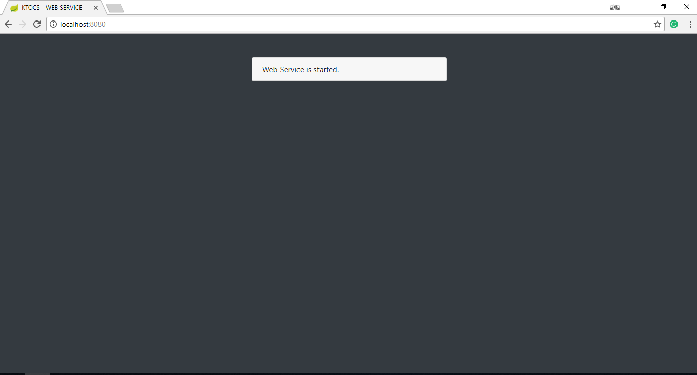

Figure 120: Test Web Service for computer

#### 1.3.2 Setting up for Android device

* Change setting to install unknown source apk.
* **Setting > Additional settings > Privacy > Unknown sources**

Figure 121: Change setting to install unknown source apk

* Connect to the same network as the server

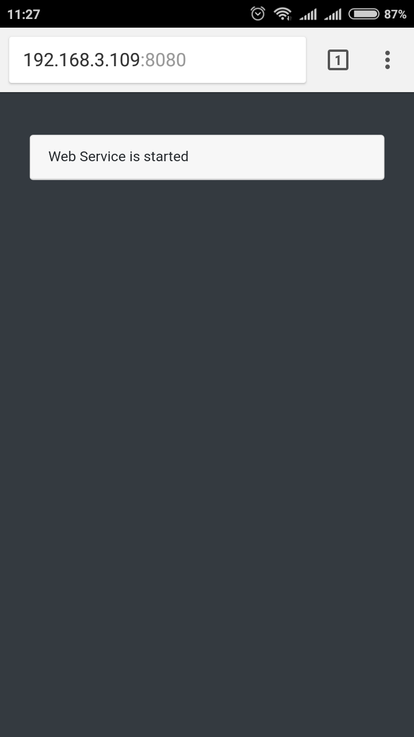

Figure 122: Test Web Service for phone

* Use browser and goto address:

<https://drive.google.com/file/d/1MJ6on0WoGpSSSPsV5djFilhJJNJeIIHg/view?usp=sharing> and download app

* Install App

## 2. User Guide

### 2.1 <User> Give App Permission

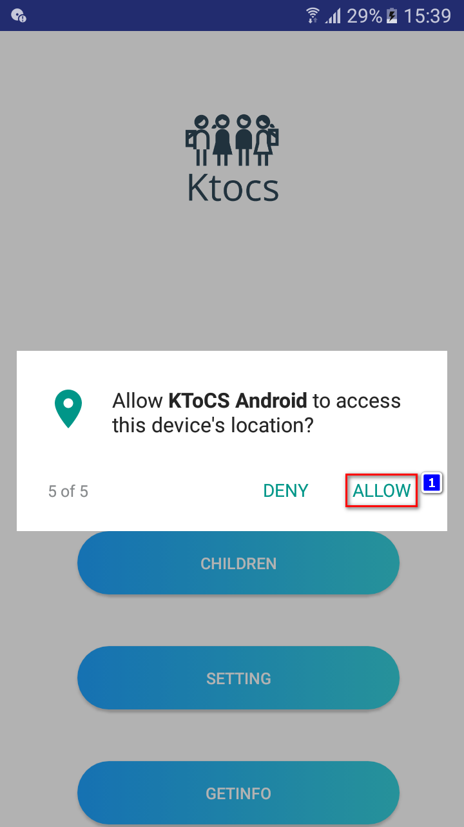

|  |  |
| --- | --- |
| **Step** | **Description** |
| 1 | User press allow for all permission for application to run properly |

### 2.2 <Guest> Register

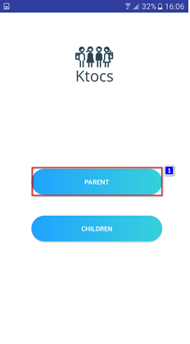 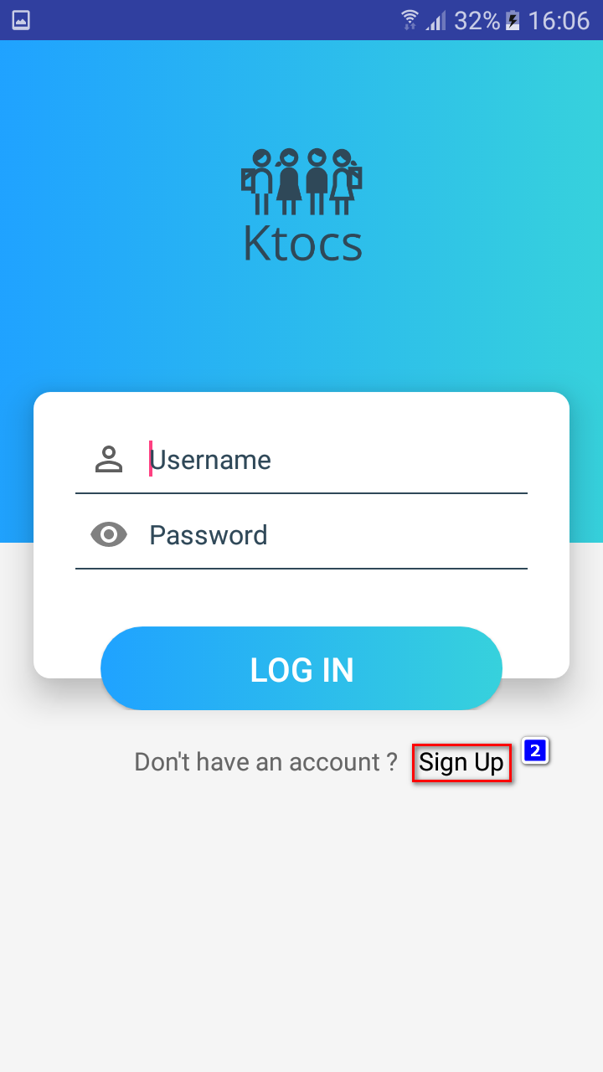

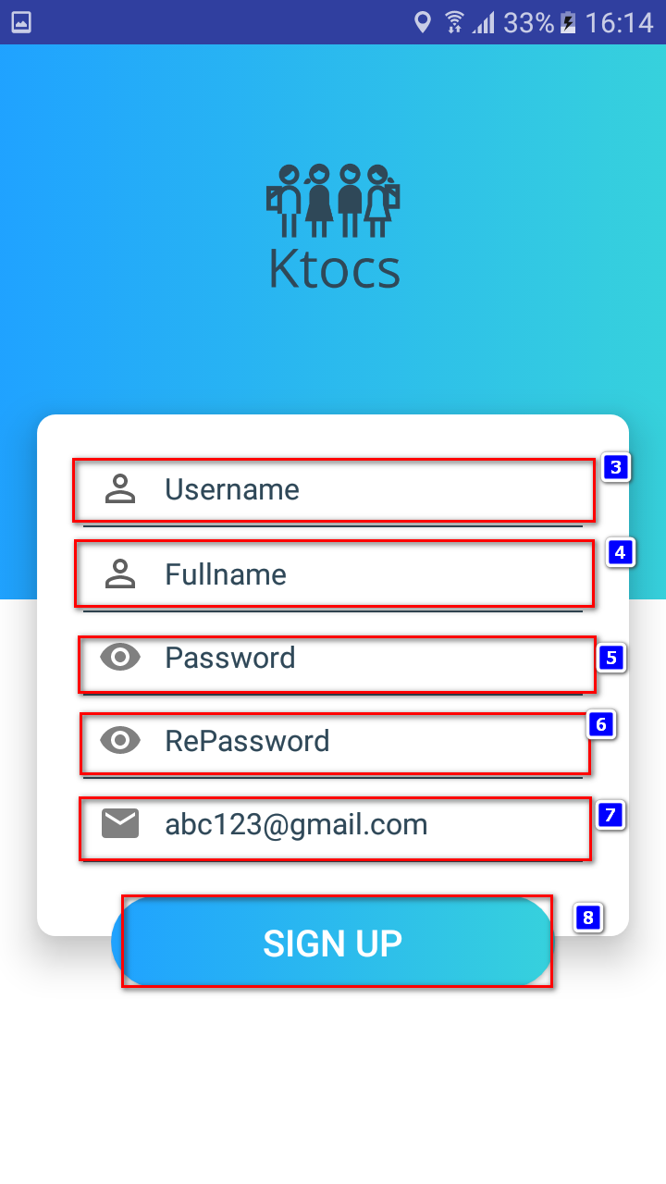

|  |  |
| --- | --- |
| **Step** | **Description** |
| 1 | User press Parent |
| 2 | User press Sign Up |
| 3 | Input Username for Login |
| 4 | Input your name for profile |
| 5 | Input your password |
| 6 | Input the repassword |
| 7 | Input your email |
| 8 | Press Sign up |

### 2.3 <Parent> Login

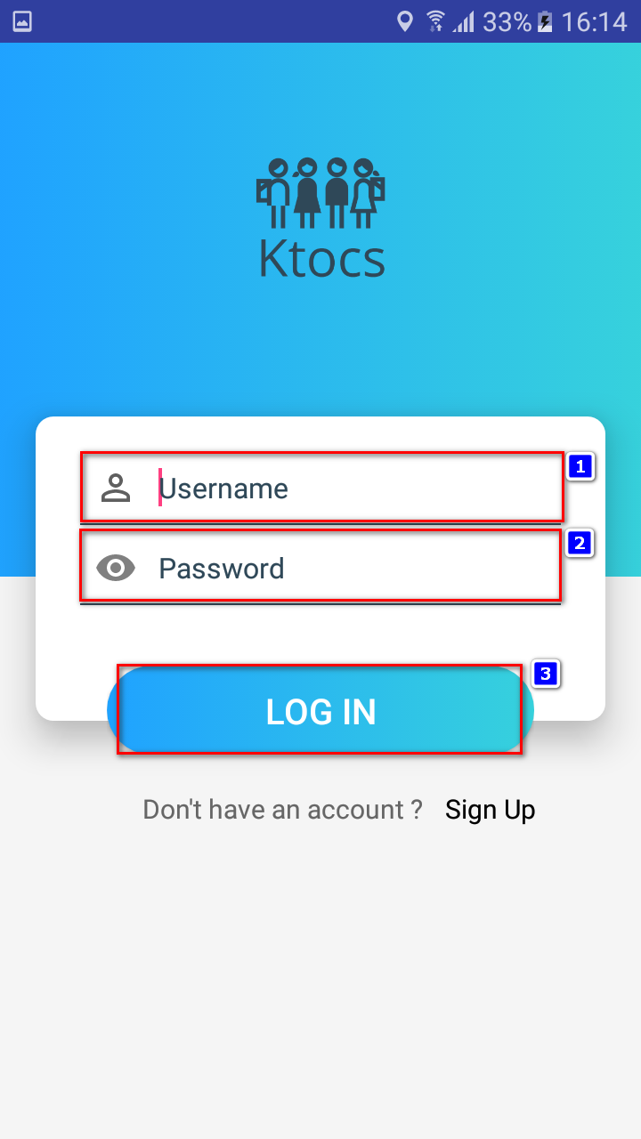

|  |  |
| --- | --- |
| **Step** | **Description** |
| 1 | User input username |
| 2 | User input password |
| 3 | User press Login |

### 2.4 <Parent> Add a children

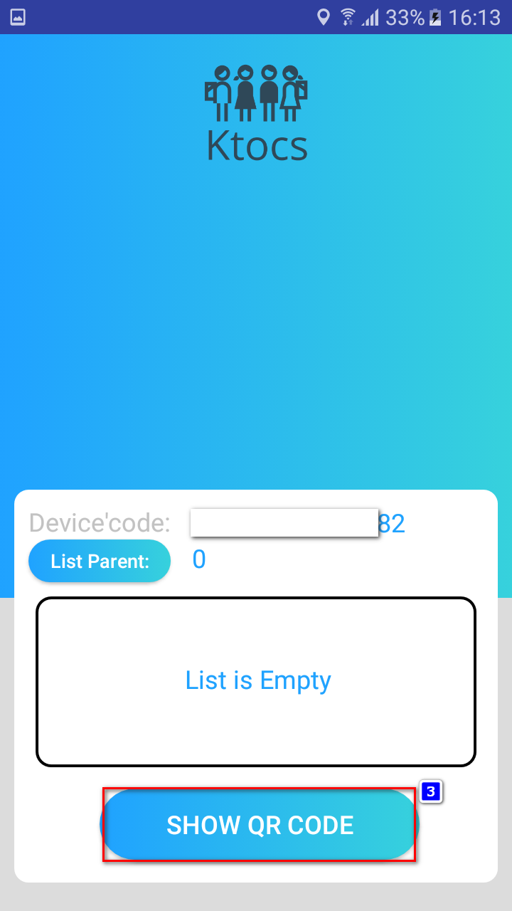 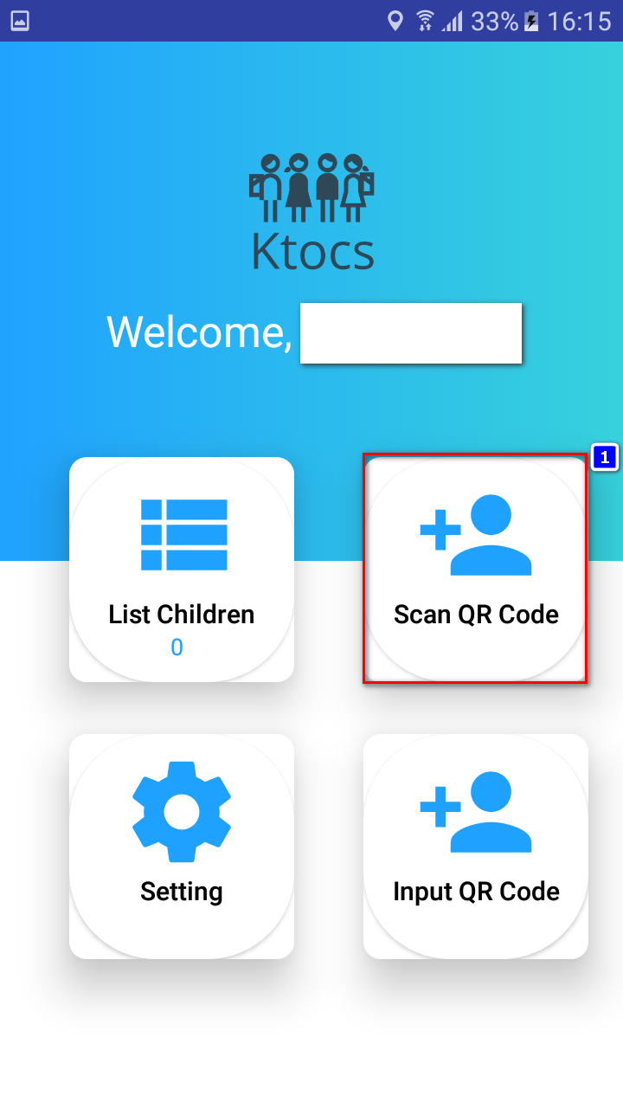

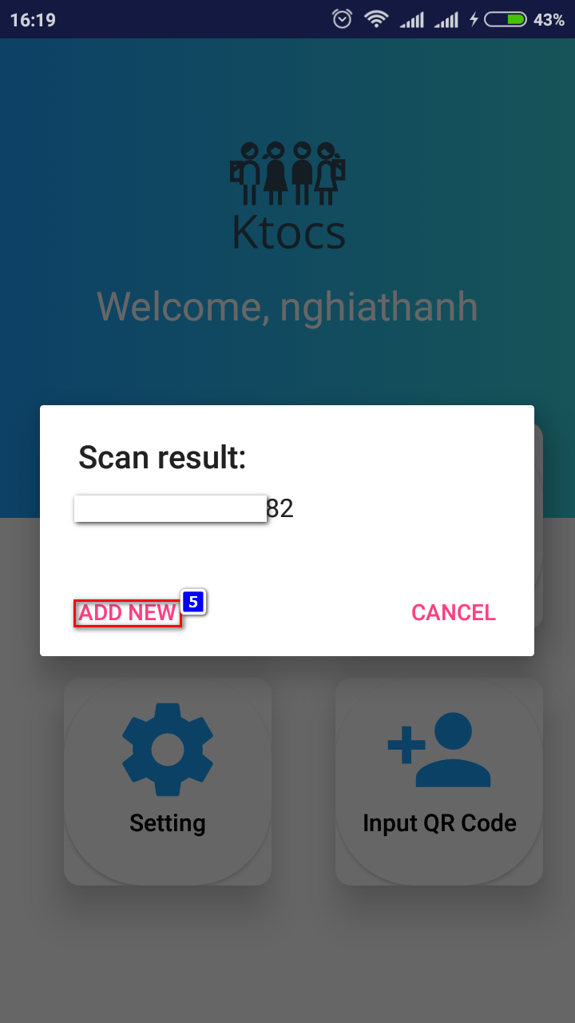 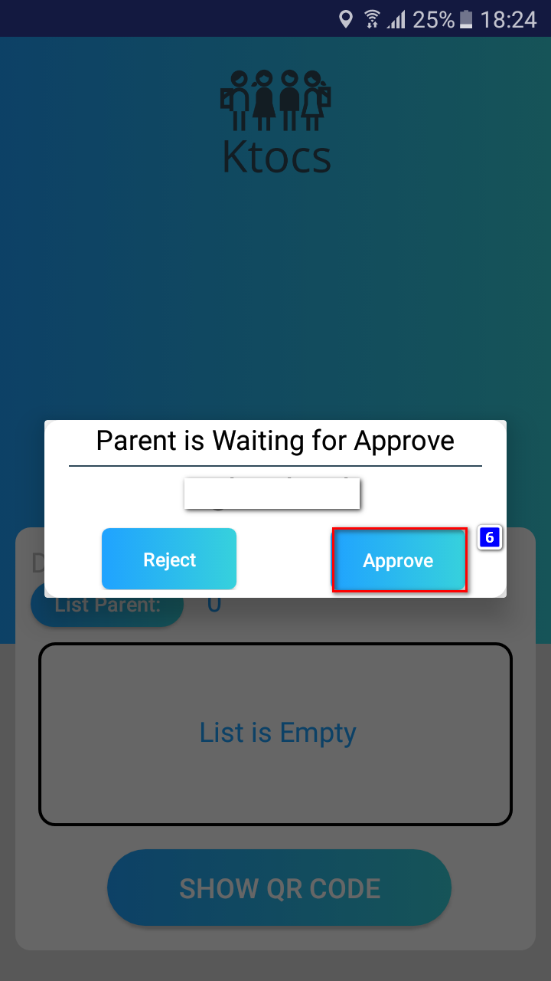

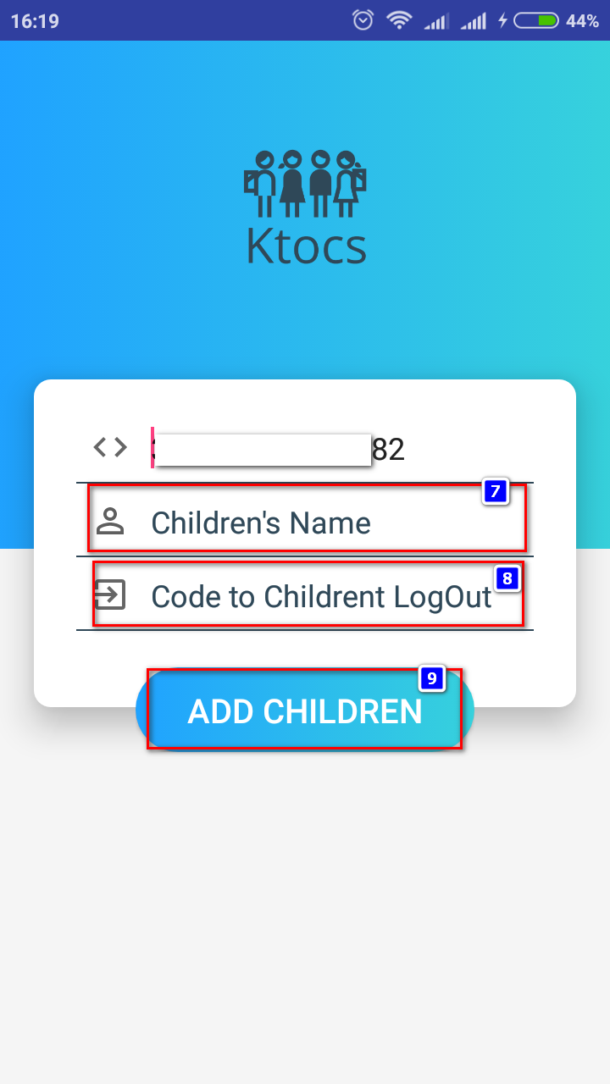

|  |  |
| --- | --- |
| **Step** | **Description** |
| 1 | <Parent> Press Scan QR code |
| 2 | <Children> Press on children button |
| 3 | <Children> Press on Show QR Code button |
| 4 | <Parent> Scan the QR code |
| 5 | <Parent> Press ADD NEW |
| 6 | <Children> Press Approve |
| 7 | Input children’s name |
| 8 | Input code for children to logout |
| 9 | Press button ADD CHILDREN |

### 2.5 <Parent> View Children’s Menu

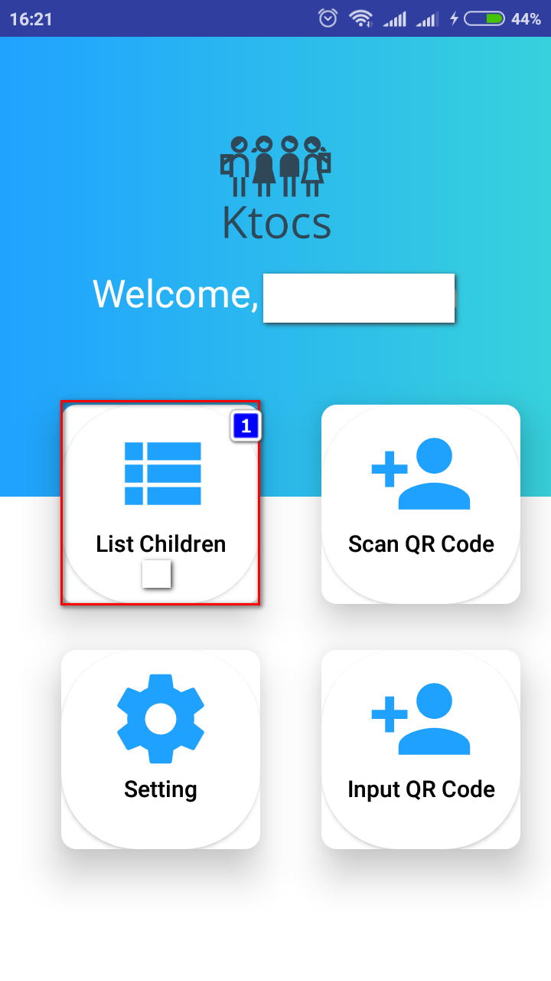 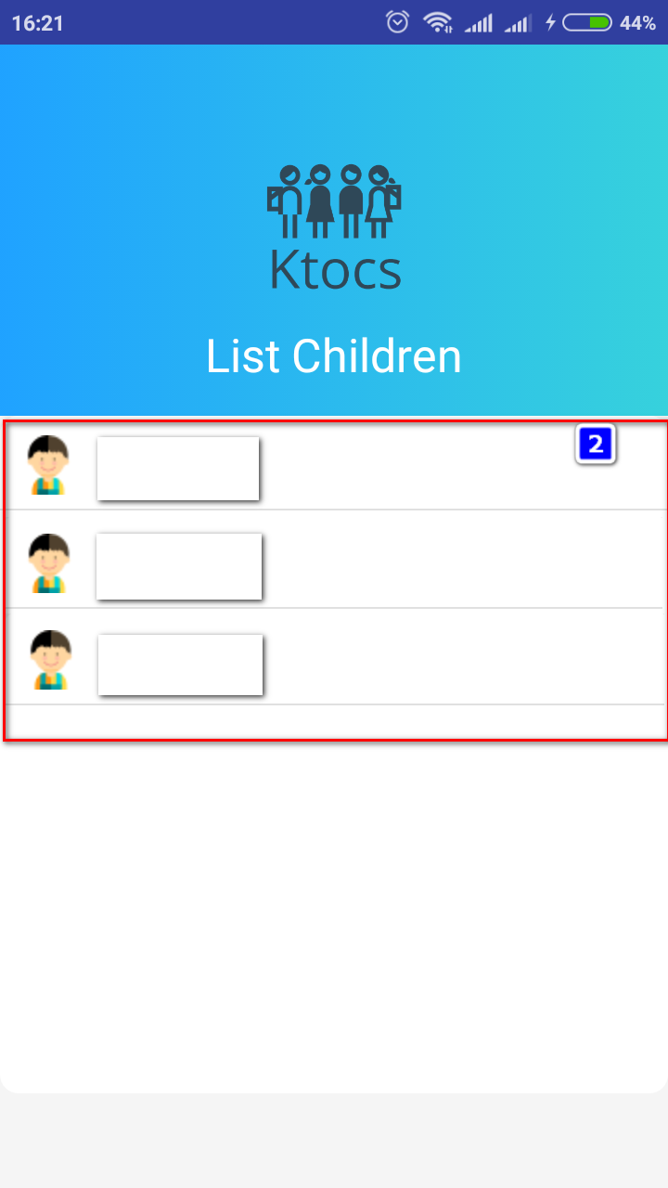

|  |  |
| --- | --- |
| **Step** | **Description** |
| 1 | Press list children |
| 2 | Select child’s device |

### 2.6 <Parent> Children’s Menu

|  |  |
| --- | --- |
| **Step** | **Description** |
| 1 | Press Contact button to view list Contact on children’s device |
| 2 | Press Call Logs button to view list Call log on children’s device |
| 3 | Press Message button to view list Message on children’s device |
| 4 | Press Children Location button to see the current location of children’s device and direction to the nearest location |
| 5 | Press Trusted location button to see list of trust location, add new trust location, edit trusted location |
| 6 | Press Notification Center button to view list all Notification on children’s device |
| 7 | Press Edit Children button to edit children’s information |
| 8 | Press Delete Children button to delete this children’s device from monitor |

### 2.7 <Parent> Contact

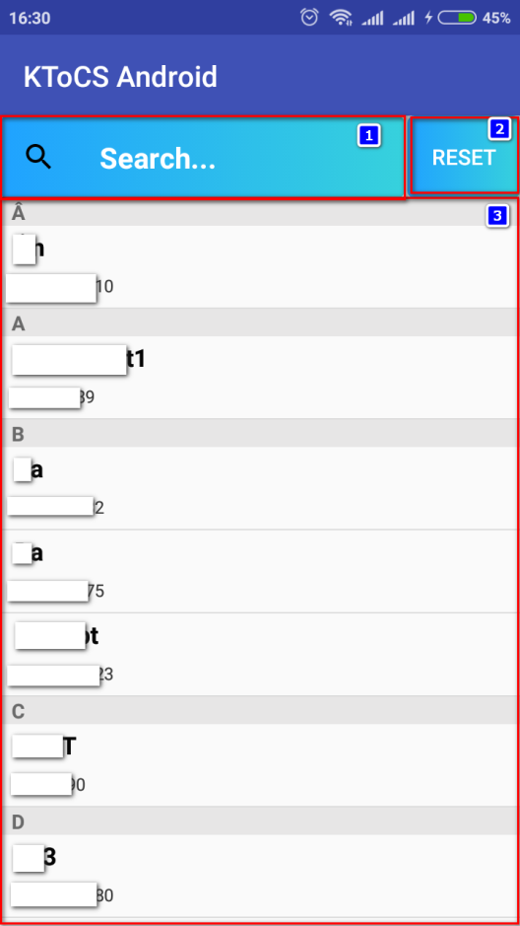

|  |  |
| --- | --- |
| **Step** | **Description** |
| 1 | Press search to search for contact |
| 2 | Press Reset button to reset list contact |
| 3 | Press on contact’s record to view contact detail |

### 2.8 <Parent> Search Contact

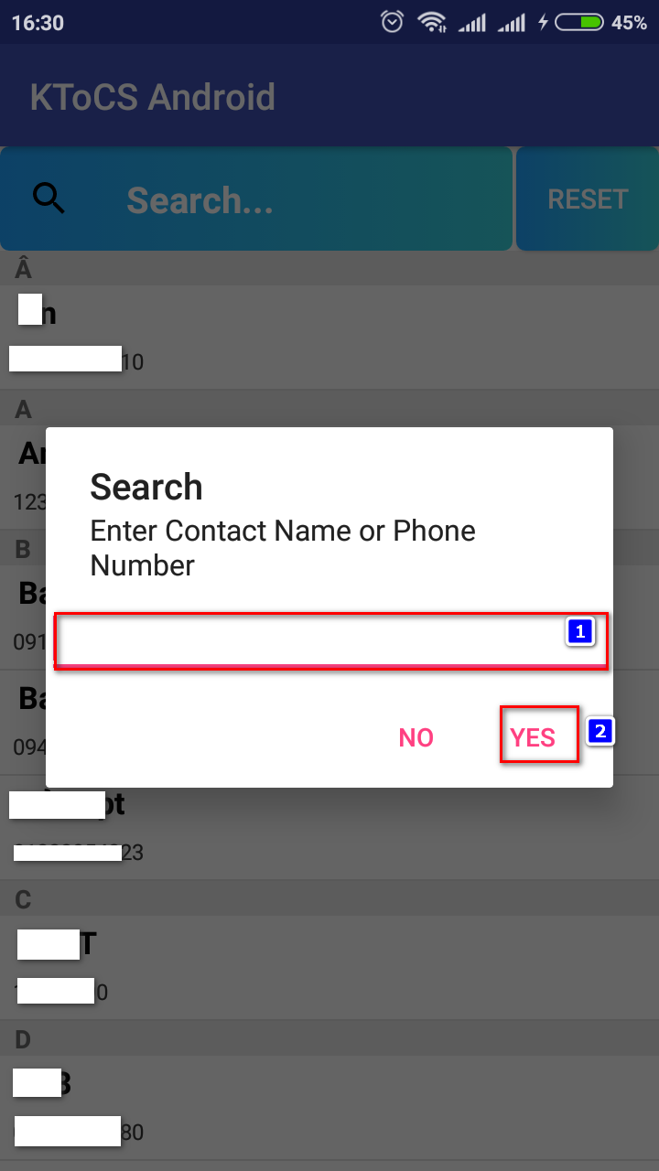

|  |  |
| --- | --- |
| **Step** | **Description** |
| 1 | Input name or number of contact to search |
| 2 | Press to search |

### 2.9 <Parent> Contact detail

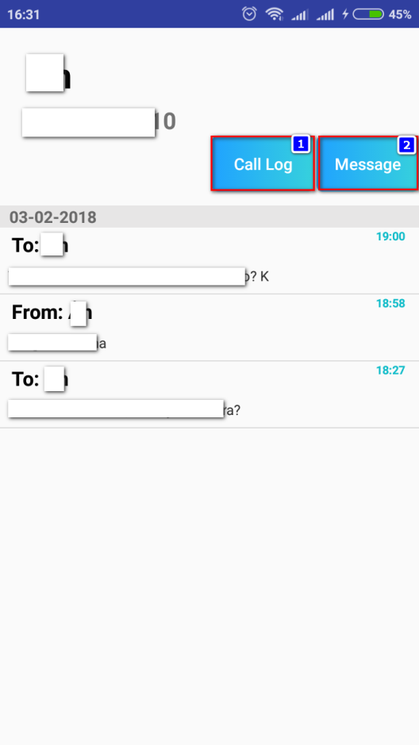

|  |  |
| --- | --- |
| **Step** | **Description** |
| 1 | Press to see list of call logs of this contact |
| 2 | Press to see list of call logs of this contact |

### 2.10 <Parent> Call Logs

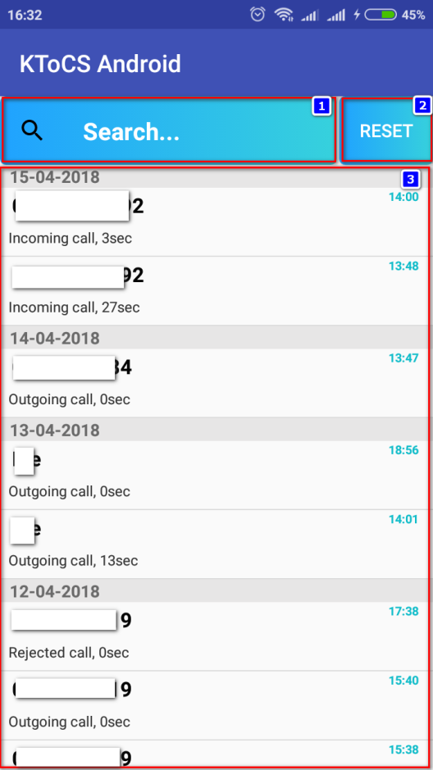

|  |  |
| --- | --- |
| **Step** | **Description** |
| 1 | Press search to search for call log |
| 2 | Press Reset button to reset list call log |
| 3 | Press on call log’s record to view contact detail (seach guide Contact detail) |

### 2.11 <Parent> Search Call Logs

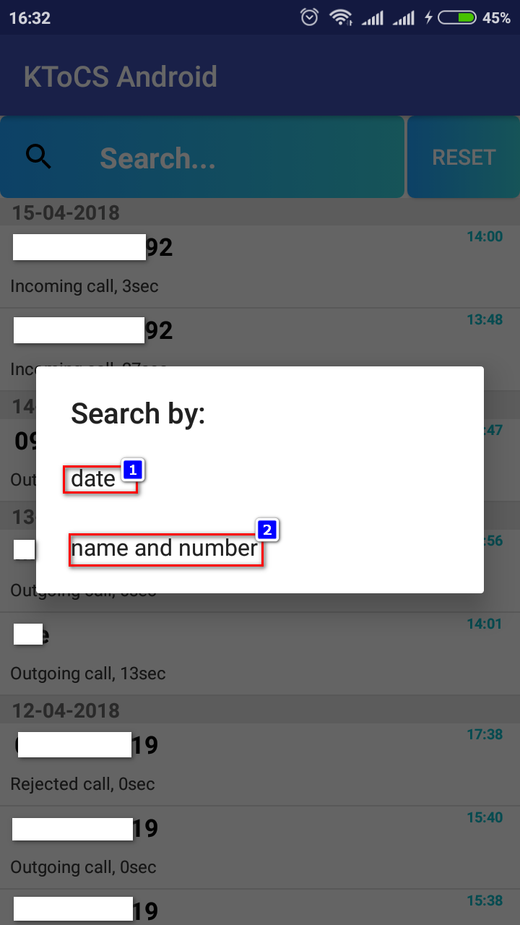

|  |  |
| --- | --- |
| **Step** | **Description** |
| 1 | Press date to search for call log by date |
| 2 | Press name and number button to reset list call log |

### 2.12 <Parent> Search Call Log by Date

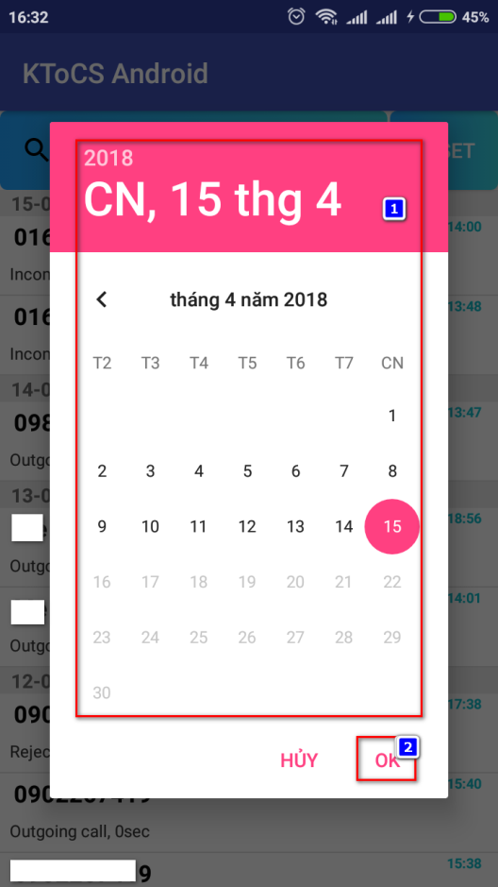

|  |  |
| --- | --- |
| **Step** | **Description** |
| 1 | Select date |
| 2 | Press ok to search |

### 2.13 <Parent> Search call log by name and number

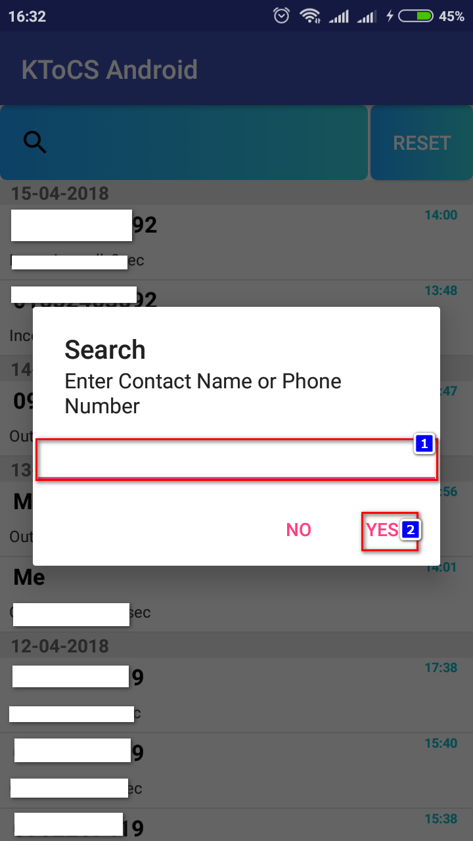

|  |  |
| --- | --- |
| **Step** | **Description** |
| 1 | Input name or number of call log to search |
| 2 | Press to search |

### 2.14 <Parent> Message

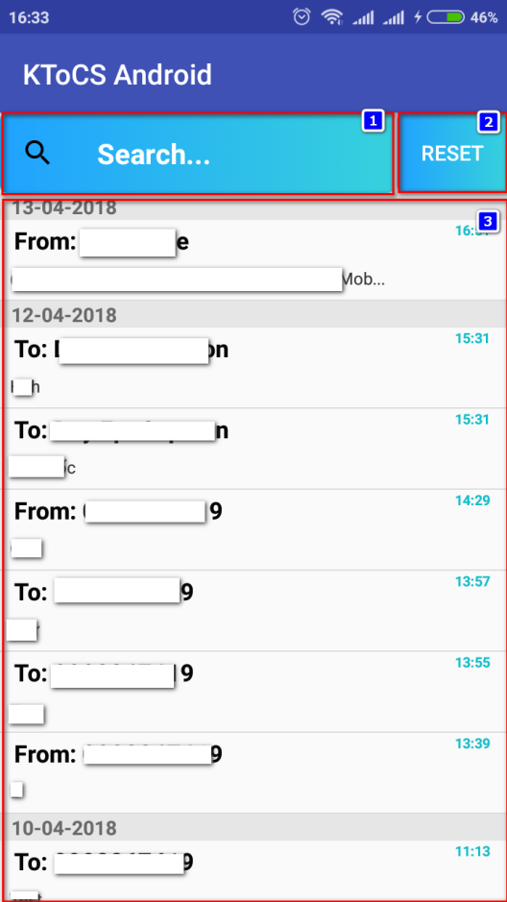

|  |  |
| --- | --- |
| **Step** | **Description** |
| 1 | Press search to search for Message |
| 2 | Press Reset button to reset list message |
| 3 | Press on message’s record to view message content |

### 2.15 <Parent> Search Message



|  |  |
| --- | --- |
| **Step** | **Description** |
| 1 | Press date to search for Message by date |
| 2 | Press name and number button to reset list Message |

### 2.16 <Parent> Search call log by date



|  |  |
| --- | --- |
| **Step** | **Description** |
| 1 | Select date |
| 2 | Press ok to search |

### 2.17 <Parent> Search call log by name and number



|  |  |
| --- | --- |
| **Step** | **Description** |
| 1 | Input name or number of Messgae to search |
| 2 | Press to search |

### 2.18 <Parent> Messgae Detail

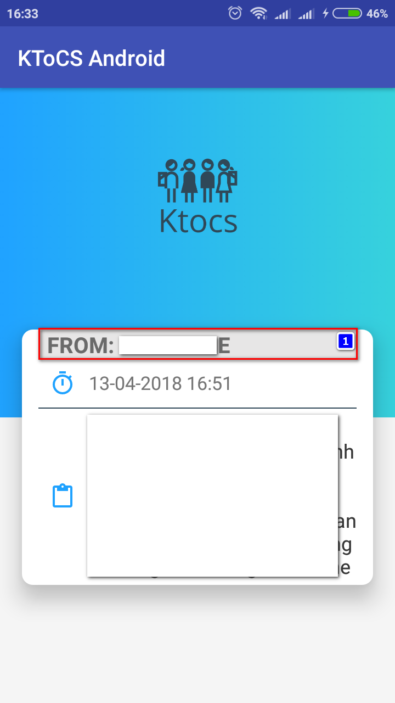

|  |  |
| --- | --- |
| **Step** | **Description** |
| 1 | Press on the contact to see contact detail (see Contact detail guide) |

### 2.19 <Parent> Children Location

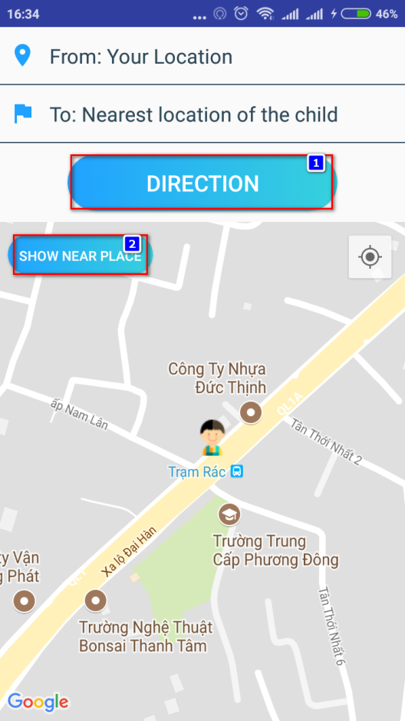

|  |  |
| --- | --- |
| **Step** | **Description** |
| 1 | Press Direction button to see the direction to the nearest place to children’s device |
| 2 | Press Show near place button to check near places name |

### 2.20 <Parent> Trusted Location

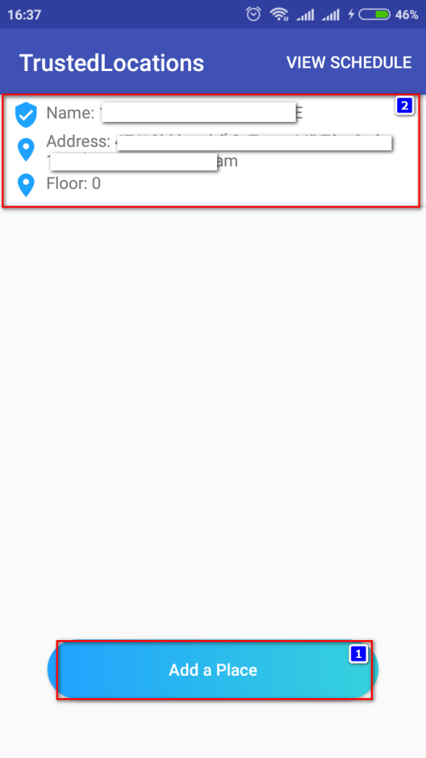

|  |  |
| --- | --- |
| **Step** | **Description** |
| 1 | Press Add place button to add Trust location record |
| 2 | Press on location record to edit trusted location |

### 2.21 <Parent> Add trusted location

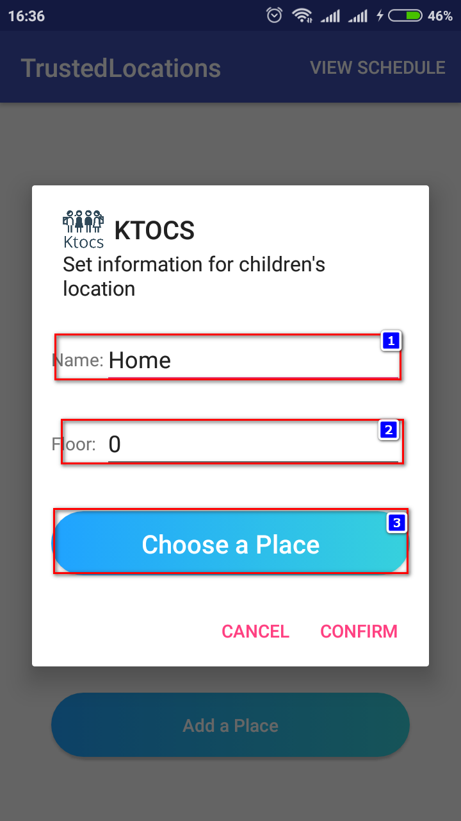 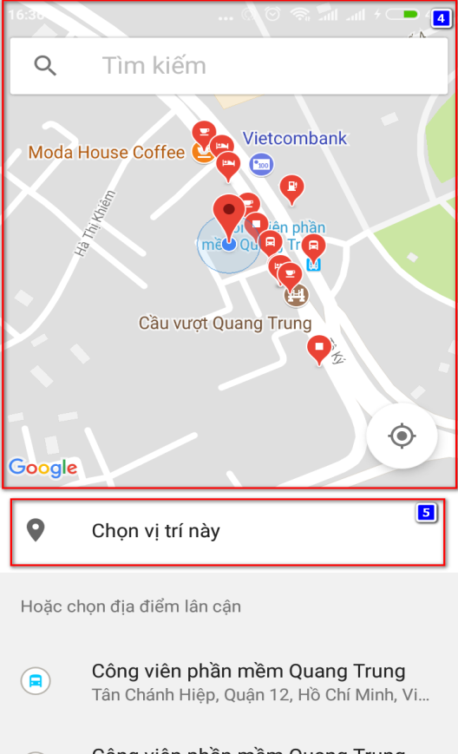

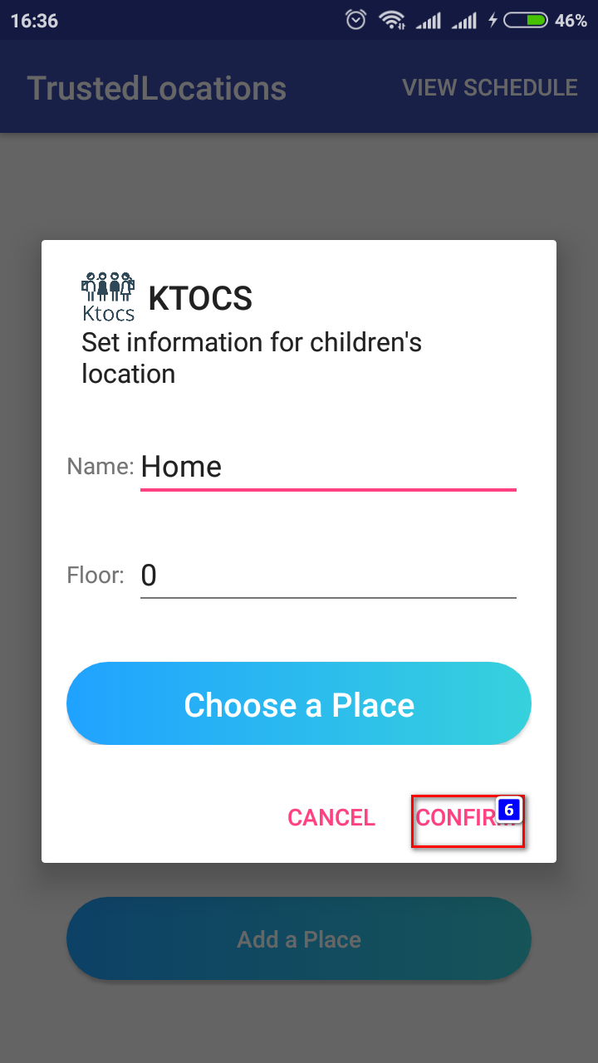

|  |  |
| --- | --- |
| **Step** | **Description** |
| 1 | Input name of trust location |
| 2 | Input floor number of location |
| 3 | Press Choose a place button to select trust location |
| 4 | Select trust location |
| 5 | Press to chooce the location |
| 6 | Press confirm to create trust location |

### 2.22 <Parent> Edit trusted location schdule

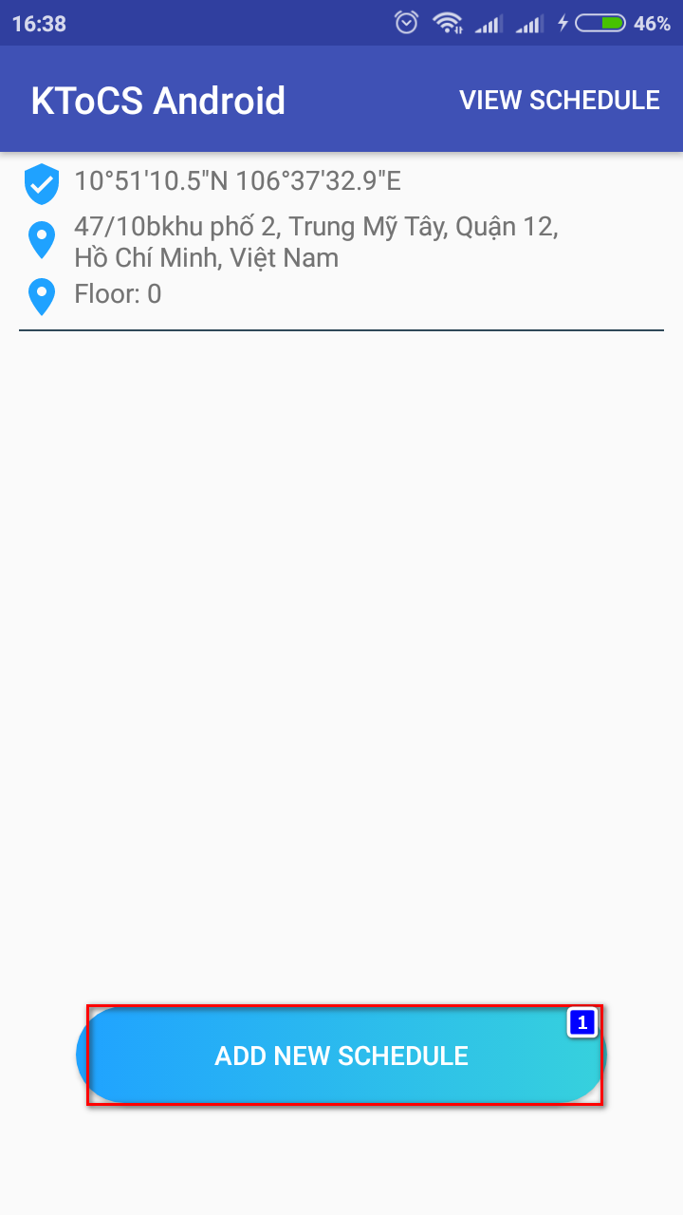 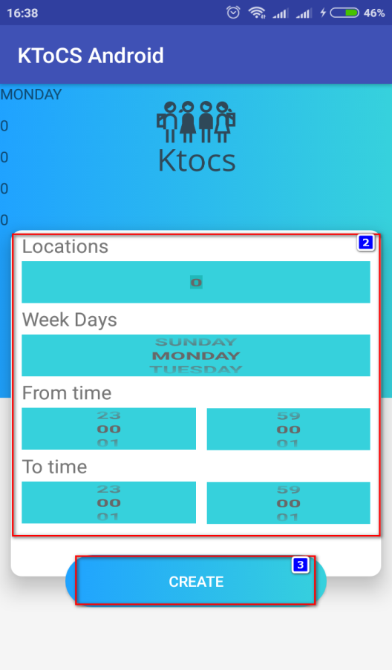

|  |  |
| --- | --- |
| **Step** | **Description** |
| 1 | Press button add new schedule to creat new schedule for the following location |
| 2 | Input information of the location |
| 3 | Press Create button to create schedule for the location |

### 2.23 <Parent> Notification Center

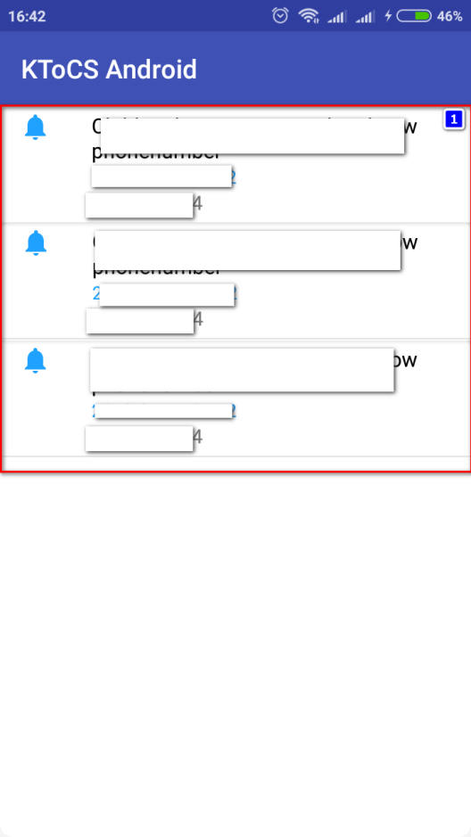

|  |  |
| --- | --- |
| **Step** | **Description** |
| 1 | Press on notification to see notification detail |

### 2.24 <Parent> Edit Children

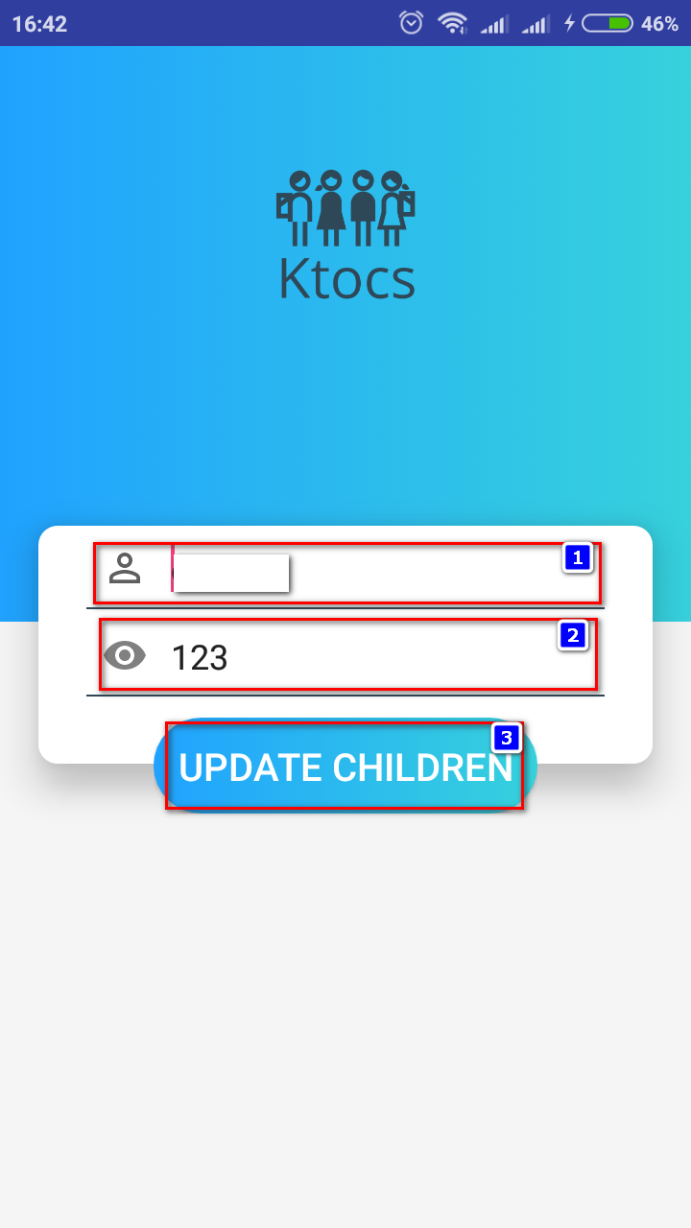

|  |  |
| --- | --- |
| **Step** | **Description** |
| 1 | Input children’s name |
| 2 | Input code for children to exit |
| 3 | Press Update children to update children’s information |

2.25 <Parent> Delete Children

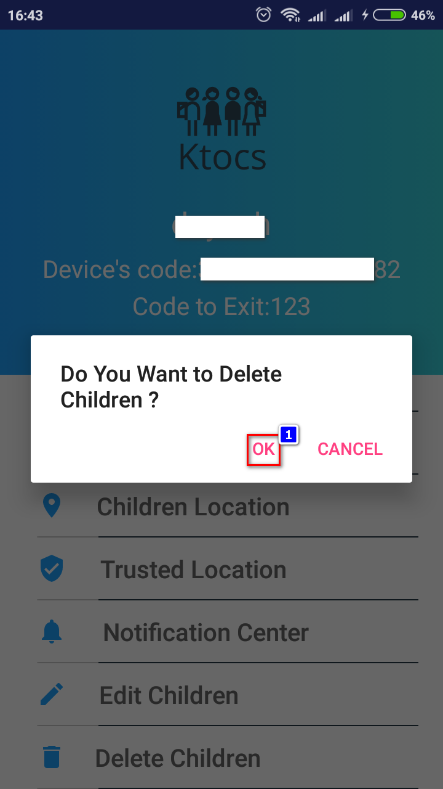

|  |  |
| --- | --- |
| **Step** | **Description** |
| 1 | Press to delete children’s device from list monitoring |

# G. Acknowledgment

First, we would like to express our greatest gratitude to Mrs. Nguyen Thi Cam Huong, our supervisor, for her guidance, support and encouragement during this project, helped us to organize and coordinate our project especially in project requirement, project’s quality and writing this report.

We would like to send our thanks to all FPT University Lecturers for have taught and guided us with great instruction and passion throughout our years of study.

We are grateful to FPT University, which provided us with great study and motivation environment.

Last, our thanks and appreciations also go to our family and friends who encourage and help us to complete this project.

Thank you for all your support to our team.

Sincerely.

# H. Appendix

1. UML standard diagrams

<https://www.tutorialspoint.com/uml/uml_standard_diagrams.htm>

2. Google API map

[https://developers.google.com/maps/](https://developers.google.com/maps/%20)

3. Google API placepicker

[https://developers.google.com/places/](https://developers.google.com/places/%20)

4. Android Developers

[https://developer.android.com/index.html](https://developer.android.com/index.html%20)

5. StarUML

<http://staruml.io/>

6. Spring-boot

<https://projects.spring.io/spring-boot/>